
Glen Fisher Consulting

Report to the Engineering Council of South Africa

Glen Fisher

28 October 2011

Research report commissioned by the Engineering Council of South Africa (ECSA) 2011

Improving Throughput in the Engineering Bachelors Degree

Acknowledgements

My thanks for their guidance and support to:

Dr Oswald Franks, CEO, ECSA
Professor Thokozani Majozi, Chair of the ECSA Strategic Advisory Committee and ECSA Vice President
Professor Hu Hanrahan, Special Advisor, ECSA
Professor Jenni Case, President of the South African Society for Engineering Education
Professor Ian Scott, UCT
Professor Diane Grayson, University of Pretoria
Jane Hendry
Allyson Lawless
Monique Adams
All interviewees
All who assisted with data provision

And, last but not least, my wife, Roberta Pazdro, for putting up with me during the absences and the writing.

Table of Contents
Acknowledgements 2
Section One: Introduction and Overview 5
Introduction 6
Methodology 7
Some systemic dimensions of the throughput challenge 11
A national challenge 11
A complex, multi-dimensional challenge 12
A multi-actor challenge 13
An institution-specific challenge 13
What is needed? 13
Higher Education and the throughput challenge 15
Faculties offering the professional bachelors degree in Engineering 20
Institutional Mergers 23
Institutional Differentiation 23
Throughput rates in Engineering 25
Conclusion 32
Section Two: Seven Levers of Change 36
The school pipeline 37
Student under-preparedness and the gap between school and university 38
The National Senior Certificate 40
Expanding the school pipeline: outreach and talent-search initiatives 41
Conclusion 42
Student Selection 44
Student choices 44
Mainstream entrance requirements 47
Conclusion 51
Student Support 53
Students’ backgrounds 53
The school-university ‘gap’ 54
Coping with the campus environment 55
Networks and support systems 55
Affective factors 56
The institutional dimension 57
Accommodation 57
Student financial aid 59
Institutional culture and climate 62
Language 64
Curriculum 67
Course load 69
Structure and sequencing of the programme 70
Combined degrees, and flexible exit and entry points 71
Alternative Admissions, Foundation and Extended Programmes 73
Access to higher education, in social and historical context 73
Foundation and extended programmes 75
Institutional contexts and institutional responses 78
Beyond foundation and extended programmes 79
Towards a flexible mainstream curriculum 82
A case for a flexible mainstream curriculum 83
Arguments against a rigid five year degree structure 86
Some implications of a flexible mainstream curriculum 87
A note on service courses 88
Conclusion 89
Teaching and learning: a core mission 93
The teaching challenge in context 94
‘Killer courses’ and student transition points 96
Barriers to improved teaching and learning 97
Developing teaching ‘expertise’ in engineering 99
Supporting teaching and learning 101
A note on online learning and other resources 103
Conclusion 104
Staffing 107
Findings from the 2008 JIPSA study 107
Improving throughputs: the staffing challenge 111
Policy choices and resource allocation 112
Loss of experience 113
Teaching, research and consulting 114
The post-graduate pipeline 116
Conclusion 118
Funding 119
State funding of higher education 119
Institutional allocation of funding 124
Student financial aid 125
A note on the costs of proposed reforms 127
University-industry linkages 128
Conclusion 132
Section Three: Conclusion and Recommendations 134
Conclusion and recommendations 135
Seven ‘levers of change’ 135
A framework for action 138
References 143
Appendix A: Interviewees 145
Appendix B: Average first-year Physics results, selected universities 149
Appendix C: A note on funding 151

Section One: Introduction and Overview

Introduction

This report is the outcome of a review initiated in April 2011 by the Engineering Council of South Africa, aimed at identifying ways of improving throughputs in the engineering bachelors degree. While the focus is on the four year degree programme, it is hoped that the study will have wider applicability, and will help inform future discussion and research into the training of technologists and technicians.
The purpose of the study, as approved on 8 April by ECSA’s Strategic Advisory Committee, is as follows:

…to propose a framework and firm recommendations for improving throughputs in Engineering Bachelors degrees, which will be supported by the Engineering profession and the universities and incorporated, where appropriate, into ECSA’s accreditation of institutions.
The focus of the analysis and recommendations will be on the support mechanisms and systemic changes that may be required, to better enable and support talented but academically under-prepared and disadvantaged students to succeed in mainstream engineering programmes.

The background to this initiative is outlined in an ECSA briefing document of 22 March:

South Africa faces a shortage of high level engineering skills and there is an ongoing need to transform the profession to ensure greater representivity. Currently the pipeline of qualified candidates from the school system into science, engineering and technology (SET) fields in higher education is constrained by the poor quality of schooling, and many entering students, although in the top decile of their cohort, are academically under-prepared and financially disadvantaged.
Currently fewer than a third of all engineering students in Bachelors programmes graduate within the regulation time, and under two thirds graduate within six years. For African students, in particular, and for a range of reasons, throughput and graduation rates are even less satisfactory. Just under a third of African students graduate in five years, as opposed to 64% of white students.
These figures point to inefficiencies in the training of engineers and represent a significant obstacle to skills development and to transformation. ECSA wishes therefore to investigate how, in partnership with higher education and other stakeholders and role-players, it might facilitate and support increased throughput rates and graduate outputs in Engineering Bachelors degrees, with particular emphasis on enabling talented but under-prepared students to succeed in mainstream engineering programmes.

Throughput, needless to say, is a more complex and contested issue than it might seem. How throughput is calculated is itself a matter for debate, and the reasons behind varying throughput rates for different faculties and departments, and for different student groups, are to be found in South Africa’s apartheid and post-1994 history, in different institutional contexts, in the stubborn realities of race, language, socio-economic status and educational background, and of course in the motivation, application and ability of individual academics and students.
For all of these reasons, it is important to look beyond a simple quantification and description of the throughput challenge, if ECSA is to better understand the issues and seek workable and realistic solutions. This is the rationale behind the present study, and in the report that follows, the issue of throughput is located within its wider social and institutional contexts, and the complex, multi-dimensional, multi-actor nature of the strategies that are required to improve throughput rates and increase graduate outputs are examined. Seven ‘levers of change’ are identified, and some pointers are provided as to how ECSA might lead and facilitate a process aimed at improving throughput rates and graduate outputs, to the long-term benefit of the engineering profession and of the wider society and economy.

Methodology
This study combines quantitative, qualitative and documentary research, with the aim of both quantifying and understanding the nature of the throughput challenge, and identifying possible approaches to improving throughput which are systemic in nature while remaining sensitive to context.
For the quantitative analysis, tables were submitted for completion to the Deans of all Faculties offering the Bachelors Degree in Engineering. The universities are as follows:

- University of the Witwatersrand
- University of Johannesburg
- University of Pretoria
- University of KwaZulu Natal
- North-West University
- Nelson Mandela Metropolitan University
- University of Stellenbosch
- University of Cape Town

The tables requested information on the following, broken down by race and gender, as well as by Department where appropriate:

- The aggregate matriculation results, and mathematics and physical science scores, of first-time entering students
- First-year mathematics and physics results of first-time entering students
- A cohort analysis of throughput, indicating the numbers and proportion of each intake graduating in 4, 4+1 and 4+2 years
- Quality of passes of graduating students
- Bursary and student financial aid data

Data was provided, in the requested format, by the Universities of Cape Town, Johannesburg, KwaZulu Natal and NMMU. Their cooperation and assistance is gratefully acknowledged. Data was also provided by the Universities of Stellenbosch and the North-West, covering some aspects of the research, in their own formats. Data from the University of the Witwatersrand was promised but was not, in the end, forthcoming, while the University of Pretoria indicated that it was unable to supply the requested data because of difficulty with a new management information system.
In fairness to those institutions which did make data available, and in view of the fact that the aim of this research is not to ‘name and shame’ institutions, but rather to highlight the overall ‘size and shape’ of the challenge as well as the importance of the contextual and situational differences between institutions that impact on throughput, the data analysis in chapter 2, below, is anonymised, although readers will no doubt be able to make educated guesses as to the institutions concerned.
While some difficulties and delays were experienced with respect to the quantitative aspect of the ECSA study, the study benefited from a high level of cooperation and openness on the part of the universities and other organisations with respect to the qualitative element of the research. Interviews were completed with a purposive sample of key informants, comprising all eight Deans and almost all Heads of School and Heads of Department, as well as a number of staff from the academic development arena. Interviews were also completed with representatives of the following:

- Council on Higher Education
- Council for the Built Environment
- Higher Education South Africa
- National Society of Black Engineers (SA)

A small number of interviews were also undertaken with companies, the Minerals Education Trust Fund and SAIMechE.
Interviews with lecturing staff, and with engineering students, would no doubt have been extremely important and informative but were beyond the scope of this study. Time, unfortunately, also precluded further engagement with employers, government departments and other stakeholders and role-players, and there may be value in pursuing this further in future phases of work.
The views that are presented and discussed in this report are, therefore, necessarily selective, and reflect a particular set of positions and perspectives. This does not mean that they are wholly subjective however: taken together, this purposive sample of key informants represents a highly experienced and informed set of expert and professional insights and perspectives, and there is a high level of congruence in the views and information that were expressed and shared.
Interviews were semi-structured and open-ended, conducted in an informal manner and aimed at ‘sense making,’ probing, and developing an understanding of the issues, as perceived by key informants. The questions were used simply as guides; the interview guide for universities was as follows:

- What attracts students to this University and to Engineering? What attracts them to this particular branch of Engineering?
- What do students find most challenging about the degree or programme?
- What are the factors that affect student success?
- How has the student intake changed over the years - and how do you expect it to change in the future?
- How have the University/Faculty/Department responded to changes in the student intake?
- What is the throughput rate in the Faculty/Department; how does this compare with other Faculties/Departments?
- Do you think the throughput rate can be improved?
  - Within the existing curriculum framework?
  - Within a more flexible or extended curriculum framework?
- Would there be value in an ECSA-facilitated forum, including the Voluntary Professional Associations and industry, to discuss the set of issues arising from this study, and possible ways forward?

For industry and other, non-academic interviews, a slightly different approach was needed:

- What is your view of the quality of engineering graduates from South African universities?
- Are you satisfied with the throughput rates and the numbers of engineers graduating from our universities?
- What, in your view, could make the greatest contribution to improving the effectiveness and efficiency of engineering education in South Africa?
- Describe your company’s/industry’s/Association’s relationship with and support for the Engineering Schools
- Given the average time to degree of 5+ years, how would you feel about the introduction of a 5-year extended degree option?
- Given the average time to degree, would you support a more flexible and tolerant approach to bursary provision, including financial support to students over 5 years instead of 4?
- Could industry play a more positive role in addressing the staffing challenge in our Engineering Faculties? How?
- Would you see value in an ECSA facilitated dialogue between industry, the VPAs and the universities, to explore ways of strengthening the Engineering skills pipeline, and would you participate?

Interviews were not recorded, but detailed notes were taken and subsequently transcribed and thematically ordered. From the analysis of the interview data, and from a review of some of the key literature, seven ‘levers of change’ emerged, and these are discussed in greater detail in the sections that follow.
In summary, the seven levers of change are as follows:

- Improving the talent pipeline from schools
- Improved student selection
- Coherent, integrated and timely student support
- A flexible curriculum, with appropriate foundational support
- Improved teaching and learning
- Staffing
- Funding

Some systemic dimensions of the throughput challenge
Identifying what this review calls ‘levers of change’ is helpful in breaking down a complex problem into constituent parts, so that these can be examined in more detail.
It is important to keep in mind, however, that it is the complex relationships and interactions between these elements that underpin the wider, systemic challenge of improving throughputs, and in looking for ways to engage and seek solutions to this, ECSA needs to adopt a systemic approach, even as it applies itself to specific aspects of the problem.
The issues, in other words, are complex and multi-dimensional, involving a wide range of actors including government, the universities and industry, but they are also institution- and context-specific, playing out in different ways in different institutional environments and settings.
In the closing sections of this introductory chapter, attention is briefly directed towards these wider, systemic dimensions of the throughput challenge.

A national challenge
Predicting the demand for skills is a notoriously unreliable art, especially when, at the time of writing, the global economy faces a renewed period of crisis, with uncertain implications for smaller, emerging market economies such as ours.
One indicative measure, however, is the number of engineers per thousand of population. According to Lawless (2005: 231), South Africa, at one engineer per 3166 of population, ranks well behind such countries as Brazil (227), the United Kingdom (311), Australia (455) and Chile (681), although well ahead of such African countries as Tanzania (5930) and Zimbabwe (6373).
While estimates of the demand for engineering skills may differ, and vary over the course of the economic cycle, there is general consensus that, as the Presidency’s Joint Initiative on Priority Skills Acquisition (JIPSA: 2009) concluded, the engineering skills pipeline in South Africa poses a long-term challenge for social and economic development.
While the supply of engineering skills can be managed in the short term (and arguably has been), responding to what Merrifield and Langenhoven describe as ‘the deeper challenges of restoring the skills pipeline’ remains an area of critical national concern, especially in the context of poor quality schooling, low participation rates in higher education, and low throughput rates and graduate outputs from our engineering faculties. Given the constraints on the schooling or input side, improving throughput rates must, as JIPSA argued, form an important part of any national strategy to improve the supply of engineering skills.
The engineering skills pipeline remains, for these reasons, a focus of the National Human Resources Development Council and the National Human Resources Development Strategy, and this report argues that ECSA as the statutory Council for the engineering profession can play a vital role in facilitating a national response to the challenge.

A complex, multi-dimensional challenge
As the discussion that follows will show, the challenge of improving throughputs is complex and multi-dimensional. It is not a simply a curriculum problem, although the curriculum is an important issue; it is not a bursary problem, although there are numerous concerns regarding bursaries and student financial aid; it is not a staffing problem, although staffing is a critical part of the challenge, requiring a range of interventions. The throughput problem is a factor of all of these issues, and more - and it is the interplay between these factors, in different institutional settings and contexts, that has to be recognised and addressed.

A multi-actor challenge
Improving throughput is also a multi-actor challenge, insofar as different actors ‘own’ different parts of the problem, and of the solution.
Important actors include the Department of Higher Education and Training and other departments and agencies at all three levels of government; the universities, engineering faculties and departments; the Council on Higher Education (CHE) through its Higher Education Quality Committee (HEQC); industry, the voluntary professional associations, bursary funders, and of course ECSA itself.
Similarly, successfully addressing the throughput challenge will rely upon different sources of expertise and authority (political, professional, administrative), and different kinds of resources (human, financial, technical).

An institution-specific challenge
Finally, and most importantly, improving throughput remains an institution-specific challenge, requiring that individual faculties and engineering departments address the issues in ways that speak to the particular institutional contexts in which they occur.
As this study shows, universities, engineering faculties, and engineering departments differ significantly along a range of dimensions, including the demographics of their staff and student bodies, the ‘quality’ of their intakes as measured by school-leaving results and socio-economic background, their provision of student support and approaches to academic development, their staff-student ratios and funding levels and so on.
It is the university, the faculty and the individual engineering department, ultimately, that has responsibility for student outcomes (this is not to overlook the responsibility of the individual learner) and control over the means to improve them. Institutions can, however, be ‘steered’ and supported through appropriate policy frameworks, incentives, monitoring of performance, and networks of professional advice and support, as Scott, Yeld and Hendry (2007) have persuasively argued.

What is needed?
The systemic, multi-dimensional nature of the throughput challenge, and of improving the engineering skills pipeline, suggests that there is no single, decisive intervention or ‘silver bullet’ that can be used to meet South Africa’s demand for engineering skills.
Some actors, however, have central roles to play - in particular, the universities themselves, DHET and, it is suggested, ECSA, by virtue of its role as the accrediting body for engineering education and the independent, statutory council for the engineering profession in South Africa. At the same time, a range of actions and interventions, and the cooperation and support of a range of actors, will be needed.
As will be seen, the majority of those who were interviewed for this study believed that ECSA could play a necessary and invaluable role, in bringing key role-players and stakeholders together, and in shaping the development of a common vision and strategy. This is captured in the following resolution of the first annual Engineering Summit, held on 22 September 2011 in Sandton:

…ECSA should be requested to play a leadership, convening and facilitating role, harnessing the collaborative efforts of key role-players and stakeholders, including the universities, professional associations, employers and government, with the aim of:
- expanding the talent pipeline from schools into higher education;
- improving student selection, placement and support services in higher education;
- expanding the capacity of the higher education system to produce the engineers, technologists and technicians needed for growth and development;
- improving throughputs in engineering degrees and diplomas;
- comprehensively addressing staffing constraints in engineering education;
- promoting research-led improvements in teaching and learning in engineering education, and enhancing the status of and support for educational expertise and teaching excellence;
- ensuring the ongoing relevance and responsiveness of the engineering curriculum to the needs of society and the economy, taking into consideration international agreements, national quality standards and the needs of the diverse student intake;
- ensuring that the training of engineers is appropriately funded and resourced, and that all engineering students, including those on foundation and extended programmes, receive the financial and social support they need;
- monitoring, reporting on, and facilitating professional and public debate on progress in addressing the engineering skills bottlenecks and towards improved output of engineering professionals.

Higher Education and the throughput challenge

From the standpoint of skills and human capital formation, higher education in South Africa can be characterised as a low participation, high attrition system (Fisher and Scott, 2011).
Overall participation in higher education in this country, as measured by the gross enrolment ratio (GER) is relatively low, while throughput rates indicate that large numbers of students are dropping out, at considerable cost to themselves and their families, as well as to society and the economy.
The South African GER of 16% compares unfavourably with Central and Eastern Asia and the Pacific (25%) or Latin America and the Caribbean (31%) and is much lower than that of North America and Western Europe (70%), although a good deal higher, as might be expected, than the rest of sub-Saharan Africa (5%) (CHE, 2009: 4). Significantly, the GER remains stubbornly below the 20% target outlined ten years ago in the National Plan for Higher Education (Ministry of Education, 2001: 19).
If relatively few enter higher education, fewer still succeed. According to the Council on Higher Education (CHE, 2009: 34) the overall higher education graduation rate, calculated as the total number of qualifications awarded at an institution, divided by its total enrolments in the same year, is 16%. A more meaningful measure of throughputs is provided by a cohort analysis (Scott, Yeld and Hendry 2007: 12) which found that only 30% of all first-time entering students in higher education had graduated after five years; 56% had left their original institutions without graduating, and 14% were still in the system.
According to the latest available data, student enrolments have been increasing, together with the numbers of graduates.
Total headcount enrolments in higher education increased from 744,489 in 2004 to 761,090 in 2007, while the numbers of graduates increased from 116,561 (2004) to 126,641 in 2007 (CHE 2009: 5,17). Growth in the numbers of all engineering graduates averaged a steady 4% per annum over the period 2000 − 2004, while the period since 2004 saw a more rapid rate of growth of 12% per annum. In absolute terms, the numbers of engineering qualifications awarded increased from 6032 in 2004 to 8381 in 2007 (CHE, 2009: 47).
An influx of students in 2009, following the introduction of the National Senior Certificate (NSC) in 2008, is still working its way through the higher education system, and the impacts of this, if any, on throughput rates will only become clear from 2011-12 onwards.
Enrolment and graduation figures for Engineering Bachelors degree for the period 2000-2007, derived from HEMIS, are as follows (Tables 1 and 2):

Table 1: Enrolments for the Engineering Bachelors Degree, 2000-2007
B Eng / B Sc (Eng) |  |  | 2000 | 2001 | 2002 | 2003 | 2004 | 2005 | 2006 | 2007
 | Black | Male | 1731 | 1875 | 1991 | 2299 | 2924 | 3111 | 3214 | 3547
 |  | Female | 349 | 466 | 580 | 725 | 946 | 998 | 1021 | 1028
 | Coloured | Male | 197 | 217 | 220 | 236 | 275 | 288 | 358 | 412
 |  | Female | 34 | 43 | 56 | 68 | 91 | 116 | 142 | 187
 | Indian | Male | 847 | 893 | 922 | 1034 | 1355 | 1875 | 2302 | 2547
 |  | Female | 257 | 298 | 357 | 447 | 507 | 617 | 812 | 978
 | White | Male | 3413 | 3551 | 3629 | 3721 | 4323 | 4951 | 5012 | 5268
 |  | Female | 534 | 684 | 655 | 714 | 828 | 936 | 988 | 1126
 |  | Total | 7362 | 8027 | 8410 | 9244 | 11249 | 12892 | 13849 | 15093
Source: Professor Hu Hanrahan (personal communication)

Table 2: Graduation Figures, Engineering Bachelors Degree, 2000-2007
B Eng / B Sc (Eng) |  |  | 2000 | 2001 | 2002 | 2003 | 2004 | 2005 | 2006 | 2007
 | Black | Male | 234 | 240 | 241 | 268 | 283 | 311 | 322 | 416
 |  | Female | 27 | 39 | 49 | 55 | 75 | 92 | 112 | 151
 | Coloured | Male | 34 | 43 | 40 | 34 | 24 | 38 | 49 | 55
 |  | Female | 6 | 7 | 6 | 3 | 13 | 29 | 43 | 43
 | Indian | Male | 134 | 139 | 128 | 130 | 151 | 187 | 201 | 256
 |  | Female | 38 | 26 | 39 | 44 | 55 | 69 | 85 | 93
 | White | Male | 739 | 715 | 733 | 770 | 754 | 793 | 812 | 932
 |  | Female | 99 | 132 | 124 | 150 | 154 | 169 | 181 | 208
 |  | Total | 1311 | 1341 | 1360 | 1454 | 1509 | 1688 | 1805 | 2154
Source: Professor Hu Hanrahan (personal communication)

Table 3 provides a comparative overview of throughput rates for the Year 2000 cohort in the generally more selective, four-year professional Bachelor’s degree, in selected CESM categories:

Table 3: Professional first B-degrees, by selected CESM, excluding UNISA
CESM | Graduated in 5 years | Still registered after 5 years
04: Business/Management | 60% | 7%
08: Engineering | 54% | 19%
12: Languages | 42% | 13%
13: Law | 31% | 15%
Source: Scott, Yeld & Hendry 2007: 13

As can be seen, the throughput rate in the four-year Engineering Bachelors degree is significantly higher than the overall 30% graduation rate within five years for higher education as a whole, and higher than for professional first Bachelors degrees in Languages and Law.
Throughput within five years, for engineering, also compares favourably with graduation rates over five years, for three-year general academic degrees, as the following table shows:

Table 4: General academic degrees, by selected CESM, excluding UNISA
CESM | Graduated in 5 years | Still registered after 5 years
04: Business/Management | 50% | 7%
15: Life/Physical Sciences | 47% | 13%
16: Mathematical Sciences | 51% | 9%
22: Social Sciences | 53% | 6%
12: Languages | 47% | 7%
Source: Scott, Yeld and Hendry 2007: 13

The limited data that has been made available by Faculties of Engineering for the present study, supported by Faculty and Departmental interviews, suggests that there has been continuing growth in recent years, both in enrolments in the four-year engineering bachelors degree and in graduate outputs, although overall throughput rates, notwithstanding the favourable comparisons with other disciplines, remain an area of concern. It is essential, if ECSA is to take forward an initiative to improve engineering throughputs and to increase the graduate output of engineers, that complete and up-to-date information is made available, on an ongoing basis.
Before moving on to a more detailed discussion at the Faculty and Departmental levels, it is important to take a closer and more critical look at the issue of throughputs.
While the central focus of this ECSA review is on the possibilities for improving throughputs in the mainstream, four year professional bachelor’s degree in engineering, it is important to ensure that the issue of throughputs is not constructed in an unduly mechanistic or narrowly quantitative way.
Indeed, the issue of throughputs and graduate outputs from the higher education system sits at the intersection of major national debates about access, equity and quality, and is not simply a matter of ‘efficiency’ or of presumed institutional ‘deficiencies’ in meeting national skills requirements.
In her Foreword to a Council on Higher Education cohort analysis Dr Lis Lange argues that,

The problem of poor student outcomes is a complex and multilayered one which is shaped by issues such as the lack of preparedness of students and staff; the nature and organisation of teaching and learning at higher education institutions; the conceptualisation of the educational process, particularly in terms of the appropriateness of content and assessment methods and its relationship with different institutional cultures; the extent or lack of professionalisation of academic staff; the nature and extent of funding; and the role that system differentiation might have in addressing under-preparedness.
The very complexity of the issues at hand might require redefining the problem and the careful examination of the impact that individual and system level initiatives, policies and frameworks are having on equity and quality (Scott, Yeld and Hendry, 2007: iv).

Three university case studies conducted under the auspices of the Council on Higher Education contextualise the issues of access and throughput within different institutional settings.
As these case studies show, ‘Students entering university do so from positions of extreme inequality, most obviously in schooling, but also in terms of financial and other resources’ (CHE, 2010: 6). Moreover, as the CHE case studies reveal, and as the interviews conducted for this ECSA review amply confirm, the ‘mix’ of students and the range of challenges that students face - academic, financial, social and so on - vary significantly across institutions, whilst the institutions themselves differ in important respects, for example in their staff composition, research profile, postgraduate enrolments, and different approaches to curriculum and to academic support.
Students, moreover, do not necessarily pursue linear paths through higher education. Some may interrupt their studies for financial reasons, returning later to complete their degrees; others may complete a year or two of a course and then transfer to a different programme or faculty, or even to a different institution. For all of these reasons, and more, ‘quantitative measures of throughput fail to reflect the intricacies of social conditions and the teaching and learning process’.
Nonetheless, the question of how long it takes to complete a degree, and who leaves university without a qualification, are questions which matter considerably to students and their families, to higher education institutions, to government - and the taxpayer - as the main funders of higher education, and of course to employers who are in a sense a major ‘client’ of higher education. As the CHE (2010: 6) observes,

Despite their limitations measures such as graduation rates calculations or cohort studies are useful indicators of the need to investigate more deeply and systematically the process of teaching and learning and how students’ readiness, socioeconomic factors, lecturers’ pedagogical resources and the institutional environment combine to produce different academic results.

The interview data from the present study richly illustrates the need to understand more deeply, and address more systematically, the wide range of social, academic, financial and institutional factors that shape and influence student outcomes.
Graduation and throughput data, needless to say, is important also for institutional and higher education system planning, and particularly in the case of key professions such as engineering, of wider concern to government and industry, and to the profession itself.

Faculties offering the professional bachelors degree in Engineering
The four-year professional bachelors’ degree in engineering is currently offered at six ‘general’ and two ‘comprehensive’ universities across the country (the comprehensive universities having being formed out of a merger of former universities and technikons). The size, composition and organisational structure of Faculties varies considerably, with some incorporating information technology and the built environment, while others include only engineering departments:

Table 5: Institutions offering the 4-year Bachelors degree in Engineering
General Universities | Faculty | Departments
Pretoria | Engineering, Built Environment & Information Technology | Chemical Engineering  Civil Engineering  Electrical, Electronic & Computer Engineering  Material Science & Metallurgical Engineering  Mining Engineering  Industrial & Systems Engineering  Mechanical & Aeronautical Engineering
Witwatersrand | Engineering & the Built Environment | Civil & Environmental Engineering  Chemical & Metallurgical Engineering  Mining Engineering  Mechanical, Industrial & Aeronautical Engineering  Electrical & Information Engineering
KwaZulu Natal | Engineering | Bioresources Engineering & Environmental Hydrology  Chemical Engineering  Civil Engineering, Surveying & Construction  Electrical, Electronic & Computer Engineering  Mechanical Engineering
North West | Engineering | Mechanical Engineering  Electrical, Electronic & Computer Engineering  Chemical & Mineral Engineering
Cape Town | Engineering & the Built Environment | Chemical Engineering  Civil Engineering  Electrical Engineering  Mechanical Engineering
Stellenbosch | Engineering | Civil Engineering  Electrical & Electronic Engineering  Industrial Engineering  Process Engineering  Mechanical & Mechatronic Engineering
Comprehensive Universities | Faculty | Departments
Nelson Mandela Metropolitan | Engineering, the Built Environment and Information Technology | Mechatronics
Johannesburg | Engineering & the Built Environment | Mechanical Engineering Science  Electrical & Electronic Engineering Science  Civil Eng Science

Institutional Mergers
Two of the ‘general’ universities, namely the University of KwaZulu Natal and the University of the North West, as well as the two ‘comprehensive’ universities, have been affected by the institutional mergers that commenced in 2002, following the publication of the then-Department of Education’s National Plan for Higher Education (DoE, 2001).
While the impact of the merger on the Potchefstroom campus of the University of the North West, where the Faculty of Engineering is situated, appears to have been quite limited, respondents at the Universities of Johannesburg and KwaZulu Natal reported that in their view, the mergers had had quite significant reputational and institutional impacts. In both cases, the mergers were said to have been followed by significant shifts in student demographics and by a significant turnover of staff. The wider impacts, for example on institutional climate and culture, on student life and on staff-student relationships, are difficult to quantify but emerge in various ways in the interview material.
The single bachelors degree programme in Engineering, in Mechatronics, at the Nelson Mandela Metropolitan University, was established after the institutional merger process had been completed. The merger, from this perspective, cannot have had a direct effect on the programme, although the institutional location of a small Mechatronics Department within a large Faculty comprised almost entirely of former technikon departments may pose distinctive risks and opportunities, which may be worth further analysis.

Institutional Differentiation
The categorisation of universities into ‘general’ and ‘comprehensive’ institutions, and ‘universities of technology’ is open to criticism (see Stumpf, 2010; Fisher and Scott, 2011) on the grounds that these distinctions do not meaningfully reflect the actual diversity of institutions, nor do they appear to provide a sufficiently clear basis in policy for institutional differentiation and diversification.
In a 2009 Report, ‘Pathways to a diverse and effective South African Higher Education System’, Higher Education South Africa refers to other possible ways of classifying South African institutions, into for example ‘previously disadvantaged institutions’, ‘rurally-based institutions’ and ‘research intensive institutions’.
In an attempt to develop a more substantive basis for reflecting the de facto differentiation of higher education institutions, the Centre for Higher Education Transformation in 2009 conducted a study which sought to cluster universities on the basis of a number of input and output variables. The study resulted in three fairly distinctive clusters of institutions; interestingly, four of the Faculties offering the engineering bachelors degree are located in institutions which fall into Cluster 1, and four fall into Cluster 2.
As summarised by Stumpf (2010: 28-29)

- Cluster 1 only contains general universities which have the following in common: All were not materially affected by the merger and incorporation programme, they all have high research and post graduate outputs and would regard themselves as research oriented institutions, and would all be regarded as historically advantaged institutions
- Cluster 2 contains some general universities and some comprehensive universities but no universities of technology. In addition it contains some universities that would be regarded as historically disadvantaged. All these institutions would attempt to establish a strong teaching and research balance and would focus their research efforts in a few areas in which they feel they can compete effectively.
- Cluster 3 contains all 6 universities of technology and two comprehensive universities both of which sought to emphasise science, engineering and technology as one of their main defining characteristics and both of which would be regarded as historically disadvantaged. Universities in this cluster would tend to be teaching oriented with lower postgraduate and research outputs.

The Engineering Faculties in institutions which fall into Cluster 1, according to the CHET typology, are as follows: Cape Town, Pretoria, Stellenbosch and the Witwatersrand. The Universities of Johannesburg, KwaZulu Natal, Nelson Mandela Metropolitan and the North West, all fall into Cluster 2. There are no engineering faculties offering the bachelors degree in Cluster 3 institutions.

The point here is not to try to ‘pigeonhole’ the eight universities, or to draw rigid or deterministic inferences on the basis of one or other institutional typology or classification. Rather, this brief discussion of institutional differentiation serves two purposes.
First, it highlights the issue of different institutional roles and missions as one which merits much closer attention, if South Africa is to respond effectively, with the resources available, to a range of competing social, economic and academic and research imperatives.
Second, the variety of typologies draws attention to the importance of institutional context, including the impact of the mergers, and highlights the need to locate the analysis of throughputs, and the institutional and other factors affecting student access and success, within a nuanced appreciation of local conditions as well as in relation to wider social and systemic factors. This is an argument that will be taken up in the conclusion to this report, in framing a set of recommendations for ECSA’s consideration.
Institutional contexts, and different institutional missions and roles, should also be kept in mind when reviewing the available data on throughput rates across the sector.

Throughput rates in Engineering

According to Department of Education figures, overall throughput rates in Engineering averaged around 60% between 1996 and 2005 (du Toit and Roodt, 2009: 47). More recent HEMIS data is awaiting analysis.

As has been noted, not all institutions provided data for the present study. Nonetheless, cohort data for five institutions (Figure 1) reveal quite significant differences in average completion rates and in time to degree across institutions, while data for three institutions show significant variations between racial groups, as Figures 2 and 3 illustrate. Figure 4 shows that significant differences may also occur between departments within the same institution.

Figure 1: Average completion rates within 5 institutions, 2003-5
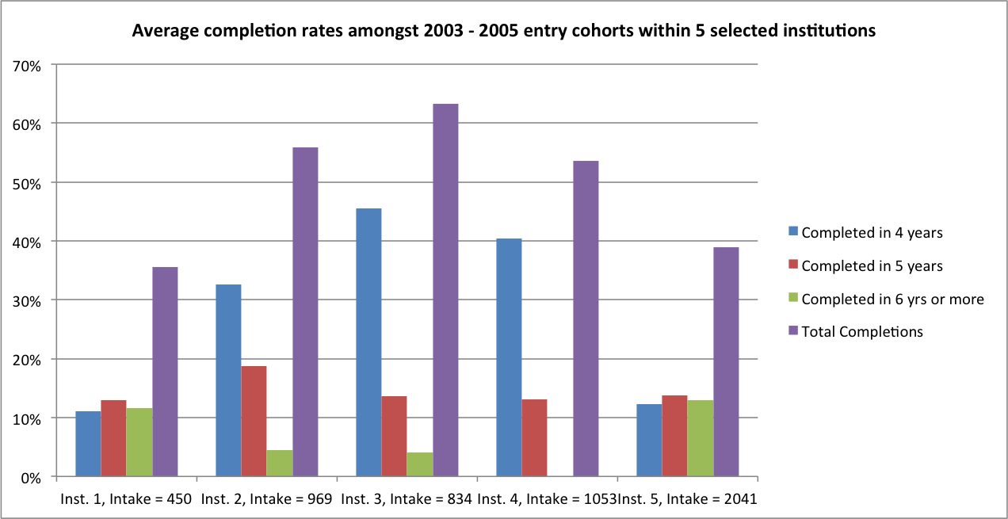

Figure 2: Average completion rates, black 2003-5 entrants, within 3 institutions
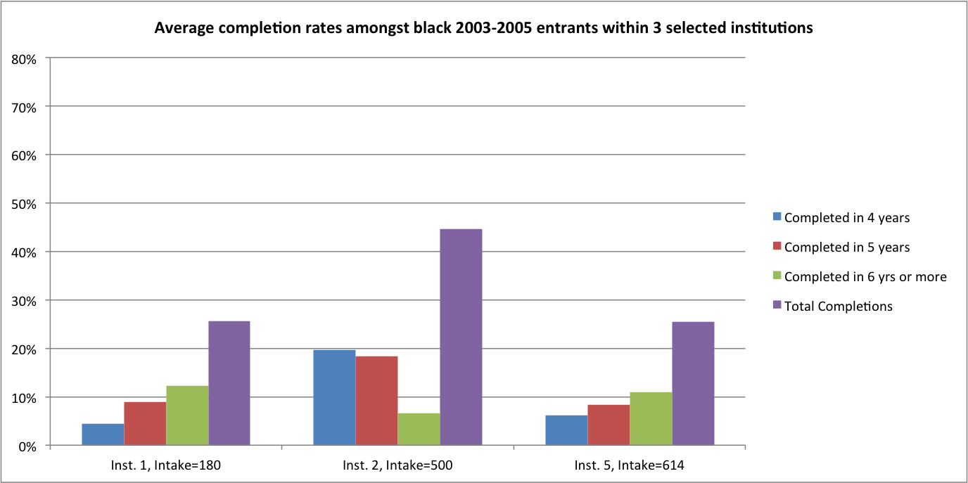

Figure 3: Average completion rates, white 2003-5 entrants, within 3 institutions
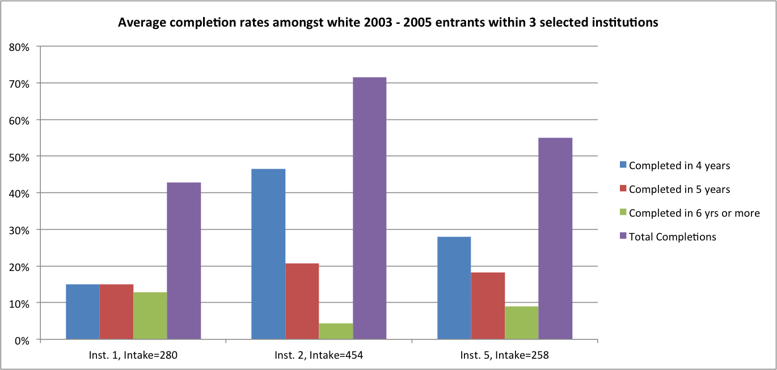

Figure 4: Comparison of average 3003-5 cohort completion data across 3 institutions: Chemical & Mechanical Engineering
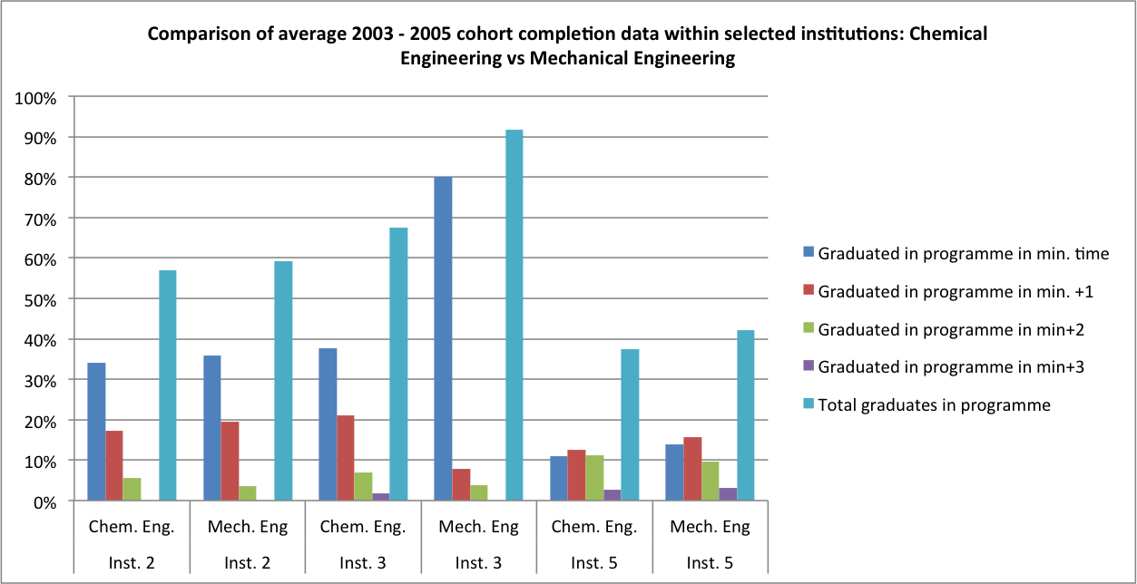

Two figures are particularly informative in comparing overall completion rates across institutions: completion in minimum time, and total completions. Figure 1 shows that average completion in the minimum period of four years varied quite considerably, ranging from just over 10% at two institutions, to a little over 30% at a third, and around 40-45% at two others. Similarly, total completion rates ranged from a low of around 35% to a high of over 60%.

As has been noted, completion rates also vary quite significantly within institutions, between departments, as Figure 4, comparing completion rates in Chemical and Mechanical Engineering, across three universities, illustrates.

Behind these stark comparisons lie important differences in student intakes which, together with a range of other institutional factors, may help to account for these patterns. For example, it is clear both from the CHE cohort study (Scott, Yeld and Hendry, 2007) and from the figures above, that completion in minimum time, as well as overall completion rates, are much higher for white than for black students. Given that student demographics vary significantly across faculties (and across departments) it seems safe to assume that race may be one factor behind differences in throughput.

Another may be student performance in first-year mathematics and physical science courses, which in turn is likely to be related to students’ school backgrounds, matriculation results and university entry points. In the interests of space, average first year mathematics results for three institutions are shown below; figures for first-year Physics are summarised in Appendix B. While the differences in student performance, across institutions, are quite apparent, the diversity of the student intakes and levels of student under-preparedness, as well as possible variations in assessment, student support and teaching quality, are all potentially factors lying behind these results.

Figure 5: Average 1st year maths performance 2006-9, Institution 2
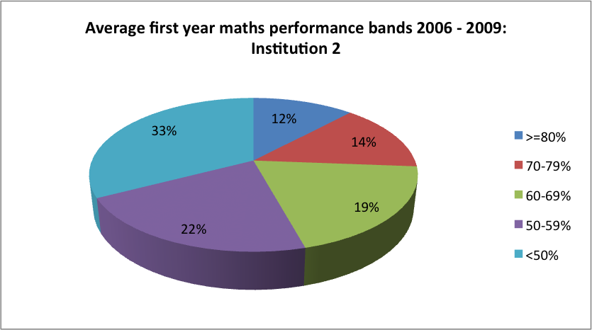

Figure 6: Average 1st year maths performance, 2006-9, Institution 1
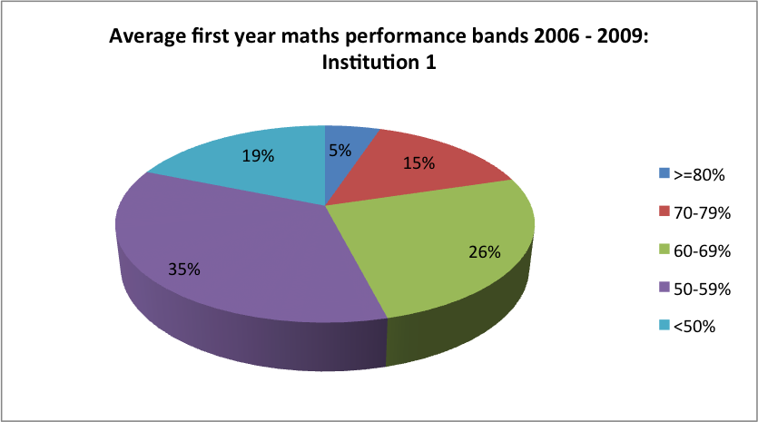

Figure 7: Average 1st year maths performance, 2006-9, Institution 4
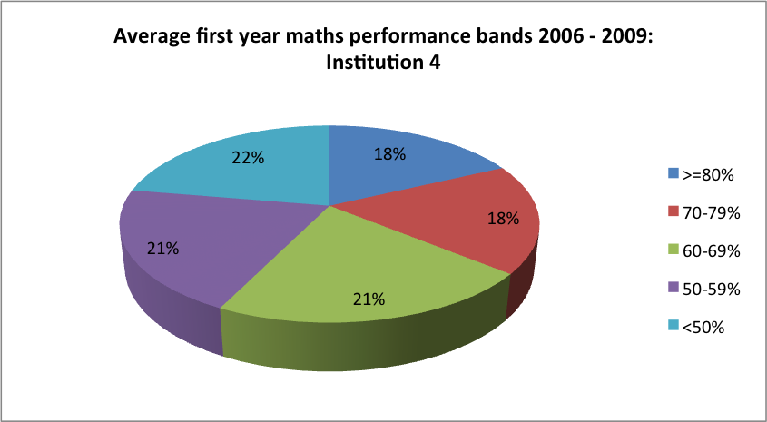

It is important to bear in mind that it is not only the differences in intakes and in student demographics that may impact on completion rates, but also such factors as course load, staffing, the availability of foundational programmes and academic support, together with student financial aid, accommodation and related matters. These dimensions of the throughput challenge are discussed in greater detail in the chapters that follow.

Finally, it is worth considering not just the raw data on throughputs but the quality of final degree passes. Here again, significant institutional differences are apparent - the caveats, regarding the variety of factors that might lie behind these patterns, apply here as elsewhere.

Figure 8: Average graduate performance 2006-10, Institution 2
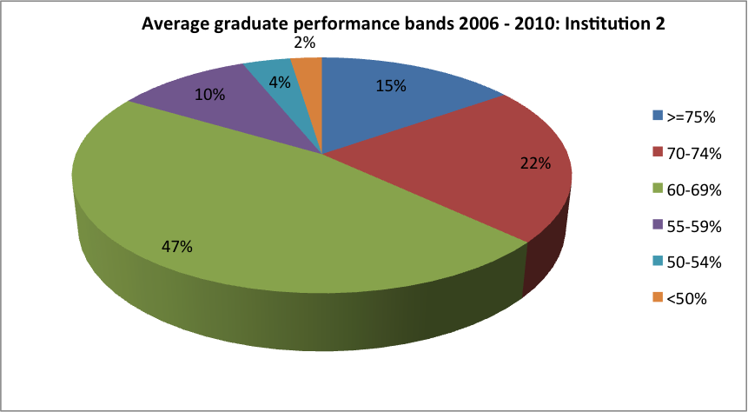

Figure 9: Average graduate performance 2006-10, Institution 1
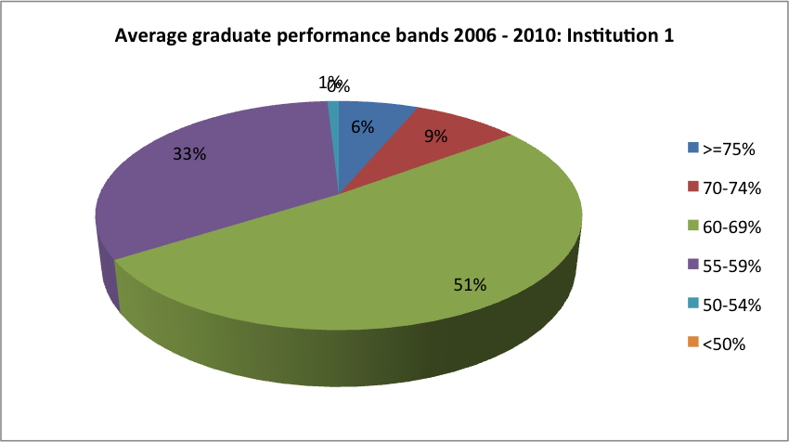

Figure 10: Average graduate performance, 2006-10, Institution 5
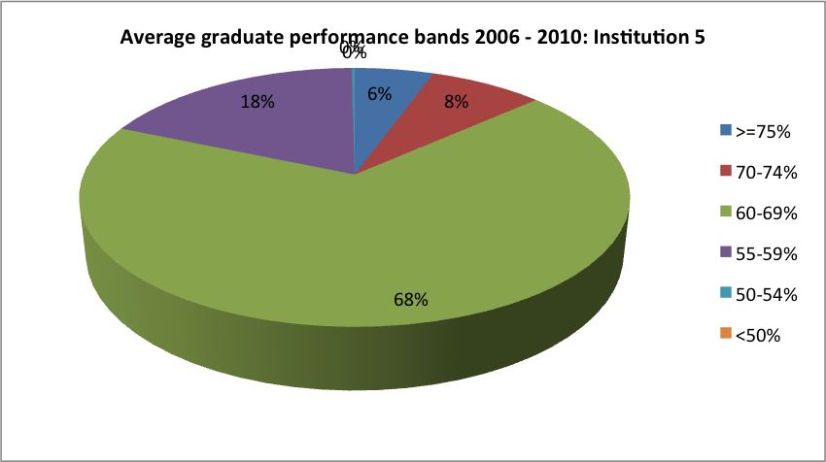

Figure 11: Average graduate performance, 2006-10, Institution 6
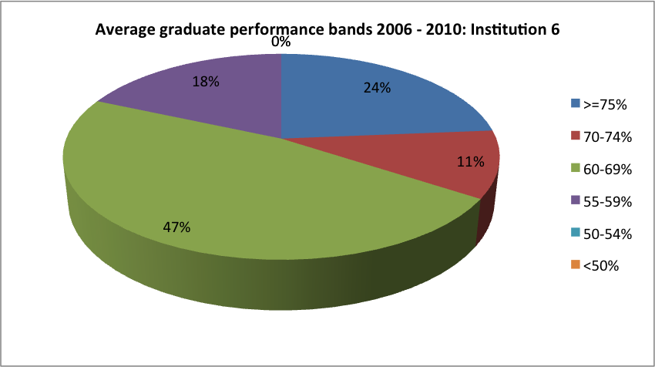

Conclusion
Higher education in South Africa has been characterised as a low participation, high attrition system (Fisher and Scott, 2011). In a context of poor quality schooling, high levels of inequality and social as well as educational disadvantage, and a higher education system which is under strain from expanding, and increasingly diverse and under-prepared student intakes as well as staffing shortages and chronic under-funding, the challenge of improving throughputs, to meet the needs of society and the economy, and to achieve the wider goals of social inclusion and transformation, looms large.
Against this backdrop, throughput rates in science, engineering and technology, perhaps surprisingly, compare relatively favourably with overall success rates in higher education, in part because entry to such programmes is highly selective. Nonetheless, overall throughput and graduation rates in engineering, while varying considerably across universities, and between faculties and departments, require improvement if graduation growth targets are to be met.
The data outlined above reveals some, though by no means all, aspects of these important institutional differences in student outcomes, but it does little to explain them. In response, it has been suggested that a wide range of factors, including student demographics and school backgrounds, differing course loads across the eight engineering faculties, and varying institutional responses in the form of mainstream teaching and foundational support, all play a part in determining student outcomes, and these aspects are explored in greater detail in the chapters that follow.
The point to stress here, however, is that the way in which all of these elements play out - the diversity of the student intakes, and the institutional response to this - varies significantly from one university to another, suggesting that while the issues are in an important sense systemic, the institutional challenge and response is critical.
One way of illustrating the interplay of student intakes and institutional responses is to plot these along two axes, as sketched below, in Figure 12:

Figure 12: Student intakes and institutional responsiveness
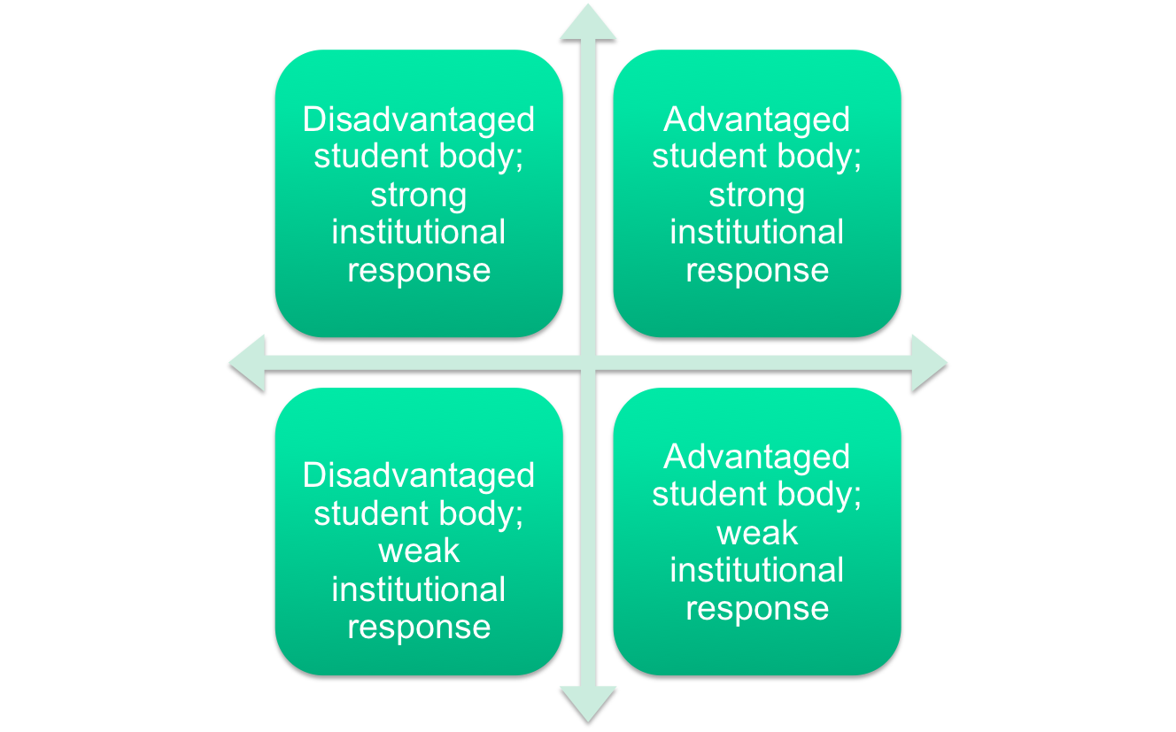

The argument can be illustrated further by outlining three different ‘cases’, loosely based upon actual institutions:

Table 6: Illustrative examples - student intakes and institutional responsiveness
Table 7: Three illustrative examples - student intakes and institutional  Institution ‘A’ | Institution ‘B’ | Institution ‘C’
Close to planned limit to growth  Relatively homogeneous student population  Highly selective admissions  High course load  Limited teaching and curriculum innovation  Plans to increase black enrolment to 30% over time  Graduation in minimum time 35-40%  Total graduation around 70%  Challenge: maintain and improve throughput, while increasing black enrolment | Has capped student growth  Fairly diverse student population  Highly selective admissions  Moderate course load  Wide range of teaching and curriculum interventions  Graduation in minimum time 30-35%  Total graduation around 60-65% -planning to increase this by 10%  To meet its goal, needs to ensure similar success rate for black students as for white | Has experienced a marked shift in student demographics and academic preparedness  Least selective entry requirements  High course load  Weak teaching and curriculum support  Graduation in minimum time 9-13%  Final graduation around 36%  Black graduation in minimum time 1-7%; total black graduation around 25%  Challenge: improving throughput dramatically, especially for black students

In the case of institution ‘A’, a predominantly white, Afrikaans-speaking student intake and staff complement, a highly selective admissions policy, and a high course load, do not appear to call for major curriculum innovation or academic support, at least as long as language, demography and the quality of student intakes remains unchanged.
Institution ‘B’, on the other hand, has made a considerable investment in curriculum innovation and student support, allowing it to maintain a reasonably satisfactory completion rate despite a diverse student intake. Improving its throughput, however, will require significant improvement in the performance of black students, especially.
Institution ‘C’, by contrast, has a weak student intake but a demanding course load, and provides very little academic support to a student population whose demographics have changed quite dramatically in the space of a few years. Unsurprisingly, perhaps, its completion rates are the lowest of the three institutions, and outcomes for black students, in particular, are dismal.
These slightly fictionalised examples serve to make the point, that successfully tackling the challenge of improving throughputs will require careful attention to institutional contexts, and institutional action, as well as to the wider systemic issues which are discussed below.

Section Two: Seven Levers of Change

The school pipeline

In considering the issue of throughput rates and graduate outputs, it is essential to take account of the ‘school pipeline’ into higher education, and the composition and characteristics of the student intake.
There is a strong perception that the higher education intake is increasingly characterised by the academic ‘under-preparedness’ of school-leavers, and that this is a key factor behind the throughput rates in higher education generally. There is certainly evidence to support this (see for example Scott et al., 2007; Fisher and Scott, 2011) but this is also too simple a picture. For example, it is widely recognized that the social and economic backgrounds, home language, and personal circumstances of students are also important factors influencing throughputs.
Challenging and highly selective programmes such as Engineering, moreover, attract many of the top academic performers, of all races and backgrounds, so that while there undoubtedly is a ‘tail’ of under-prepared students, it is also often the case that, as one Head of Department observed, ‘The top end of the class, the top 20%, are frighteningly capable human beings.’
From a broad national perspective, nonetheless, there is justifiable concern about the small numbers of school-leavers with good passes in mathematics and physics, and this is clearly a constraint on expanding participation in SET programmes and programmes in the social and business/management sciences where mathematics is a requirement (Fisher and Scott, 2011).
However, it is noteworthy that engineering enrolments have, according to many informants, been on the increase, while Faculty admissions requirements for mainstream degree programmes are generally high. At some universities entrance requirements have been raised in recent years, while at others there are plans to raise these in the future.
The assumption seems to be that engineering will continue to be able to recruit sufficient numbers of reasonably well-qualified students, from the relatively small pool of eligible matriculants, despite the concerns expressed by informants regarding perceived grade inflation and the underlying recognition that students’ formal school qualifications may not be reliably associated with academic preparedness.
School background, students’ social and economic backgrounds, and highly selective Faculty admissions requirements are all dimensions that shape and characterise the student intake in Engineering. Rather than focusing on student under-preparedness as the sole, or most important characteristic of the student intake, it is argued (see Fisher and Scott, 2011) that a more balanced and realistic perspective should focus on the diversity of the intake.

Student under-preparedness and the gap between school and university
The continuing racial disparities in the quality of schooling and in educational outcomes are an important factor behind differential success rates for black and white students in higher education, and in Engineering. However, as several informants pointed out, it would be misleading to conflate race with student under-preparedness.
In fact, increasing numbers of black students are matriculating with good or outstanding results from ‘good’ formerly white schools, while there are many white students from ‘good’ schools who are unprepared for university study. There are also encouraging indications that some schools in rural and disadvantaged communities are producing good results.
However, as many informants pointed out, for all students, of all races and backgrounds, there is a huge ‘gap’ between the demands and expectations of school and university, and this poses a significant challenge for high-achieving students as well as for those who are academically under-prepared.
As a recent case study at the University of Pretoria observes,

Students in all faculties notice a huge gap between the academic demands of high school and the academic expectations of the university. It is significant that the claims about this gap are made with equal stridency by students from top schools with top Matric results and by those from rural and poor schools with poor school-leaving results (CHE 2010: 109).

This gap between the academic demands of school and university is experienced by students in three main ways, according to the CHE report:
- in the intensity of the work;
- in the rapid progression from one set of concepts or procedures to another;
- in the independence which is expected of students at university with respect to their own learning.
In part, the gap between school and university is manifest in the lack of meta-cognitive and ‘thinking’ skills as well as students’ capacity for independent learning. It may also, however, reflect weaknesses in the school curriculum and a decline in the ‘challenge level’ of the school-leaving examination.
Indeed, recent analyses of the cognitive demand or ‘challenge level’ of school-leaving examinations, combined with the omission from the examinable school syllabus of topics required for higher education study, point to a decline in the level of difficulty of subjects such as Mathematics and English as an Additional Language (Yeld, 2011, and Scott et al., 2007, cited in Fisher and Scott, 2011).
Results from the National Benchmark Tests likewise point to disturbingly low levels of preparedness amongst both higher education applicants and registered students, in Mathematics and in Academic and Quantitative Literacy, a finding which is supported by qualitative studies of first-year performance in a range of subjects (Slonimsky and Shalem, 2005, cited in Fisher and Scott, 2011).

‘Schools are really not preparing students for university study. The problem is not simply one of curriculum but of ‘thinking skills’ - even students from good schools are coming to university under-prepared in terms of thinking and problem-solving skills. Teachers are ‘drilling’ students, rather than encouraging critical and analytical thinking.
Metacognitive skills are a critical concern. Students are unable to judge if they are coping or understanding, or if they need help. Even the kids from good schools are lacking in this respect. Students lack the ability to take responsibility for their own learning. The lack of metacognitive ability shows in how students study, for example going through the textbook and notes instead of working through problems.
The transition from school to university is too great, both in terms of metacognitive and life skills as well as in the students’ subject backgrounds. The problems of the black students are not qualitatively different from those faced by white kids, it is mostly a matter of degree.
A key implication is the need for more effective mainstream responses to the articulation gap between schools and university and the deficiencies of the school system, as the problem of student under-preparedness is not just applicable to black students but affects a large part of the total student intake.’

The National Senior Certificate
Along with a concern about ‘thinking skills’, ‘problem solving skills’ and independent learning, many interviewees also expressed misgivings about the meaning and reliability of the matriculation examination. Several respondents referred to the first National Senior Certificate examinations in 2008 as a critical moment, in which unexpectedly large numbers of students qualified for admission, and where perceived ‘grade inflation’ led to unusually high failure rates in first year university courses.
Concerns about the school-leaving examination seem to focus on three aspects, in particular:

- A perception of ‘grade creep’ or grade inflation, which several informants believed had been in evidence prior to 2008, but which they thought had become more apparent following the introduction of the National Senior Certificate
- A perception that the Senior Certificate results are unreliable, and that previously strong correlations between matric performance and success at university no longer seem to hold
- A concern about student performance in particular school subjects, especially mathematics, physics, and language.

Matric mathematics and physics were repeatedly highlighted as areas of concern. The lack of trigonometry and key aspects of geometry in the NSC mathematics syllabus was raised by a number of informants; more generally, a lack of problem-solving skills was highlighted. As one head of department with a keen interest in school-level mathematics put it, ‘today’s school students learn mathematics by rote, revising old exam papers, but they don’t learn to solve problems.’
Students’ poor language and communication skills were also regularly highlighted: as one dean observed, language and comprehension is a big problem, and what students are able to take out from a lecture is often very limited. A Head of Department at another university observed that the lecturers speak a very high level of English which is way above the heads of some students, and the communication skills of disadvantaged students are very limited. The level of English when students submit their final year reports, according to him, ‘is actually shocking.’
Against this chorus of concern, one university reported that an extensive analysis of matric scores against the weighted credit scores in first-year subjects across the institution had shown a 5% drop in scores following the introduction of the National Senior Certificate in 2008.

‘In 2009, with the first cohort of the National Senior Certificate, there was another round of grade creep - the Department was swamped with students with high marks, distinctions - but by midyear we had a catastrophe in maths and physics. A third of the students failed the midyear examinations so badly that they were forced to restart mathematics from the beginning - and these were students who had got As and Bs at school.’
‘The old syllabus was fairly demanding, and the matric results were a fairly accurate predictor of success, but now we have students with straight As dropping out of university, and average students making it.’
‘The integrity of the indicators is quite a problem. Matric results are no longer a reliable predictor.’
‘There was a big bugger up in 2009 after the new National senior certificate came in. There was a similar problem with the 2010 school results being inflated after the World Cup and teachers strikes.’

One unfortunate consequence of what is widely regarded as grade inflation is that, as several informants observed, students often arrive at university with an inflated sense of their own abilities, and little sense of the level and the amount of hard work that higher learning requires.
Consequently, even top students may stumble in the midyear examinations. While the better students may recover after this first shock, and go on to pass their first year, less capable or less hard-working students find it less easy to lift their game, and may find themselves having to repeat a year, or to consider transferring to another programme or dropping out, sometimes with serious financial as well as personal consequences.

Expanding the school pipeline: outreach and talent-search initiatives
Although the issue was not systematically explored, the research for this study picked up on a range of school outreach initiatives across the country at university, faculty and departmental level. These appeared to be motivated by a range of considerations, including:
- Marketing the university, faculty or department
- Talent search - identifying and recruiting talented students, especially from ‘non-traditional’ backgrounds
- Promoting an awareness of engineering as an attractive career and profession
- Promoting equity and transformation
- Helping the schools
While marketing and recruitment in the schools may reflect in part the level of competition between institutions for students and talent, there would seem to be scope for a more coordinated and cooperative approach to promoting greater awareness of engineering, to broadening the talent pool, and to supporting schools, in the national interest and in the wider interests of the profession.

‘It would be good for the lecturers also to be exposed to the realities of South African schools–my department visited a number of Cape Town schools last year and learned a lot. If we can massify this it would be great.’
‘Without improving the school system, we can’t make “leapfrog” change, we can only make marginal improvements, and this comes at a cost in terms of resources and it’s distracting us from our core business.’
‘Many young people in school lack the background to enter accounting or engineering, not through their own fault or lack of ability, but because of poor teaching and so on. Therefore a focus on high schools is very important, to reach out to such students. A simple thing like a workshop in which a company comes in and talks to school students, can make a huge difference. Taking students on visits to industry plants and offices etc can also be helpful and very relevant.’

Conclusion
The central conclusion to be drawn from the discussion above is that much closer engagement is needed, between the engineering profession and the school system, in order to expand and improve the school pipeline. This engagement should focus on:

- The quality of schooling - especially thinking and analytic skills, independent learning, problem solving, and language and communication skills, both oral and written
- The NSC mathematics curriculum, including the issues of geometry and trigonometry
- Concerns about standards, grade inflation and the reliability of the NSC exam results
- A more cooperative and ‘joined up’ school outreach strategy, aimed at promoting engineering as a career, and supporting the development of the thinking, analytic, problem solving, independent learning and life skills that are key to university success as well as to success in the workplace.

While engaging the school system is important, it is also important to keep in mind that improving the quality of schooling is a long term project, and that the challenge of student under-preparedness, accordingly, will continue to require a systemic and ongoing response from higher education, for many years to come (Fisher and Scott, 2011).

Student Selection

The problem of selecting the ‘right’ students into engineering is critically important, not only from the standpoint of institutional throughputs and efficiency, or the requirements of employers and the engineering profession, but also from the perspectives of equity and transformation.
The question of how society, and higher education, should set about the task of ‘choosing elites’ as Robert Klitgaard (1985) put it more than twenty years ago, has important social, political and ethical dimensions and is not simply an exercise in neutral, ‘meritocratic’ selection.
At the same time, the analysis of different selection techniques and methodologies, and of the correlation between admissions criteria and student retention and academic performance is a major area of research and scholarship in itself.
Needless to say, it is beyond the scope of this study to explore these complex questions in any depth. Rather, the discussion below has a more limited set of objectives:
- To examine students’ choice of university, and of engineering
- To outline current selection criteria
- To flag the role of first-year in selection
- To discuss concerns and suggestions raised by informants about selection criteria and selection processes
- To consider the implications of the above

Student choices
This study did not directly investigate the issues of students’ choice of university and of engineering as a field of study; nonetheless, the perspectives of Deans and Heads of Department on these questions, although subjective, are illuminating.
Asked why students choose to enrol at a particular university, respondents identified the following factors, amongst others (in no particular order) -
- The reputation or academic standing of the university or faculty
- The language and culture of the institution
- The institutional setting or physical location
- Family and social connections
- Cost
- Entry requirements
- Perceptions of safety on campus and institutional stability

While probably all informants would maintain that the institutional reputation and academic standing of the university was a factor influencing students’ choices, the international ranking of the university was a particularly important factor for some.
The language and culture of the institution were considered by faculty at some institutions as factors strongly influencing student choices, while the importance of institutional setting or physical location manifested in a number of ways.
For some institutions, especially those recruiting from less affluent or disadvantaged communities, proximity to home appeared to be a significant factor. At UKZN, for example, most students appear to be recruited from within the province, primarily from African and Indian communities.
In other cases, proximity to the mountains and the sea, or the winelands, were considered draw-cards, as were the ‘town and gown’ environments of Stellenbosch and Potchefstroom. Family and social connections were said to be important, perhaps more so for Afrikaans students at Pretoria, Potchefstroom and Stellenbosch, and Indian students (UKZN). Cost, and faculty entrance requirements, are also considerations.

‘There are very important social dynamics that influence students’ choice of university. The university is not the top South African university–this is not the attraction and students and parents are not making informed academic choices, but choices tied to locality, family, and community.’
‘Students love the student life here. There are school outreach programs which help to attract students. The quality of education at the university is seen as high and the university campus is seen as a very safe environment, with a “student village” environment. Language is a big factor–the primary language of instruction is Afrikaans and many parents are grateful to be able to send their children to an Afrikaans institution. Other universities are seen as experiencing problems whereas this university is seen as stable. Parents want their children to focus on their academic work and not on politics and this is another attraction of the University.’
‘Another attraction is that the university is small–the staff student ratios make for good staff student interaction and personal relationships unlike the very large institutions.’
‘The merger had incredible reputational damage, to the university and the Faculty of Engineering. You won’t believe how long it took to change the image of the university and the Engineering Faculty. These perceptions have affected the decisions of parents regarding the choice of university and at this university we have lost almost completely the white market.’

Factors said to influence students’ choice of engineering as a field, and of particular disciplines within engineering, are also significant, and raise important questions not only about student selection into engineering, but about student counselling and placement.
Amongst the factors said to influence students’ choice of engineering are:
- The ‘challenge’ of engineering
- The status or prestige of engineering
- Family background
- The desire to make a difference, to create and fix things
- Ignorance of what engineering is really ‘about’
- Bursaries
- Job prospects
- Career flexibility and mobility
For many of the brightest students, the fact that engineering has a reputation as a difficult and challenging course is said to be a major attraction. Relatedly, the high status and prestige of engineering is an attraction, although some of the top students may select engineering as a second option, after medicine.
Family background, where a parent or relative is an engineer, is a significant factor in some cases, and the desire to make a difference in society, to be able to create and to fix things, was reported to be a strong motivation for many.
On the other hand, there is a strongly held view amongst Deans and Heads of Departments that too many students registering for engineering have little or no understanding of engineering as a field, or of what engineering work actually entails. Some students discover early that they are not cut out to be engineers, and transfer into other faculties; some persist, but leave engineering after a short period in employment; and still others struggle on only to fail and drop out.
In some cases, student choices are believed to be unduly influenced by the availability of bursaries, particularly where these are targeted at designated groups such as African students and women. Such students may find themselves in a difficult position when they fail, or wish to leave engineering, only to find themselves under financial obligations to the company that has sponsored them.
The likelihood of securing a good job, with stable career prospects, seems to be a motivating factor for some, while the fact that engineering may also offer a route into management or entrepreneurship, and into other careers, is also a motivating factor. The global mobility offered via the Washington Accord is also seen as an attraction.
In short, students’ reasons for choosing engineering are varied, and may be more or less informed. Students also enter into engineering from a variety of different educational and socio-economic backgrounds, and with varying levels of academic preparedness. The difficult-to-measure questions of students’ ‘aptitude’, ‘insight’ and ‘attitude’ are also significant, as will be seen below.
Two main implications flow from the above discussion, concerning student selection. First, it seems clear that students choose a university, and choose engineering as a field, for a variety of reasons, and that these choices may not be always be influenced by, or responsive to, higher education access and transformation or growth policies or institutional recruitment strategies.
Second, it seems clear that institutional selection processes could do well to take more careful account of applicants’ reasons for choosing engineering as a field, as well as their understanding of what engineering work entails.

Mainstream entrance requirements
Admission to the engineering bachelors degree is highly selective and, relative to higher education as a whole, the engineering faculties appear to be drawing from the cream of the crop. As has been noted, several institutions indicated that they have raised their entrance requirements in recent years, while others stated that they were planning to do so.
At the same time, as has also been noted, quite serious concerns have been raised about the ‘integrity’ of the National Senior Certificate as a predictor and the correlation between matric results and university performance.
National Benchmark Tests (NBTs) have been developed under the auspices of Higher Education South Africa as an alternative means of assessing students’ competence. A number of institutions have either considered, or have trialed, the use of the NBTs; while a few require applicants to write the NBTs and make use of them for placement purposes, others have subsequently dropped them.
Table 5 below summarises entry requirements for the four-year engineering degree at the different universities. This should be interpreted with caution, however, and direct comparisons may not be possible.
Some institutions, for instance, use a combination of selection methods, such as the National Benchmark Test or internal selection tests, and at least two - the Universities of Stellenbosch and the Witwatersrand - utilise a weighted formula, to calculate an overall admissions score.
In addition, the faculties have different NSC requirements for mathematics, physics, languages and other subject combinations, and different admission requirements may be in place for alternative admissions, foundation and extended programmes or for different departments.

Table 8: Minimum admissions requirements, by university
Institution | APS | Maths | Science | Comments
Pretoria | 36 | 70-79% | 70-79% | + Compulsory proficiency test
Johannesburg | 28 | 60-69% | 60-69% | Lower requirements for extended programme
Stellenbosch | Uses own weighted calculation | 60-69% | 60-69% | Foundation course option from 2010 on
Cape Town | Combines APS & NBT; own weighted formula | 75% | 65% | ASPECT option
Witwatersrand | Weighted formula, varies by department - 30-42 points | 60-69% | 60-69%
NWU | 31 | 70-79% | 60-69% | Selection test
UKZN | 33 | 70-79% | 70-79% | INCITE option
NMMU | 38 | 60-69% | 50-59%
Source: Summarised from faculty handbooks and websites

These differences in approach to the question of student selection may be reflective of different university philosophies and experiences as well as different student intakes and degrees of selectivity.
Looked at from a wider, systemic perspective, however, they also suggest both a degree of innovation and experimentation regarding selection, as well as, possibly, a lack of consensus as to what methods and approaches work best, or are most appropriate.
A key question is the extent to which these various approaches to selection can be shown to correlate with student performance.
It has not been possible to review the research into this topic, but informants referred to various internal studies and analyses that have been conducted, and some published research is available. A number of informants indicated that there was evidence, in particular, confirming the significance of mathematics, physics and languages as predictors for student success, although the reliability of the NSC examinations remains a concern.
In any event, given the available evidence on student’s first-year performance and on throughputs, there would seem to be scope for a broader, systemic analysis and review of current approaches to selection, together with greater sharing of information and more open debate about what is being done, what is being learned, and how selection processes could be improved.
A recurrent sense of unease about the limitations of current approaches to selection, from the interview data, lends further support to the idea that a review of student selection into engineering is needed.
In looking for more relevant and reliable means of selecting students, that go beyond the current, largely paper-based and administrative selection process, driven primarily by students’ school-leaving results, informants stressed the need to identify those students who had ‘aptitude,’ ‘insight,’ ‘problem-solving ability,’ an ‘ability to analyse’ and the ‘resilience’ to work at difficult problems and find solutions.
The use of student interviews and admission tests, as well as the importance of student counseling and placement, were amongst the measures suggested by informants, although the costs of alternative selection processes were also noted.
However, it must be asked, given both the failure and drop out rates and the numbers of students who, evidently, enter engineering without really understanding the field, or who are not suited to it, whether the costs of a more nuanced and in-depth process of recruitment and selection would not be justified.
An alternative approach seems to be to accept the inevitability of a high level of student ‘wastage,’ and at one university, given the uncertainty about how to select, first year is widely seen as a necessary ‘filter,’ and high first-year failure rates are regarded as a perhaps unavoidable way of sorting potential engineers from the rest of the intake.
The idea of using a general first year as a means of selecting students was also proposed by some informants from other universities too, on the grounds that school results were unreliable, and that the best test of a students’ ability and potential was performance at university.
At some universities, alternative admissions programmes have been in existence since the 1980s, although with mixed success, according to informants. It would seem to be important that both the selection methodologies that have been developed, and the contribution of these programmes to student success, is systematically evaluated and debated, within the wider framework of improving selection into engineering.

‘The top students are better these days than in the old days, they are some of the best engineers who’ve ever graduated here, but there is also a longer tail of weak students. This long tail of weaker students works very hard, takes notes of everything, but if you say good morning, they will write that down too!’
‘The challenge is the setting up of a fair contract–we don’t want to take people who can’t make it, but we want to give people the chance to try. Entrance requirements to the faculty are amongst the highest in the country, but the integrity of the indicators is quite a problem as matric results are not a reliable predictor. There is scope for better selection, but what measures should be used and what will it cost?’
‘The entrance requirement for mathematics is an A, a B for science, and an APS of 36 points. The good engineers of the old days, who played rugby, would not get into engineering nowadays!’
‘We’re taking very, very good, exceptional students, but we probably only graduate a third to fifty per cent of them ultimately.’
‘We see no distinction between public and private schools–we’re taking the top 25% of kids here. But the problem with first year is that we don’t have the measures to determine who should be in first year–there is a selection problem. The university tried using the National Benchmark Tests for two or three years but saw no trends in the data and so has dropped the test. First year is definitely a killer. But it’s the only real measure we have, to determine who should be in university or not. Using first year as a selection year is a very expensive way, but we haven’t found a better way, there are just too many variables involved.’
‘Throughput is tied to input. First year is a kind of filter; then from second year to fourth year we don’t expect anyone to fail. There is almost a 100% pass rate – good passes – in fourth year.’

Conclusion
A review of access and throughput in three universities by the Council on Higher Education draws a number of potentially far-reaching conclusions about the need for improved student selection, as well as the need for closer linkages between universities and schools, in order to broaden the intake of suitably prepared students into higher education:

It is impossible to improve throughput in undergraduate education without greater selectivity being applied about which students to admit to higher education in the first place. This does not mean crude exclusionary policies but it does mean greater precision in choosing those most likely to succeed in higher education, and may include rigorous preparation at pre-university colleges. The notion that universities can simply wait for students from historically excluded groups to ’show up’ is not enough; it is important to build long-term relationships with partnership schools to prepare targeted high school learners in advance for the rigours of university education. It is a step towards an open access model that, short of dropping all selection criteria, supports bridging options and a broad range of tertiary study options (CHE, 2010: 181)

The argument that greater selectivity in admissions is needed is critical; the question however is whether this should mean simply increasing formal entry requirements, or more careful selection which takes into account students’ interest in and understanding of engineering as a field and other factors such as aptitude, problem-solving and analytical ability and so forth.
Likewise, the argument that universities cannot simply wait for excluded groups to ‘show up’ is important, especially in the South African context.
However, as Fisher and Scott (2011) have argued, the likelihood that a pre-university college model could make a significant difference to the quality of student intakes is severely limited, for a number of reasons, while outreach to schools must be regarded as a useful but limited and short-term response to the wider challenge, not only of school reform, but of identifying talent and ability which, it must be assumed, are normally distributed across the school population as a whole.
The issues of student preparedness for university study, and of selection into higher education, go beyond the question of selection into engineering and require a broader, systemic response. From the more limited and practical perspective of this study, however, the following would seem to be important:

- As discussed in the previous chapter, an engagement with the Department of Basic Education regarding the mathematics curriculum, and the standards and reliability of the school-leaving examination
- Better understanding of the factors affecting student choice of engineering as a field
- Improved student counselling and placement systems
- A comprehensive analysis of the lessons to be learned from university alternative admissions programmes,
- Consideration of additional selection methods, such as student interviews and placement tests
- Careful monitoring of student performance, especially in first year, and early intervention strategies
- Consideration of the option of a general first year with selection into engineering at the second year level; linked to this, the provision of alternative pathways into, and out of, the Engineering degree, as discussed below in the chapter on curriculum.

Student Support

For all students the gap between school and university is a significant hurdle which they have somehow to overcome. Students need to learn how to cope with their new-found freedom; they have to become independent learners; and they have to adjust to the very different pace, volume and complexity of higher learning.
For some, coming from poorer schools, from townships or from deep rural areas, the shock of city life, the cultural environment of the university, and the social and intellectual challenges of university work are a further obstacle to overcome.
Financial difficulties, a lack of accommodation, and a lack of support systems, make the transition to university especially difficult for disadvantaged students. For some, the problems are as basic as food to eat and a place to sleep.
Some of the challenges students face - finance, accommodation, for example - can be addressed directly; others can only be addressed indirectly, through peer support, student counselling, mentoring and advisory services.
Students’ school leaving results, in short, are only one, imperfect indicator of their preparedness for university and their prospects of success. Their persistence in higher education and likelihood of graduating is dependent on a range of personal, social, financial and other factors, as well as on their academic ability.
As this section shows, however, there are gaps and inadequacies in student support, which leave many students unnecessarily at risk.

Students’ backgrounds
Asked about the factors impacting on student success at university, and in engineering specifically, one Dean’s response was, ‘I think, by and large, family circumstances.’ A head of department observed, similarly, ‘the issues students face are background issues, it is not the school system.’
In a challenging and highly selective programme such as the engineering bachelors degree, where students’ school backgrounds and academic ability might be expected to be a primary concern of the engineering faculty, it is striking that their family backgrounds, and the social and affective factors shaping student persistence and performance, together with practical concerns such as food, money and accommodation, should form a powerful and recurrent theme.
For some students, family and socio-economic background was seen to play a strong role in their choice of university and field of study. Old university ties - the ‘old Matie’ affinity referred to earlier - as well as matters of language and culture, attract some students to particular universities, and may be assumed to play a role in easing the social and cultural transition from school to university.
For others, first generation students especially, traveling long distances by taxi from a township or coming from a deep rural area, the urban or town environment, and the institutional climate of the university, may seem alien, impenetrable and even hostile. The problems that students from poorer communities may face are wide ranging, and informants referred to crime, sexual violence, broken homes and a lack of parental nurturing and support, HIV/Aids and poverty as some of the more obvious examples.
As one Head of Department commented, ‘kids are coming in with far more serious personal and family problems than I have ever encountered before–partly because the demographics have changed. Here we have kids who really have problems, and their families are not in a position to help them.’

The school-university ‘gap’
School background, as has been noted, is important, influencing not only students’ academic preparedness but their confidence, attitudes to work, and their ability to function as independent learners, to ‘read’ their new environment and realistically assess their own abilities and progress.
A recurrent theme in the interview data is that students arrive at university with unrealistic expectations and a poor understanding of what it will take to succeed at university, and specifically to succeed in engineering. ‘Students are confident that they will be able to cope, they miss the signs that they are not coping, and then find that they are not doing nearly enough, or doing what is needed, to succeed.’
Paradoxically, students from good schools who have achieved excellent school-leaving results may struggle with the demands of university precisely because ‘they have been spoon-fed and had things hammered into them.’
Students ‘get confronted with a different way of thinking at university - at school they focus on rote learning and memorising, but here they have to think for themselves. A lot of students get lost on campus in their first year - it’s a major shock for them. No-one tells them how to study - they need self-discipline.’
In this context, student attitudes and aptitudes, ‘the tenacity to solve problems,’ are seen as critically important.
So too is what one informant called ‘the reference frame’. The experience of ‘tinkering’ with things, of fixing a plug or working on a car or a farm machine, of using tools or being able to drive, and a curiosity about how things work, were repeatedly said to be an important part of what may be called the ‘cultural capital’ that some students bring to their engineering studies - and that some students lack.

Coping with the campus environment
Once at university, students from all backgrounds are faced with new-found freedoms and responsibilities, heavy workloads and a demanding curriculum for which most, even those from the better schools and with good school-leaving results, were said to be insufficiently prepared. Respondents emphasised repeatedly that Engineering was a tough course, and that it was essential for students to develop the right work habits and to keep up with the programme from the very beginning.
Learning to cope with freedom and independence, it was noted, can be a challenge, not only for disadvantaged students but for those from privileged backgrounds, too. As one informant jokingly remarked, ‘DSTV, a flat, and a car,’ and having too much money to spend, can be big distractions for a young student.
Many students have not lived on their own before; they may not know how to choose their friends, how to manage their learning and their personal affairs, and may be easily distracted from their studies.
Students may become actively involved in the rich student life that some campuses offer, such as student committees, social activities, arts and sports, and this may take up a good deal of their time.
As one informant put it, ‘students have to be social, and enjoy life, do sport, find a partner in life and all of this takes them away from their studies, especially those who need to put in 60 hours a week or more in order to cope.’

Networks and support systems
Family and peer support can be important as students negotiate the complex transitions of young adulthood and student life. This can be strengthened, in some cases, by the institutional culture and family traditions: at one university, for instance, it was said that parents were closely involved with student life on campus and with their offspring’s engineering projects and activities, and that this involvement helped to guide and motivate students. Residence culture, too, can provide a mutually reinforcing environment in which students can form peer groups, studying and learning together and keeping one another motivated. Residence, and student accommodation generally, will be discussed in more detail below.
As we have seen in the discussion on selection, students may arrive at university with little idea of which direction they wish to take with their studies. For some, choosing engineering as a field may have been driven by the offer of a bursary rather than by any intrinsic ‘feel’ for the discipline or understanding of what it entails. Students need advice and support in making their subject choices, and counselling when it transpires that they are in a field for which they may not have the ability or which they do not like.

Affective factors
The confidence that students feel, and their ‘level of comfort’ in negotiating their way through the university, may be a key factor influencing their ability to manage and assess their own learning and to seek help where needed.
Several informants observed that there were noticeable differences in the way that black and white students approached working in groups, for instance, or engaging with their lecturers; these behavior patterns, it may be assumed, are related at least in part to the lack of black academic role models and the largely white composition of the academic staff in engineering faculties.
The comments below are representative:

‘Black students in particular do not have confidence to ask questions and so they withdraw when they run into difficulties or when they fail. For example, when students have to do design, white kids will come with their projects and explain what they are doing and demand to be helped, but the black students tend not to come forward and ask for help.’
‘The students don’t know how to interact with lecturers and other students, how to ask questions in class….’
‘White students will often form groups and work together, and will approach lecturers as a group to ask for assistance or raise issues, whereas black students are often outside of such groups and don’t benefit from the support and lack the same access to staff.’
‘Black students tend to work in isolation, whereas white students will get together in groups - this may be related to the fact that black students are such a minority, and are very dispersed across the institution, so they tend not to band together. Also accommodation on campus, in the residences, is very limited. So students simply fall away, drop out, without having sought support from the staff and the university.’

Where there are high failure rates, a ‘culture of failure’ may set in. Instead of having a positive approach to success, African students in particular may feel that the system is out to get them, and so they withdraw, they don’t attend classes, and they become fatalistic about their prospects of success.
Social expectations, family pressures and bursary considerations may persuade failing students to persist, nonetheless, against the odds. At one university, the Dean sees all first-year students who have failed to meet an aggregate cut-off point and advises them to de-register. Most, however, do not, and struggle on until they ultimately fail and drop out, running up large debts in the meanwhile.

The institutional dimension
Significant and symptomatic as these observations about student behavior may be, it is important not simply to accept them at face value, but to look ‘behind’ them and ask whether the institutional climate and context may not also be significant factors.
Individual or group responses by students need to be understood, in other words, in relation to the academic environments in which students find themselves.
Institutional climate, and the difficult issue of language, are addressed in later sections.

Accommodation
Along with the complex social and affective factors influencing students’ prospects of success, two issues stand out from the interviews with informants: student accommodation, and student bursaries and financial aid.
Student accommodation seems to be an important factor influencing retention and success, in three main ways:
- first, in terms of meeting students’ basic needs and providing a conducive physical environment for their studies;
- second, in fostering students’ social integration into student life and the university;
- third, for engineering students in particular, in creating a supportive peer group environment and encouraging positive work and study habits.

There is a clear view amongst informants that students who have bursaries and decent accommodation are more likely to be successful than those who lack funding and a suitable place to stay.
For disadvantaged students, in particular, staying in residence may be preferable to living at home. Students living at home may face travel and transport challenges, they may lack a conducive home atmosphere and facilities, and there may be no-one at home with whom they can study and discuss their work and problems.
For those at the large urban universities who live ‘downtown’ in student digs, the environment may not be conducive to study, and student accommodation may be located far from the campus and libraries. In this regard, the residence policy at one university where, it was said, students who lived within an 80km radius of the institution were excluded from admission to the residences, was strongly criticised.
Although the importance of student accommodation is widely recognised, many informants spoke of the difficulties that some of their students face - one Head of Department at a large urban university, for instance, spoke of finding students ‘sleeping in the labs downstairs, because they have nowhere to stay.’
Another spoke of rural students who ‘are also new to the city–they come from a village in Limpopo, and all of a sudden they are in Johannesburg. They have to look for accommodation, they don’t have money even for food.’
Against this background, some informants argued that it was important to give priority to first year students when providing residence accommodation and bursaries, as this was when they were most in need of support, rather than waiting until they had ‘survived’ into second or third year.
However, while poor and disadvantaged students might be particularly in need of the secure accommodation and conducive environment that a well-run residence can provide, a consistent view also emerged of the wider benefits of residence accommodation for engineering students of all backgrounds, especially where such students were grouped together. There was a less favourable view, on the other hand, of residences where there are mixed groups of students from a variety of fields and disciplines, and where it was believed that there was too much noise and distraction.
Engineering students, it was felt, needed to work hard, and benefited where there was a ‘critical mass’ living and studying together in a residential setting. This helped to motivate students and to promote a strong work ethos, providing peer support and creating a student culture which was ‘more in tune with the faculty’s needs.’
The ‘koshuis culture’ of some universities was held out as a good example of the social and academic benefits of residence life.
Interestingly in this regard, the Thuthuka bursary and student support model adopted by the South African Institute of Chartered Accountants (SAICA) was highlighted by one informant as an example of what was needed: ‘at this university, all the Thuthuka students stay in residence - they get the best, proper food and so on. They are placed in hostels in groups, and all this helps with their success.’
The significance attached to student residences, finally, is underscored by the fact that a number of informants went so far as to say that they would like to see dedicated engineering residences established, along similar lines to medical residences.

Student financial aid
Student financial aid may take a variety of forms, including bursaries, NSFAS grants, and student loans. Bursaries and financial aid are an important element of student support, and significant resources are dedicated to this by companies, government departments, donors and the National Student Financial Aid Scheme (NSFAS).
Limited hard data on student financial aid is available, and detailed analysis is beyond the scope of this review. However, in view of the critical importance of the issue in promoting student access and in influencing graduate outputs, further analysis is clearly essential.
From the perspective of student support, three sets of issues, in particular, deserve consideration:
- The availability of funding
- Funding policies
- Students’ ability to manage their finances
The significance for some students of financial aid is captured in the response of one informant who said without hesitation, when asked what factors impacted most on student retention and student success, ‘if they lose their bursary’. Finance was a ‘huge problem’ for students, and possibly the major challenge they faced.
Financial aid is not seen universally as an issue, however, and many informants believed that student financial aid was not a major concern. Thus, one Dean explained that, at his institution, there were ‘lots’ of bursaries available from the university, as well as from companies and the Faculty itself - financial need, in his view, was ‘not an issue.’
Yet at another university, the Dean painted a very different picture: ‘there is a perception that all engineering students have bursaries, but in fact only about 25% get bursaries.’ The Deputy Dean at a third institution believed that ‘poverty’ was a major factor affecting student success.
It seems probable that black students, on average, are more likely than whites to require financial assistance, and concerns about student financial support were most sharply expressed at those universities with large black, and especially African intakes.
It would be overly simplistic, however, to conflate race with financial need. Some black students come from well-off backgrounds, and black students, especially? black females are, according to many informants, the preferred beneficiaries of targeted bursary support, especially from state-owned enterprises and some large companies.
In many cases, bursaries are earmarked for certain disciplines or specific university departments. Consequently, the availability of bursaries might vary considerably from department to department, within the same faculty.
Without hard data, it is difficult to make any strong claims about the adequacy of student financial aid. Nonetheless, four broad conclusions emerge quite consistently from the interview data:
- First, it seems clear that not all engineering students who require financial assistance, are able to secure the funding that they need.
- Second, it is also clear that bursaries, specifically, are unevenly distributed across Faculties, departments and disciplines, and that students in some departments and Faculties are in much greater financial need than in others.
- Third, a recurrent concern was raised, with respect to both the National Student Financial Aid Scheme and many bursary schemes, that students received their funds too late in the year, leaving them stranded without the money they need for food, accommodation and books.
- Finally, the amount of funding that students receive may not always be sufficient to meet their actual needs.
Respondents were quite critical of a number of aspects of NSFAS and company policies and rules regarding student financial aid, and some believed that ECSA could play a useful role in bringing donors and funders together to consider these.
Rules governing student eligibility for NSFAS funding were criticised on a number of grounds, with one informant arguing, for instance, that ‘there is a problem in that the NSFAS targets only students whose parents are unemployed–it won’t assist students whose parents are teachers or nurses for example, yet these are the ones who might make good engineers and who have good school results, but nobody will help them.’
Similarly, it was suggested that NSFAS rules which prevented students from changing from one course to another forced them to persist with engineering, when they might do better by transferring to another Faculty.
The proposal emanating from the recent NSFAS review, to end preferential support for students in scarce skills areas such as engineering, should also be a matter of concern to ECSA, employers and the engineering faculties (Fisher and Scott, 2011).
Informants were critical of companies which refused to provide bursaries for first-year students, and there was widespread criticism of companies which withdrew their bursary support for students who failed a course or who had to repeat a year. Such practices were said to cause students real hardship and distress, and failed to take account of the fact that the majority of students, of all races, take five or more years to graduate.
As has been noted, strong concern was expressed about the distorting effects that bursary policies could have on student choices and on recruitment into engineering. As one Dean rather tartly put it, ‘industry basically buys the students, gives them the money and then forgets about them.’
Another informant believed that between a third and a quarter of the class were not doing engineering because it was what they wanted to do, but because ‘someone dangled a cheque book or a bursary in front of them.’
Some of these students, it was pointed out, ultimately fail their courses and drop out, or transfer to another faculty, after having accumulated a substantial amount of debt; others, who go on to graduate, leave the profession shortly after graduating. As with selection into Engineering itself, a more considered and responsible selection of bursary grantees seems to be called for.
More positively, respondents valued the role that some companies played in providing bursary students with work exposure before or during their studies.
Exposure to the ‘real world’ of engineering was perceived to have two main benefits: motivating students and enriching their learning, by affording them the opportunity to experience the application of engineering knowledge and skills in practice; and helping some students to realise that they had made the wrong choice of careers, and to change course accordingly.
A final area of concern relates to students’ ability to manage and control their finances. Students from poor backgrounds may be under pressure to use their bursaries to help support their families, at the expense of their own wellbeing and their studies. Others may use the money irresponsibly, or be unable to budget realistically and ensure that they have the necessary funds to see them through the year.
As one informant said, ‘it is no good just to throw money at students’ - student financial aid, if it is to achieve the purposes for which it is intended, needs to be well managed and carefully monitored, and students need to be equipped with the skills to manage their finances responsibly, and to provide first and foremost for their own needs as university students.

Institutional culture and climate
Institutional culture and climate are hard to pin down, and the effects are difficult to isolate and to ‘prove.’ The brief visits made to each campus, and the interviews that were conducted with Deans and Heads of Department, can only provide a second-hand, proxy view of some of the elements that might influence the teaching and learning environment and impact on student performance.
Nonetheless, it seems reasonable to assume that where an institution has a good academic reputation, where the routines of teaching and learning are settled and broadly understood and accepted, where the staff and student bodies are stable and fairly homogeneous, and where students ‘feel at home’ and are generally well-provided for, educational outcomes are likely to be positive.
As one informant put it, ‘students know that this is a serious university and so they put more effort into their work.’
Conversely, where an institution has undergone significant organisational change, where the composition of the staff and student bodies has shifted significantly over a short space of time, where many amongst the current intake come from poor educational and socially disadvantaged backgrounds, and where social and academic support systems are limited, it can be anticipated that educational outcomes might suffer as a consequence.
Of the eight universities which offer the Bachelors degree in Engineering, four have been involved in the institutional merger processes which followed from the National Plan for Higher Education (DoE, 2001).
In the case of Nelson Mandela Metropolitan University, a merger between a former technikon and a university, the Bachelors degree was introduced after the merger had been completed, and the Engineering Faculty was carried over largely intact from the pre-merger period. In a second case, where the different campuses of the new University of the North West have largely retained their pre-merger roles and identities, the Engineering Faculty appears to have been left largely untouched.
In the two remaining cases, however, the mergers were said by informants to have had significant institutional impacts.
At the University of KwaZulu Natal, a merger between the former Universities of Durban Westville and Natal was preceded by a significant internal restructuring of the latter, and the subsequent merger between the two Faculties of Engineering was said to have been fraught with difficulties. Currently, a further reorganisation of the School and Faculty structure is on the cards.
The UKZN merger, it was reported, had been followed by a significant shift in student demographics and high staff turnover. The staffing situation remains a challenge, according to informants, and some scepticism was expressed as to whether the academic and student support systems that are currently in place are able to meet the needs of an increasingly diverse student population.
The faculty is however seeking university approval for a major curriculum overhaul which, it is hoped, will better respond to the diverse student intake.
At both the University of KwaZulu Natal and the University of Johannesburg, informants believed that the merger had resulted in significant ‘reputational damage’ to the institutions, and as with UKZN, the University of Johannesburg merger was said to have been followed by significant shifts in the composition of the staff and student bodies.
As one informant put it, the University of Johannesburg ‘has lost the Afrikaans students completely, and lost most white students. They have gone to Pretoria and Potchefstroom’. Among black students, few were said to be from the Johannesburg area, with many coming from Limpopo and further afield. There was ‘a huge social problem’ at the university, with many students experiencing financial difficulties, lacking accommodation, and faced with transport and other challenges.
Informants also cited a loss of experienced staff and high staff turnover as significant challenges. Staff-student ratios were said to be low, and the relationship between staff and students was seen by some as problematic; as one senior informant explained, ‘the university has tried to be more accessible to students, but the changing demographics have been the biggest challenge, and we have not got a firm handle on that.’
The university, moreover was having to manage a merger, a change in language policy, a shift in student demographics as well as a rapid expansion in student numbers, all at the same time.
It may be significant that the most direct and widespread comments about institutional climate came from the two institutions where, according to informants, the mergers have resulted in rapid and evidently uncomfortable processes of change. It is more difficult to ‘read’ the institutional climates at other institutions.
It may be observed, however, that each institution has different staff and student demographics, and reveals differences in outlook and approach to the questions of student diversity and social and academic support for students and, in the case of the historically Afrikaans-language universities, different approaches to language policy and the medium of instruction.
The ‘town and gown’ settings of Stellenbosch and Potchefstroom, according to informants, create a very different environment from the busy urban settings of UCT and Pretoria, while the relative demographic homogeneity of Stellenbosch and Potchefstroom mark these institutions off, in some respects, from Pretoria, Wits and UCT.
The changes here may be more subtle than expected, however: at both Pretoria and Stellenbosch, it appears, there are increasing numbers of white English-speaking students, and English as a medium of instruction is becoming more prevalent.
What can be concluded from these, unavoidably sketchy and subjective observations on institutional climate? The object is not to pass judgment, but to highlight the important point that different institutional contexts and realities may have important effects for teaching and learning, including throughput rates and graduate outcomes.
For present purposes, the following points stand out:
- Institutional climate and context may have important impacts on teaching and learning, and hence on throughput rates and student outcomes
- Institutional throughput rates should be seen in context, and crude comparisons between institutions capture only part of the picture
- Efforts to improve throughputs need to be context-sensitive
- Some institutions may require assistance to address the challenges they face; others may benefit from dialogue and engagement, at a strategic and policy level
- There is a need for more fine-grained institutional research, to better understand institutional climate and its impacts on student access and success.

Language
Language is, in a number of senses, an important dimension of the institutional climate and culture discussed above. Language is part of the culture and identity of institutions, and a strong factor in students’ choice of university, as well as a means of - or barrier to - communication, and access to knowledge.
For increasing numbers of students, English is a second, or even a third or a fourth language. At some campuses, where staff turnover has resulted in the appointment of academics from other African, as well as from central European and other countries, English may be a second language for increasing numbers of staff, too - and accents, and a grasp of the local vernacular, may add to the difficulties of communication.
At some ‘Afrikaans’ universities, on the other hand, dual- or parallel medium language policies, and increasing numbers of white English-speaking as well as black students, require that Afrikaans-language lecturers teach, or at least communicate, in their second language, while Afrikaans-language students are also obliged in some instances to learn in English. A case study of three faculties at the University of Pretoria shows that language policies and the challenges of teaching and learning in two languages throw up a range of challenges for students and lecturers alike. As the study concludes, , ‘at the heart of the challenge of access to knowledge and student success…, for black and white students alike, lies the problem of language’ (CHE 2010, 105).
Language and communication, along with mathematics, was one of the most commonly cited challenges facing students. Setting aside the distinct challenges of dual- or parallel-medium teaching, the high level of academic English used by lecturers at university was said to be a challenge even for first-language students, and a serious obstacle to learning for students from disadvantaged and second-language backgrounds.

‘Language is a big challenge - the lecturers speak a very high level of English which is way above some students, and the communication skills of disadvantaged students are very limited. The level of English when students submit their final year reports is actually shocking.’
‘Language and comprehension is a big problem. What students are able to take out from a lecture is often very limited.’

Language issues moreover are not static but play out in specific institutional settings, against particular institutional backgrounds and histories, which may change over time.
A sharp shift in recent years in student and staff demographics led one (foreign) informant, for example, to observe that her historically English-medium university had effectively become a second-language institution – ‘including many of the lecturers.’
At another university, it was pointed out, the origins of the institution were closely tied up with issues of language and identity, ‘but nowadays Afrikaans parents regard the university as an English-speaking one, while English parents don’t see it as English, so students are migrating north, in their droves.’ According to another informant, the university had for a time followed a dual-medium approach, which had worked well at first. ‘However, over time, the Afrikaans numbers just dropped, until it was no longer viable to maintain the Afrikaans programmes.’ The university was struggling to understand why it had lost white, and especially Afrikaans students.
Partly for these reasons, issues of language and identity, and of access and diversity, seemed to be ‘the elephant in the room’ as one informant put it, at a number of institutions, and language policy as well as the practicalities of language in the classroom are evidently sensitive as well as deeply complex issues. Language, in other words, is no longer - if it ever was - a simple matter.
From the perspective of this study, however, the language question points to four main issues which require further investigation and debate:
- The language and communication competence and skills of undergraduate students, in engineering
- The impacts of different language policies and the uses of language in the classroom, on teaching and learning, and student success, in general and in particular institutional settings
- The implications of the foregoing, for student counseling and support, and for student socialisation within institutional, disciplinary and student cultures
- The professional development of lecturing staff, to better equip them to manage learning in second-language and dual- or parallel medium settings.

Curriculum
From the perspective of this study, three key challenges are evident with respect to curriculum and throughput:
- The challenge of ‘training for professional practice’ in a changing world (see Sheppard et al., 2008)
- Increasing student diversity, with students coming from disparate educational and socio-economic backgrounds and with different levels of preparedness for university study
- Throughput trends, indicating that most students take five years or more to complete the Engineering Bachelors degrees, that in general, black students take significantly longer than this, and that a third of each intake will never graduate in Engineering at all.
The Carnegie Foundation for the Advancement of Teaching, in an extensive study of undergraduate engineering programmes in the United States, has aptly captured the curriculum challenge, in which the constant pressure to adapt and expand the technical knowledge base in response to fast-moving technological and social change needs to be re-balanced against the need to prepare young engineering graduates for a lifetime of professional practice:

From the environment to medicine, transportation to communication, household appliances to space exploration, engineers affect the world. Yet just as the technology born of engineering has transformed much about our world, so has it transformed the work of engineers. Amidst complex challenges of unprecedented scale and urgency, the profession of engineering has new global significance—and responsibilities. Undergraduate engineering programs, the source of the professional degree, struggle to transmit a base of technical knowledge even as it grows exponentially, leaving little room for students to develop the skills and professional identity necessary to meeting the responsibilities of engineering in this new century.

…The solution has always been to add more rather than to consider the overall design. Thus, although the 1,740 undergraduate engineering programs in the United States vary in their emphases and serve diverse student populations, they are remarkably consistent in their goal: U.S. engineering education is primarily focused on the acquisition of technical knowledge.

A jam-packed curriculum focused on technical knowledge is the means for preparing students for a profession that demands a complex mix of formal, contextual, social, tacit and explicit knowledge (Sheppard et al., 2008: 3, 4).

As we have seen engineering students, in common with the wider student population in higher education, come from an increasing diversity of social, economic and educational backgrounds. A small ‘head’ of highly talented, ‘frighteningly capable’ students is followed by a longer and longer ‘tail’ of disadvantaged and under-prepared students. Results from the National Senior Certificate are regarded by a majority of informants as inflated and unreliable, and students with similar school-leaving results may display very different capabilities and potential. Under these circumstances the student selection problem, as discussed earlier, looms large. Moreover, the social, financial and affective challenges that disadvantaged students, in particular, may face, impact on academic performance, and require more than simply academic responses.
It is in this context that the question of curriculum comes sharply into focus. What kind of curriculum is needed, to prepare the engineers of tomorrow for professional practice; to respond appropriately to different levels of student preparedness and to students’ very different backgrounds and circumstances; to reduce the failure and dropout rates, and improve throughputs, whilst maintaining internationally recognised exit standards, as reflected in the Washington Accords and recognised by ECSA? What are the implications for the current four-year degree programme of statistics showing that students, on average, are taking more than five years to complete the bachelors degree?
In the discussion that follows, informants’ views on the current four-year and extended degree programmes are considered and, drawing both on earlier studies and analyses (Scott, Yeld and Hendry, 2007; Fisher and Scott, 2011) and on interview data, an argument for greater curriculum flexibility is made. The role of service courses is briefly touched upon.
Detailed consideration of the mainstream Engineering curriculum is beyond the scope and competence of this study. From the interview data, however, four key aspects of the current four year programme seem to warrant further discussion:
- The course load, measured in notional learning hours
- The structure, pace and sequencing of the curriculum
- The need for flexible entry and exit points, and consideration of combined-degree options and alternative degree structures
- Possibilities for a flexible mainstream engineering curriculum

Course load
The ECSA requirement for the four-year Engineering Bachelors degree is 560 credits (where one credit stands for ten notional learning hours). According to informants, the course load in the mainstream Bachelors degree at Wits, Pretoria, UCT, UKZN and NMMU is between 560-576 credits, while at the Universities of Johannesburg, Stellenbosch and the North West, credits are in the region of 600 or more.
Respondents differed as to whether or not they believed that the Engineering course was overloaded - and their views were not necessarily based on the credits noted above. In some cases higher credit loads were deemed appropriate, while in other cases where the course load was lower, respondents nonetheless expressed concern about the overloading of the course, at the expense of time to reflect, to master concepts and to understand their application.
‘It’s an engineering course. It’s supposed to be difficult,’ was a not uncommon response, as was the view that ‘you can’t take things out’ of the curriculum.
Yet a Dean, for example, commented that students find the academic workload of 576 credits ‘very high,’ adding that he was concerned that ‘the faculty may not be calculating the self-study element properly’ when it calculates notional learning hours, so that actual workloads might be even higher than claimed. He ‘felt intuitively’ that the engineering programme was overloaded, observing that good, as well as average students, ‘put in a phenomenal amount of work’ yet still battle to juggle their priorities and meet their commitments. ‘Students have too little time to think and reflect…we would produce better engineers if we cut out some of the content.’
One way his faculty was trying to address this was by reducing the overlap between courses, but the difficulty was that this resulted in a faster pace of work and allowed less time for repetition and practice, reducing the chance that students might come to understand the fundamentals from different points of view. The difficulty, he believed, lay in getting the balance right, a particularly difficult task at his institution given the diversity of the student body.
In contrast, at another university where the course load stood at 600 credits, the Dean observed (notwithstanding the course load) that his faculty was consciously trying to maintain a balance in the curriculum and ‘to develop a set of thinking skills and practical capabilities - it is not possible to try and teach everything. The bachelor of engineering degree is a broad-based degree and students can specialise in their masters degrees if they wish.’
The following was a fairly typical response, however, from Heads of Department: ‘Most of our programmes are heavily overloaded…. We are forcing so much onto students that they don’t understand anything - a deeper understanding of less would be better.’ ‘We kill a lot of our students with the workload,’ commented another.
In short, while there is general acknowledgement that the engineering programme is demanding and heavily loaded, there is no clear consensus amongst Deans and Heads of Department as to whether this amounts to ‘overloading.’ As we have seen, the number of credits varies between universities, and institutional contexts differ significantly, especially in terms of the backgrounds and academic preparedness of the student intakes. Across all institutions, a consistent message was the need to maintain standards, and a belief that each university should have the freedom to tailor its curriculum as it thought best, within the overall requirements set out by ECSA.
Nonetheless, it seems clear from the interviews that there would be value in a wider discussion between the universities and ECSA on the issues of course load and credits, taking into consideration both the nature of the student intakes as well as the required exit standards. The balance in the curriculum between ‘technical knowledge’ and what the Carnegie report calls ‘preparation for professional practice’ as well as the ‘time to reflect’ that was emphasised by a number of informants, also merits wider discussion.
While none of the respondents wished to see ECSA prescribing to the universities, the great majority favoured some sort of ECSA-led ‘conversation’ about the curriculum, and many would welcome a thorough review, encompassing not only course load and content, but the structure of the degree.

Structure and sequencing of the programme
Several issues emerged from the interviews concerning the pace, sequencing and structure of the four-year degree programme:
- The sequencing and structure, with prerequisite and co-requisite courses are such that students who fail a course are often compelled to take an additional year before graduating
- The lack of flexible entrance and exit points works to students’ disadvantage, closing off alternative progression routes
- The rigid structure of the degree, requiring all students to move at the same pace and in much the same sequence through the programme, is ill-attuned to the needs of a diverse student intake.
By common consent, the pace, sequencing and structure of the degree programme at all of the universities is demanding and quite rigid, so that students who fall behind, failing and repeating a critical course, quite easily find that they have added a year to their degree. As one Head of Department observed, ‘the curriculum is extremely structured with prerequisites and heavily loaded courses - if you fall off the bus, it is very difficult to get back on.’
There appear to be some efforts being made to accommodate students who fail, to try to keep them ‘on track.’ At the University of Cape Town, for instance, students are given an opportunity to rewrite courses they have failed, without having to drop out of the class or repeat a year. The Faculty runs summer and winter schools over a 6 to 8 week period, after which students are allowed to rewrite their exams. Students may rejoin their class if they pass. While UCT is not the only university providing vacation programmes of this sort, such initiatives do not appear to be widespread.
A Head of Department at another university believed that the introduction of a three-term academic year might give students the opportunity to pick up the courses they have dropped without adding an extra year to degree; this was merely an individual suggestion however.

Combined degrees, and flexible exit and entry points
Many informants expressed concern about the lack of options for students, and the need for more flexible entry and exit points. In the opinion of one Dean, ‘the structure of the curriculum is too rigid for my liking,’ and students’ choices were unduly limited; the curriculum, in his view, was over-regulated and inflexible.
Amongst the options put forward by informants were combined degrees, for example with science or commerce; provision for students to transfer into engineering from a B.Sc degree, and the possibility of introducing a three-year undergraduate degree, followed by a Masters qualification. According to one informant, his university has decided to introduce a three-year Bachelor of Engineering Science qualification, which will allow entry into the third year of a professional B.Eng degree.
The need for alternative exit points into science or education, for example, or into a diploma or B.Tech programme, for students who did not complete the B.Eng degree, was raised by several informants.
One Head of Department pointed out that in former days students who dropped out had a “safety net”, in terms of being able to transfer to a technikon or a distance education program within the same year, but with the new programs at the universities of technology, this avenue was closed–‘if you drop out, you are lost! This is a big disservice to the country and to industry.’ In his view, the university system was doing ‘a huge injustice to these kids’ by failing to provide alternative opportunities for them, together with the guidance, advice and support that they needed.
Conversely, it was noted at one university that students who had completed a technician or technologist programme before entering the Bachelors programme tended to do well, perhaps because they were more mature, or had had industry experience. Despite their previous backgrounds, however, they were required to ‘start the degree over.’
While transfer (in both directions) between the universities and the universities of technology was seen to be desirable, the institutional and attitudinal barriers to this, however, were also highlighted.
One Dean complained rather bitterly that the university of technology response to students seeking to transfer from the Bachelors programme was, ‘I will not take your rubbish!’ In this informant’s view, the Faculty of Education at the university was similarly unhelpful in considering applications from engineering students who had good mathematics and physics results but were not ‘cut out’ to be engineers.
In another instance, the successful establishment of a working relationship between a former technikon and a university was said to have required considerable individual time and effort, over a period of years.
As one Head of Department observed, ‘One of the issues we are afraid to tackle head-on is the relationship between the universities and the universities of technology.’ It was important that this was addressed, in the interests of the overall supply of engineering professionals as well as to create better options and academic pathways for students.
Several informants suggested, accordingly, that ECSA could play a useful role in ensuring that effective pathways were established between the different types and levels of engineering qualifications, while there is some interest, evidently, in a wider discussion about different models and approaches to the undergraduate programme.
Given that the institutional barriers noted here appear to apply not only between universities and universities of technology, but between faculties within the same institution, it would seem that ECSA might also usefully engage with the leadership of the universities, and with the Minister for Higher Education and Training, about the changes in attitude and culture that might be needed to better support the talent pipeline in higher education.
Along with the factors outlined above, an underlying set of concerns regarding the mainstream engineering curriculum has to do with the challenges arising from the diversity and under-preparedness of the student intake, the need to improve throughputs and to reduce the failure and drop out rates, and the average time to degree which, as has been noted, is in excess of five years, for the four year programme.
These issues point to the need for both academic support for students as well as a more flexible approach to the curriculum, and are discussed below.

Alternative Admissions, Foundation and Extended Programmes
A range of alternative admissions, bridging and foundation programmes, and extended curriculum programmes, have been developed and in some cases abandoned, or modified, or replaced over the years, at the various universities. While some general observations may be made, it is important also to take into account the social and historical, as well as the particular institutional contexts in which foundation and extended programmes have developed, and to acknowledge the different features and approaches that the individual programmes exemplify.
Not only does each of the programmes have its own particular history and characteristics, but each could be argued to represent a particular form of institutional response to social and historical circumstances, and to a student intake which varies considerably from one institution to the next, which in some cases has changed quite significantly over a relatively short period of time.
The discussion that follows briefly addresses:
- Changing approaches to the question of access to higher education, within a wider social and historical context
- An overview of foundation and extended degree programmes
- A note on institutional context
- The need to look beyond current foundation and extended programmes, towards mainstream solutions

Access to higher education, in social and historical context
Alongside and, in some cases, more or less integrated with the mainstream degree programme, the various Faculties of Engineering offer a range of foundation and extended programmes and academic support systems, aimed at assisting less-prepared students. These programmes are rooted in a long history of concerns about access to and successful participation in higher education, especially for ‘non-traditional’ or ‘disadvantaged’ students, dating as far back as the late 1970s and 1980s.
The Council on Higher Education identifies three broad periods in the research into these issues, beginning with a focus on contestation and resistance to apartheid barriers to formal access to higher education, and responding through the late 1980s and into the early 1990s to the ‘recomposition’ of student bodies in terms of race, gender and other aspects of identity, as ‘non-traditional’ and ‘previously disadvantaged’ students increasingly gained admission. From the late 1990s and into the present period the focus of concern has been shaped by the ‘massive expansion’ of the student population (CHE, 2010: 33) in the course of which ‘non-traditional’ and ‘previously disadvantaged’ students have moved from the margins of higher education and into the mainstream of the academic enterprise.
Within this broad periodisation, according to the CHE, the focus of research has changed over time, from an initial concern with youth culture, politics and resistance to apartheid education, to a focus on ‘epistemological’ as opposed to merely formal access to the university and to questions of learning styles, academic development and support strategies, and aspects of educational disadvantage.
More recently, following significant increases in the student population and greatly expanded access for black students, many from socially and educationally disadvantaged backgrounds, the focus has broadened to include a strong concern with student retention and throughputs (CHE, 2010: 35-9).
Research has followed broadly along two theoretical and methodological trajectories; quantitative studies, concerned with measuring academic performance, in terms of input and output measures as well as surveys of campus climate and other institutional factors; and studies which emphasise explanation rather than measurement, focusing on individual student, group or institutional dimensions.
As the CHE study shows, a rich and burgeoning institutional and academic research literature has emerged, which highlights the complex interplay of factors influencing access, student retention, and throughput and success rates.
Interviews with Engineering Deans and Heads of Department revealed a generally sympathetic understanding and awareness of many of the themes and issues identified in the research, as might be expected given the breadth of experience and senior positions of the informants, and in many cases reflecting positively on the internal monitoring of student performance and results as well as faculty-level or departmental research.
Faculty and departmental responses to the challenges of student under-preparedness and throughputs, however, appear for the most part to fall into a limited number of fairly well-defined approaches, including academic support measures (addressed below, in the section on Teaching and Learning) and a range of foundation, extended and augmented programmes. In other words, it would appear that the broader understanding of the issues affecting student success is not always fully followed through, in terms of comprehensive and coherent institutional responses, partly, perhaps, because such responses require effective management and coordination across faculty, departmental and administrative boundaries.

Foundation and extended programmes
According to the Department of Education (cited in Scott et al., 2007: 43),

Foundational provision is commonly intended primarily to facilitate the academic development of students whose prior learning has been adversely affected by educational or social inequalities. Foundational provision is thus aimed at facilitating equity of access and of outcomes.

The ECSA criteria for accreditation, it is important to note, expressly acknowledge the need for academic support, requiring in Section 3, paragraph 7 that ‘The learning progress of students is appropriately monitored and where necessary, academic development support is provided to students through structured and monitored interventions’ (ECSA, 2008). Likewise, the ECSA Whole Qualification Standard, Section 11 (ECSA, 2004) provides that:

This standard is specified as a set [of] exit level outcomes and overall distribution of credits. Providers therefore have freedom to construct programmes geared to different levels of preparedness of learners, other than those with the minimum assumed learning indicated in section 12, including:

- Use of access programmes for learners who do not meet the minimum learning requirements;
- Creating articulation paths from other qualifications.

The Department of Education defines foundational provision in the following terms:

Foundational provision is (the offering of) modules, courses or other curricular elements that are intended to equip underprepared students with academic foundations that will enable them to successfully complete a recognised higher education qualification. Foundational provision focuses particularly on basic concepts, content and learning approaches that foster advanced learning. Even where the subject matter is introductory in nature, foundational provision must make academic demands on the students that are appropriate to higher education.
An extended curriculum programme is a first degree or diploma programme that incorporates substantial foundational provision that is additional to the coursework prescribed for the standard programme. The foundational provision incorporated must be (a) equivalent to one or two semesters of full-time study, (b) designed to articulate effectively with the regular elements of the programme, and (c) formally planned, scheduled and regulated as an integral part of the programme (cited in Scott et al., 2007: 43).

Provision for the funding of foundation programmes was made in the new higher education funding formula of 2003, and earmarked funding of some R1 billion has been made available for three funding cycles, between 2004 and 2012. Funding remains a concern, however, as discussed below.
As the study by Scott et al. points out, and as the institutional visits and interviews elaborated, a range of initiatives and approaches to foundational programmes and curricula have evolved over the years, within the different universities, broadly in accord with the framework provided by the Department of Education (now the Department of Higher Education and Training).
These include general foundation year programmes such as that at the University of Stellenbosch, focusing on mathematics, physics, and chemistry, together with engineering drawing and scientific communication skills, where students who pass the programme with 60% or more may be admitted to the mainstream engineering degree programme; extended programmes such as the long-running UNITE programme at the University of KwaZulu Natal and the University of Cape Town’s ASPECT programme; as well as individual courses specially tailored to provide an introduction or orientation to engineering, such the ‘Engineering Practice’ course offered in first year at the University of the North West.
Some universities, including Stellenbosch and Wits, have moved away from earlier foundation models, evidently on the grounds that these were costly and unsuccessful, and it appears that results from the extended programme at the University of Johannesburg have also proved disappointing. On the other hand, the ‘augmented’ ENGAGE programme at the University of Pretoria seems to have had a positive response within the Faculty, building on an earlier, less successful model, and the University of KwaZulu Natal appears poised to introduce a five-year extended curriculum of its own.
Surprisingly, despite the fairly considerable investment by the state as well as by the universities and corporate and other funders, and despite the long history and the diversity of programmes and approaches, there has thus far been no system-wide comparative analysis of the effectiveness of foundation and extended programmes and related interventions.
Drawing on a range of smaller studies and on their own extensive experience however, Scott et al. argue that many students who would not otherwise have been admitted into higher education, or who would not have succeeded in obtaining a qualification, have benefitted from such initiatives, especially where these have been ‘purposefully integrated’ with the mainstream curriculum; where approaches to teaching and learning have not been ‘remedial’ but ‘recognise and build on the capabilities that students bring with them,’ and where the nature of the programme response has been tailored to meet the needs of different student intakes.
In some cases, they argue, students will benefit from a full year of foundational or bridging study, before embarking on a mainstream programme, while for other groups, an extended programme which includes some mainstream courses together with ‘foundational’ elements may be appropriate:

Because the emphasis needs to be on enabling students to successfully complete the whole degree or diploma programme, rather than on just coaching them through to the next level, effective foundational courses are ‘forward- looking’, usually focusing on conceptual development and key academic skills rather than only on making up content deficits. It has consequently been found that foundational provision and approaches can be successfully blended with the content of ‘regular’ first-year (or even higher-level) courses, to produce innovative courses that ‘cover the syllabus’ of regular courses but take additional contact and learning time. The return on this investment is students’ passing, enhanced learning outcomes, and sound foundations for more advanced study. Courses of this kind can take different forms (the main ones now being commonly referred to as ‘extended’ and ‘augmented’ courses) that suit the student profile and the undergraduate programme they are located in (Scott et al., 2007: 44-5).

A further, important lesson has to do with the pace and workload within extended programmes. As a number of informants observed, students who enter the mainstream curriculum from an extended programme frequently ‘crash and burn,’ or ‘hit the wall,’ because they are unprepared for the volume of work and pressure of the mainstream curriculum.
As Scott et al (2007: 45) point out, it is critically important therefore that articulation between foundational courses and senior courses in the curriculum is carefully managed, by ‘steadily increasing the students’ independence as learners,’ and the interview data supports the notion that it may be the failure to ensure that not only independent learning but the ability to deal with an increasing course load is built into the design of the extended curriculum, that lies behind the apparent ‘failure’ of such programmes at certain universities.
Nonetheless, foundation and extended programmes that are well-designed and implemented, and appropriately contextualised, can have a positive impact on student throughput and success, as Scott et al. argue.
At the same time, as these authors acknowledge, there are also inbuilt limitations to these approaches, and as we shall see below, informants from across the spectrum of Engineering Faculties expressed a variety of concerns about their appropriateness and effectiveness.

Institutional contexts and institutional responses
There is one significant omission from the discussion above of foundation and extended programmes, and that is the need to assess the institutional response to student under-preparedness, within a systematic examination of the institutional context, including the nature of the student intake.
While Scott et al. rightly emphasise the need to ensure that the design of foundation and extended programmes is responsive to the needs of different student ‘profiles,’ it is also important to turn the question around and to ask whether, and to what extent, each institution has put in place programmes and initiatives which are appropriate to its student intake and to the demands of the mainstream curriculum.
The focus of discussion, in other words, needs to be not only on the design and merits of the foundation and extended programmes themselves, but on the institution, and the adequacy and appropriateness of its response to student need.
As was highlighted earlier, one institution, for example, might set relatively low admissions requirements, and enrol a predominantly under-prepared group of students, yet combine this with a high course load and a lack of academic support, and an extended degree programme which, by its own admission, is not achieving its objectives of improving student throughput and success.
Another institution, in contrast, might be highly selective in its admissions, prescribe a more manageable course load, and provide an integrated package of student support as well as an extended programme and specialist academic development officers located within the faculty and in each academic department.
A third university might be highly selective, with a largely homogenous and advantaged student intake, and offer only a foundation or bridging programme aimed at a small number of disadvantaged students.
A fourth institution might be quite highly selective, with a diverse student intake including many disadvantaged students, but offer limited or purely voluntary tutorial and academic support.
Before the ‘internal logic’ and effectiveness of foundation and extended programmes is examined, in other words, the argument here suggests that a prior question needs confronting: whether, on the balance of evidence, the institution concerned has developed an appropriate and adequate institutional response, given its context, to the challenge of student under-preparedness and improving throughputs.

Beyond foundation and extended programmes
While generally positive about the value of foundation and extended programmes, Scott et al. (2007: 47) identify a number of important limitations and constraints. These include:
- A lack of ownership, in some cases, of foundational provision by faculties and departments, resulting in concerns about quality assurance and uneven articulation with mainstream provision
- A lack of resources, which has inhibited the development of foundational provision and the development of specialist teaching expertise; the current earmarked grants, while injecting substantial funding into the system, do not provide the long-term stability that recurrent funding would secure
- Most importantly, perhaps, ‘Foundational provision has commonly been used almost exclusively to provide access for students who do not meet minimum standard entry criteria, and has not been available to the many students who, despite meeting the minimum requirements, are underprepared for traditional programmes and fail or drop out. The impact of extended programmes on graduation rates has consequently been limited.’
Interviews suggest that nowhere are foundation or extended degree programmes regarded by mainstream academics in the engineering faculties as an unqualified success.
Pre-university bridging programmes, and ‘year zero’ foundation programmes were seen by a number of informants as a good approach in principle: as one Dean put it, the foundation programme was a good option as it got everybody up to the same level and then allowed them to proceed together. The extended programme which had previously been offered and had now been phased out, on the other hand, had been seen as stigmatising students; moreover, the ‘jump’ to third year had been too great, and only 15% of students on the extended programme had passed their third-year examinations.
While the argument for bringing all students up to the same level before commencing the mainstream degree programme may seem persuasive in theory, it is noteworthy that none of the informants said that such interventions had been successful. This raises the possibility that at least part of the attraction of bridging or foundation courses, for some mainstream academics, might rest less on evidence of their effectiveness than on the fact that they would seem to shift the responsibility for addressing student under-preparedness away from the mainstream programmes.
The more positive comments about extended degree programmes suggested that informants felt that, at best, the jury was still out as regards their value and impact, while other informants were blunt in their criticisms. ‘The extended programmes we have been running are basically rubbish,’ said one Head of Department. ‘A student on an extended programme very rarely becomes fully independent,’ said another, adding that engineering required independent and fully competent people who can ‘get it right the first time.’ Other informants referred to the stigma that they believed attached to being on an extended programme: ‘if you’re on the five-year track, you’re the stupid guy.’
A repeated observation was that students on an extended curriculum often ran into severe difficulties when confronted with the full workload of the mainstream programme. ‘Once the crutch has been removed, they fall in a heap,’ said one Head of Department. Concerns were expressed that students on an extended programme were not always being taught by engineers, but by lecturers with science or education backgrounds. A dean - who was positive, overall, about the extended programme in his Faculty - suggested that this risked ‘diluting’ or ‘mixing up’ the message, with extended curriculum tutorials possibly uncoordinated with what was being taught in the classroom.
‘It would be much better to get it right the first time, in [the mainstream] class,’ said one Head of School, adding that in his view it would be far more effective to resource the mainstream programme properly than to continue putting money into extended degree programmes:

The important thing is that the core programme should be very well resourced, but because we are putting our money into all these other things the tail is now wagging the dog.

In a chapter on Higher Education for the World Bank, Fisher and Scott (2011: 35) conclude:

The fundamental limitation of [foundation and extended] programmes… derives from a central assumption: namely, that the academic, institutional and other obstacles encountered by the great majority of students entering higher education are a minority phenomenon. One consequence is that the key foundational elements of extended programmes tend to be ‘bolted on’ to a fixed traditional curriculum structure, rather than integrated within an overall curriculum design which is effectively sequenced and structured. A second consequence is that extended programmes may be negatively perceived, by students and staff, and under-resourced or marginalized within the institution.
Possibly the most significant consequence, however, is that, because of limited state funding, extended programmes can currently accommodate no more than 15% of the student intake, and are thus not available to the large numbers of entering students who in fact would benefit from foundational support and an extended curriculum.

It may be fitting to conclude this brief overview with a critical observation, not from a mainstream engineer, but from a senior and highly experienced academic development expert, who leads a particularly well thought-out and promising extended degree programme. Asked whether further curriculum change and innovation is needed, given the introduction of the extended programme, this informant’s response was emphatic:

Absolutely! [The extended programme] is a temporary response to a problem of diversity–we must move to a more open and flexible system.

As she argued, a more open and flexible curriculum is essential if the engineering faculties are to respond effectively to the diversity of the student intake. The fact that not only disadvantaged students, but students from advantaged schools, white as well as black, are not coping well with the engineering mainstream programmes, is evidence however that it would not be helpful to impose a ‘one size fits all’ approach.
What is needed are flexible pathways and combinations towards degrees, capable of responding to student diversity, and recognising that student diversity is not only a racial category, but reflects varying degrees of under preparedness amongst the majority of students, across all races.
If fundamental, long-term improvement in engineering throughputs is to be achieved, it may be necessary to move beyond the current ‘temporary response,’ towards durable mainstream solutions. The next section takes up the question of a flexible mainstream curriculum in more detail.

Towards a flexible mainstream curriculum

‘Our students are not the problem: they are different from before, but very good students–much better than they were ten or twenty years ago. For me it’s like a power station; you design it for the type of coal that is next to it – that doesn’t mean the output is different. Our students are different, and we must design things accordingly.’

It was argued above that flexible entry and exit into and from the current Bachelors degree could help to create a range of more open-ended study and career options for students and contribute to broadening the pipeline of engineering professionals.
An argument for foundational support and for extended degree programmes was also outlined, given the realities of poor throughput rates and an average time to degree of more than five years. The diversity of the student intake, and the imperatives of transformation, were put forward in support of the case for curriculum flexibility.
A case has also been made, however, that current approaches to foundational programmes suffer from a number of inherent limitations. Chief amongst these is the fact that they are able to cater for only a fraction of the students who could benefit from additional support and an extended degree programme, and that they remain, despite extensive institutional experience stretching in some cases as far back as the 1980s, largely marginal to the mainstream academic enterprise.
On the other hand, it has been noted, there is a view amongst at least some mainstream academics, that students would be better served if the mainstream programmes were better resourced, and if students were provided with the support that they need within the mainstream programme.
In the discussion that follows, an argument for a flexible mainstream engineering curriculum is outlined.
The argument about curriculum needs to be located, at the same time, in a wider consideration of the structure of South African undergraduate degrees, in particular the case made by Scott et al. for a four-year general academic degree, and the renewed attention on the part of the Council for Higher Education to curriculum reform. Against this backdrop, the clear consensus amongst informants against the introduction of a fixed five year engineering degree, is outlined.
Finally, some of the policy and financial implications of a move to a more flexible curriculum are briefly considered.

A case for a flexible mainstream curriculum
As Fisher and Scott (2011: 33) argue,

The case for curriculum reform rests on two key propositions. First, the current degree and diploma structure plainly is not working for the majority of students. Second, existing extended programmes, aimed at meeting the needs of academically under-prepared or disadvantaged students, have demonstrated success but have also exposed the limitations of add-on initiatives that fall short of mainstream curriculum restructuring.

Likewise, Scott et al. argue for the centrality of curriculum reform, stating (2007: 48) that,

The sector’s performance patterns and experience with extended programmes outline a case for the reform of the core undergraduate curriculum frameworks, as a systemic response to the need to accommodate diversity in the student intake through providing flexibility in entry levels and progression routes to the desired learning outcomes.

In the view of Scott et al., this case rests primarily upon the following considerations:
- Traditional curriculum frameworks do not meet the needs of the majority of the student intake, as evidenced by student success rates and dropouts
- Higher education needs ‘to accept a share of the responsibility for meeting the diversity and articulation challenge,’ recognising that improvements in schooling are complex and will take time
- State recognition and funding of flexible mainstream provision would overcome the limited scale as well as the negative perceptions and marginal status of current extended degree programmes
- Greater flexibility in the mainstream degree would accommodate different entry levels, based on students’ prior learning; would allow for foundational provision, to develop the academic competencies and knowledge needed for progression to higher levels; and would allow students to progress at a flexible pace through the curriculum, including taking additional time where this is needed.
Two groups of students, especially, would be likely to benefit from a flexible mainstream curriculum: those who find themselves excluded on academic grounds or who drop out for learning-related reasons, and those who are not able to complete the qualification in regulation time.
On the other hand those students who can cope with the mainstream courses and workload would be able to progress through the degree within the traditional timeframe (Fisher and Scott, 2011).
Recognising the diversity of the student intake, and acknowledging that some students required more time and support than others, informants were generally against a ‘one size fits all’ approach, and many appeared open to the idea of greater flexibility within the mainstream curriculum.
What was needed, according to one informant, were flexible pathways and combinations towards degrees, capable of responding to student diversity, while recognising that diversity was not only a racial category but reflected varying degrees of under-preparedness amongst the majority of students, from all backgrounds.
As one Head of Department explained, ‘I don’t think we take sufficient cognizance of students who have poorer backgrounds. We have quite a tough system here. We have rules and we apply them–we treat the student who has to take two taxis from the township in the same way as the kid who comes from Houghton and has a car and a Blackberry.’ In his view, there were ‘international precedents, and international acknowledgement, that disadvantaged students will require longer to complete their degrees.’ This might mean differential entry levels as well as different rates of progression through the mainstream programme.
Conversely, according to one informant, there was a danger that a focus on mainstream approaches could lose sight of student diversity, and impose a single, ‘one size fits all’ model which could further disadvantage those students who do need additional time or support. ‘One must accept that the student body is diverse, and will need a range of responses even if this is within an overall mainstream framework.’

‘As an educator you have to try to understand students and why they are failing…. Students have difficulty handling the quantity of work. We have students who are intelligent and have the skills, but the workload is too much. The Department as well as the faculty is looking at ways of allowing students to organise their curriculum so it is not too heavy–so they can drop a course if necessary. There are also changes being made to the examination system–students learn differently–some do well in exams and others not–so we are looking into allowing students more time in the exam. Exams should not be a test of speed but how well you know the material.’

While many informants, understandably, focused on student diversity and student under-preparedness as arguments for a more flexible curriculum framework, some pointed to the advantages that this could provide, for example in allowing students to switch from one track to another, within the engineering programme, as well as affording opportunities for students to participate more fully in student and campus life, or to reduce their course load in order to accommodate family or financial pressures.
As one informant put it, the key was not to tie the engineering faculties to a fixed four or five-year curriculum, but to allow students the flexibility they needed to complete the programme within their own time - an approach which would be in keeping with the less rigid and conservative approaches adopted in the United States and some other countries.
However, while many of those interviewed were, as indicated above, supportive of or at least open to a more flexible curriculum response to student diversity, most institutional responses continue to take the well-established forms of foundation and extended degree programmes, operating more or less on the margins of mainstream provision and catering for a minority of students. Against this overall picture, the curriculum reform process currently being embarked upon by the University of Cape Town may warrant closer scrutiny by ECSA and by the engineering faculties, as an innovation of potentially wider, national and systemic interest.
Pursued at both faculty and department levels, curriculum reform at UCT appears to be located within a wider framework of institutional strategies, including the placement of academic development lecturers in each department, a system of tutors and mentors, and a cross-faculty advisory committee structure. Although still in the development phase, it seems that the new curriculum framework will incorporate an augmented five year programme as an alternative mainstream pathway, while allowing completion within four years, for those who are able. The degree will remain a registered four-year qualification, and the faculty is considering how current alternative admissions and extended programme initiatives might be incorporated, whilst retaining government funding.

Arguments against a rigid five year degree structure
Arguing for a more flexible approach to the undergraduate curriculum in general, Fisher and Scott (2011: 35-6) make the point that,

In the South African context, moving from the current rigid curriculum framework to another rigid one would not address the educational diversity that characterises the student intake. Rather, a flexible curriculum framework, allowing for a range of institutional responses, should be introduced, in the context of a diversified higher education system.

In this regard, and in the context of the case for curriculum reform put forward by Scott et al. and the current revisiting of this issue by the Council on Higher Education, it is worth highlighting the fact that almost none of those interviewed, when asked the direct question, was in favour of replacing the current, four-year qualification outright, with a new five year degree structure.
Amongst the arguments put forward against a fixed five-year mainstream curriculum are the following:
- A third of all students do in fact complete the degree within four years, and will continue to do so (Scott et al., 2007: 25)
- A five-year curriculum would need to be introduced across the board, in all engineering faculties, otherwise students would likely ‘vote with their feet’ and enrol at those universities which continue to offer a four-year degree; an across-the-board ‘solution’ is not appropriate in all cases, however, given different institutional contexts and student intakes
- It would be wrong to assume that the only key to student success is additional time; better teaching and foundational support, and attention to the ‘hygiene’ issues - accommodation, and social and financial support - are also critical, and given such support it is possible that more students would complete within minimum time
- In a five year curriculum, it is possible that lecturers would simply ‘fill up the time’ with additional content, without necessarily providing the kinds of foundational support that students require
- A five-year curriculum could have a ‘knock on’ effect, with more students taking six or more years to complete
- Employers, especially those providing bursaries or work experience, would be unlikely to support a five year curriculum, if it is believed that students can complete in four (the willingness of employers would need to be tested, however, and SAICA’s Thuthuka bursary programme, as well as some interview data, suggests that employers may not necessarily be as opposed to extended bursary support as the engineering faculties seem to assume).
In short, while the current approach, of a highly structured and inflexible four-year curriculum, alongside a system of foundation and extended courses, would seem to fall short of the broad-based, systemic response that is required to address student diversity and disadvantage, interview data suggests, and this study agrees, this should not be taken as constituting a case for a new, standardised, five year engineering degree.
Rather, the adoption of a more flexible, institutionally contextualised approach seems to be called for, which will provide students with both the time and the academic (and non-academic) support that they need in order to succeed, whilst maintaining the pressure to improve throughputs, and maintaining nationally and internationally-recognised exit standards.
The following section briefly addresses some of the implications of this position.

Some implications of a flexible mainstream curriculum
The implications of adopting a more flexible approach to the mainstream engineering curriculum will need to be carefully considered, from both a systemic and an institutional point of view, and any broad-based change will require extensive consultation and debate, as the issues are complex and multi-faceted and there is no clear consensus at this stage.
Some of the more obvious implications requiring consideration are as follows:
- The practical implications for institutions, of offering a flexible curriculum. These could include staffing, time-tabling, physical infrastructure and cost, for example.
- HEMIS and the higher education funding framework (see Scott et al., 2007: 51)
- Bursaries and student financial aid, for those students requiring longer than the minimum four-year time to degree
- The Higher Education Qualification Framework (HEQF), which currently does not allow explicitly for flexibility in the duration of core undergraduate programmes (see Scott et al., 2007: 50)
- ECSA’s accreditation requirements
- The need for a proper cost-benefit analysis, comparing the costs of current mainstream and foundational provision, including the individual, institutional and national costs of student attrition, with the likely costs and potential benefits of a flexible mainstream curriculum which integrates foundational support and allows students to complete the qualification in a planned and educationally responsible way, over four or five years.

A note on service courses
Any review of the mainstream engineering curriculum should, it is suggested, include consideration of the service courses traditionally provided by Faculties of Science. A number of issues and concerns, some of which may be institution-specific, or specific to individual departments or lecturers, and some of which may be generic, were raised by informants.
Two areas of possible concern or dispute, in particular, are worth noting. The first pertains to the alignment of first year mathematics and science courses with the needs of the engineering programme, and the second relates to the perceived commitment of science faculties to the teaching and academic support of first-year engineering students.
A number of informants questioned the extent to which service courses were aligned with the requirements of the engineering degree. As one informant put it, feedback from the mathematics department was that the engineering students were ‘deficient’ in mathematics, whereas in his view ‘they are not deficient, they just don’t want to be mathematicians.’
Traditionalist responses from the mathematics department construed these issues as debates about standards, in his view, when they should be debates about how much or what kind of mathematics or physics is needed, given the objectives of the engineering programme. ‘More is not necessarily better; harder is not necessarily better,’ he stated.
A second set of concerns relates to the perceived quality of teaching in the science faculties. In some cases this translates to a concern with individual lecturers, and in one case an informant noted a considerable improvement when one mathematics lecturer was replaced with another, deemed to be a more sympathetic and effective teacher. However, the concern may also be institutional or systemic, insofar as the commitment of lecturers in the science faculties to their engineering students may be concerned.
As one informant put it, the first year of engineering is taught mostly by the science faculty, which receives the government subsidy and student fees for this, but the faculty does not devote the necessary resources to teaching first-year engineers.

‘There are very large classes, and a big jump from school to higher education, and students struggle to make the transition. The service courses are a massive cash cow for the science faculty - it might be better if the engineering faculty handled its own first year maths and science programmes.’

While ECSA is obviously not in a position to engage with institutional and departmental issues within the universities, it may be that a clearer specification of the mathematics and science requirements for the engineering qualification would be helpful, in better defining the role and content of service courses.

Conclusion
The undergraduate engineering curriculum shapes and constrains the learning experience for every engineering student, and lies at the heart of the question posed by the Carnegie study, of how best to prepare young engineers for the world of professional practice.
The curriculum is central, also, to the challenge of improving throughputs. While throughput rates seem unlikely to improve substantially unless the issues of student selection, student support, and teaching and learning (see next section) are also addressed, it seems equally unlikely that throughputs will improve to any meaningful extent unless the curriculum as the central ‘fact’ of the educational process is also considered.
The diversity of the student intakes, in terms of socio-economic, cultural and educational backgrounds was highlighted earlier in this report, and attention has also been drawn to the academic under-preparedness of many students, including some from ‘good’ schools or who have achieved ‘excellent’ school-leaving results. Throughput data shows that only a third of the entrants graduate in four years, while particularly for disadvantaged and less academically prepared students failure and drop-out rates, as well as time to degree, are cause for concern.
Universities have responded differently to the challenge. Academic support programmes, from informants’ reports, appear to be quite marginal at some institutions, and in the absence of foundation programmes, or extended and augmented academic pathways, less-prepared students appear to be offered no alternative other than to attempt the mainstream four-year degree, with first year failure rates effectively serving as a second selection or ‘screening’ device to that provided by the school-leaving examination. This does not appear to be an efficient institutional strategy, and is arguably both wasteful of talent and unduly severe on the students.
At some institutions, as we have seen, foundation years have been established, with the aim of ensuring that students beginning the mainstream engineering degree have the necessary foundational knowledge and skills. Others provide extended and augmented programmes which allow students to complete the degree over five years, whilst providing integrated foundational support and working up to a full course load by the time that students join the mainstream degree programme. UKZN is in the process of approving an extended programme along these lines, while the University of Pretoria’s ENGAGE programme is in its second year of operation, following a less successful five year extended programme that was previously offered.
The University of Cape Town seems poised to go beyond current approaches, by introducing a new, more flexible mainstream curriculum framework which will allow students to complete the degree over four or five years, in a planned and educationally responsible manner, while academic development staff at both the faculty and department levels, together with a committee structure linked to the Dean’s office, are intended to ensure continuous review and monitoring of progress.
In simple terms, then, existing institutional responses to the challenges of student diversity and of improving throughputs lie along a spectrum, ranging from traditional mainstream curricula with limited academic support, through extended and augmented programmes which are offered alongside the mainstream four year curriculum, to the more recent initiation of flexible mainstream approaches aimed at allowing for differential entry levels while providing students with the support they need as well as providing additional time, if needed, to complete the qualification.
Paradoxically, this spectrum of institutional responses seems to be at odds, in some cases, with the academic as well as the socio-economic profile of the student intake: put simply, student support and flexible curricula are sometimes least available where indicators such as matric entry points, course load and students’ school and socio-economic backgrounds suggest they are needed most.
Nonetheless, as this chapter has argued, it would be wrong to assume that a single curriculum model would meet the needs of all institutions and all student intakes. However, the merits of different approaches, and the lessons to be learned from the experiences of the different faculties and departments, do need to be more critically evaluated and discussed at a senior, policy-making level, both by the universities and ECSA, and in discussion with government and stakeholders.
If there is one over-arching argument that this review would make regarding the curriculum, it is the need for an enabling, flexible curriculum framework. Underpinning this should be, not a one-size-fits-all model, but a focused, problem-solving, solution-oriented approach to identifying and removing the obstacles to student success imposed by current curriculum approaches, in specific institutional settings.
This has nothing to do with changing or lowering exit standards, which all informants agree must be maintained, and must remain both locally relevant and internationally comparable.
The question to be asked is, what approaches to curriculum will best serve the goals of improving throughputs, enhancing access and equity, and maintaining quality? The solutions may be varied; but the challenge is the same. It is a national and systemic, as well as an institutional problem that needs to be addressed, in a solution-oriented, problem solving way.
The key implication for ECSA, it is suggested, is that the Council should give serious consideration to formally endorsing the call for a flexible mainstream curriculum, and to establishing a formal process of engagement with government which is aimed at creating the necessary enabling conditions, in particular with respect to the higher education funding and qualifications frameworks.
This should not entail prescribing to the universities; but it could usefully include facilitating a dialogue and process of engagement between the universities and with employers and other stakeholders, as well as supporting the move towards a flexible curriculum through monitoring, research, and wider debate; and by treating key curriculum innovations, for example at the Universities of Pretoria, Cape Town and KwaZulu Natal, as national ‘experiments’ which should be monitored and evaluated at a policy and strategic level.
It is worth noting, with regard to the above, that the majority of informants indicated that they would welcome an ECSA-facilitated ‘conversation’ about the undergraduate curriculum, with some going so far as to suggest that this should be an ongoing focus of attention.
It would also be important in this regard for ECSA to ensure that it engages proactively with the Council on Higher Education and the review of the undergraduate bachelors degree that it is about to undertake.
ECSA might also wish to take these processes a step further, by initiating a high-profile research project on the undergraduate curriculum, in partnership with the universities and, for example, the HSRC and the Carnegie Foundation for the Advancement of Teaching. Appropriately constituted, this could provide a credible and influential platform from which to review and where necessary to modernise and reform engineering education in South Africa, and a catalyst for action at a systemic level.
Along with the debate about curriculum, however, there is also a need for ECSA to engage more critically with the response of individual institutions to the specific throughput and related challenges pertaining to their contexts and their student intakes.
This is provided for in the existing provisions for accreditation and programme review, but it is not clear that these aspects of institutional performance are receiving the focused and constructive attention they deserve.

Teaching and learning: a core mission
Teaching, research and service are the three primary roles conventionally ascribed to higher education. In the South African context, rapid changes in student demographics and in the preparedness for higher learning of new student intakes pose profound and in many respects novel challenges for the teaching role of universities - yet, as Scott et al. argue, state policy, and institutional policies and practices have failed to adapt sufficiently to the new realities and there is, broadly speaking, insufficient recognition of and support for the fundamental importance of teaching in higher education.
This should be a matter of serious national concern, not only on the grounds of the human and financial costs of poor throughputs and high student attrition, but from the perspective of social and economic development, and the skills requirements of an economy which needs to grow and which critically needs to create jobs.
Having said this, teaching and learning in higher education is a complex field, with an extensive international and growing national literature. The discussion that follows seeks to provide a high-level, systemic overview of some key issues relating to teaching and learning, from the standpoint of improving throughputs in mainstream engineering programmes.
The discussion traverses the following issues:
- The changing contexts of teaching and learning, and the nature of the educational challenge
- Student ‘transition points’ and ‘killer courses’
- Barriers to improving teaching and learning
- The importance of developing teaching ‘expertise’ amongst mainstream academics
- Academic development and related processes, as supports to mainstream teaching and learning
- Online learning and other tools
- Implications for higher education institutions and for ECSA

The teaching challenge in context
The discussion in the previous section of the engineering curriculum and of the growth of foundation and extended programmes was located, in part, within a periodisation of higher education in South Africa, from the late 1980s onwards, and a reflection on, first, the ‘recomposition’ of the student intake as black students gained increasing access, and more recently, on the massive expansion of higher education and the move of black and previously disadvantaged students from the margins of the academy and into the mainstream.
In the same way, any discussion of teaching and learning needs to be grounded in an appreciation of the dramatic shifts that have occurred in recent years in the scale and nature of the student intake. This has both systemic and institutional dimensions: put differently, while there has been a significant increase in overall enrolments in higher education, fuelled in large part by an increase in the intakes of black and disadvantaged students, this has been experienced differently across different institutions and fields of study.
Two of the engineering faculties, as has been noted, have witnessed fairly dramatic changes in their student composition, especially following the institutional mergers that each underwent in the mid-2000s, with a loss of many white students and significant increases in the numbers of African and, in one case, Indian students. Both institutions have also, according to informants, experienced a number of staffing challenges, which were believed to have impacted in various ways both on institutional climate and on teaching and learning.
Two other engineering faculties, in contrast, remain relatively homogeneous, although increasing numbers of white, English-speaking as well as some black students, accompanied by the adoption of dual-medium modes of instruction, pose a particular set of challenges for teaching and learning. Somewhere in between these extremes, three major urban institutions have seen steady increases in their intakes of black students, with student bodies characterised by increasing diversity. Like other ‘Afrikaans’ universities, one of these has also introduced a dual-medium language policy.
Language, as has been noted, is a general concern even in English-medium universities, where English is a second (or third or fourth) language for many students and, in some institutions, for a proportion of the lecturing staff also.
Diversity, as we have seen, is not only a matter of race (or gender) but of the increasingly varied academic and social backgrounds of the student body as a whole, and the presence of growing numbers of students who are academically under-prepared, socially disadvantaged or lacking in the ‘cultural capital’ - a familiarity with tools and practical engineering problem-solving, for example - that many amongst the earlier generations of engineering students might have been expected to have.
Along with the increasing diversity of student intakes is increasing uncertainty about how to select the ‘right’ students, with a largely rules-based selection process, based on school-leaving results, appearing to be increasingly limited and unsatisfactory in the face of perceived grade inflation, uncertainty about matric standards, and concerns about the individual attributes needed to make a good engineer.
For many students, too - more so for students at some institutions than at others - the ‘hygiene’ issues of food and accommodation, finance, and social and psychological support pose significant challenges for retention and success, and impact in a variety of ways on effective teaching and learning.
Seen against this complex backdrop, the challenges of teaching and learning loom large. It seems clear that, increasingly, traditional academic assumptions about students’ prior learning, personal circumstances, or social, cultural and linguistic backgrounds can no longer be assumed to apply. Indeed, interviews with informants revealed a high level of awareness, on the part of Deans and Heads of Department, of the changing character of student intakes, and the challenges this posed for teaching and for all forms of student support.
Yet, as Scott et al (2007:56) point out,

…traditional educational approaches continue to prevail in South African higher education despite the far-reaching changes that have taken place in the student intake. This applies not only to curriculum frameworks but also to routine academic teaching practices, from course design to delivering lectures.

Conversely, they argue,

Successfully tailoring mainstream teaching-and-learning to take account of students’ educational background and enable them to realise their potential – an ongoing process that may be termed ‘mainstream educational development’ – is … a … necessary condition for improving performance and graduate output. In a growing number of institutions, this means catering effectively for diversity in the classroom, in individual courses and programmes. Given the importance of higher education outcomes, this should be a key challenge for academic leadership, middle management and academic staff (2007:57).

As is the case with respect to the curriculum (see previous section), it would seem that awareness of a problem does not automatically translate into effective institutional responses. While there is clearly a good deal of valuable work being done to improve teaching and learning in engineering, in both mainstream and extended and foundation programmes, along with a growing body of research into engineering education, the interview data suggests that this is uneven, and that traditional teaching approaches, and uncertainty amongst academics about how to teach effectively in the face of increasingly diverse and often under-prepared student intakes, are widespread.

‘Killer courses’ and student transition points
A ‘bottom line’ concern with respect to the teaching function of universities is the unsatisfactory and in some cases declining throughput rate, especially for black students who are an increasing part of the engineering intake and from whom most of the growth in engineering outputs will have to come.
In addressing the over-riding issue of improving throughputs, it is important to take into account not only the contextual factors discussed above, but the different challenges that students may face with particular courses and at different stages of the four-year curriculum.
While much institutional and research attention has focused on student selection, on teaching and curriculum in foundation and extended programmes, and on student performance in first-year engineering programmes, informants suggested, too, that particular courses, including senior courses, may pose special challenges for students, which need to be addressed. These ‘killer courses,’ as some informants termed them, may vary from one faculty to another, and include both service and first year engineering courses as well as senior courses in the upper years.
As a range of informants pointed out, there is a further important dimension of teaching and learning, namely the very different conceptual and knowledge demands of different phases of the degree programme, from the first through to the final year of the four-year degree. An understanding of the changing demands of the programme, as students move from an emphasis on basic science through to design, application and problem-solving, may be helpful in understanding the changing dynamics of teaching and learning, and in developing teaching strategies which are appropriate to each level.
Along with the evolving challenges posed by different phases and elements of the curriculum, students themselves may carry a range of more or less persistent weaknesses or gaps in their knowledge and understanding, deriving from their social, linguistic and educational backgrounds.
As Scott et al. (2007: 57) point out,

Preparedness for higher education is a complex phenomenon, and it is seldom that the negative consequences of educational and social inequalities are eliminated rapidly, even with substantial foundational provision. This means that the effects of different educational and social backgrounds will continue to be experienced in many regular courses, including senior courses, potentially influencing student performance significantly. Issues such as the relationship between linguistic background and academic literacy, cultural capital and skills development may be persistent, or may arise in new forms as students reach more advanced levels, and need to be addressed. The influence of educational background on performance should, and can, be substantially reduced as students progress through the curriculum … but this depends on the effectiveness of curriculum and course design and teaching at each level, and cannot be taken for granted.

All of these factors further complicate the teaching challenge, and underscore the need both to validate and reinforce the central importance of the teaching role of engineering faculties and departments, and to develop and reward teaching expertise amongst the lecturing staff. Yet, as the discussion below explains, significant barriers exist to improved teaching and learning in higher education, including the faculties of engineering.

Barriers to improved teaching and learning
In their wide-ranging analysis of the challenges of improving teaching and learning in higher education, as a key means of improving throughputs, Scott et al. identify a range of institutional factors and factors related to academic cultures and values, together with systemic barriers or constraints which under-value or impede the teaching missions of institutions.
For example, despite the urgency and importance of addressing student under-preparedness and improving throughputs, the institutional frameworks and the professional networks supporting improved teaching and learning are generally ‘thin’ in South Africa, in comparison with many more developed countries and despite the evidently much greater need.
The Council for Higher Education, through the HEQC, is the only statutory body with an explicit responsibility for improving teaching and learning, although Higher Education South Africa, as the body representing the Vice-Chancellors of higher education institutions, together with various professional and other bodies and associations, have an interest in the area. As Scott et al. (2007: 62) point out, however, there is presently no national network for promoting teaching and learning, and while the inclusion of Teaching Development grants in the higher education funding framework is a welcome development, it remains the case that ‘funding for educational capacity building and research is very limited at national and institutional level.’
In the case of engineering, fortunately, the ECSA accreditation requirements and processes explicitly address both teaching and learning and academic development, and the recently launched South African Society for Engineering Education (SASEE), alongside older initiatives such as the University of Cape Town’s Centre for Research in Engineering Education and established academic development programmes and networks, is an encouraging development which ECSA should continue to support.
Scott et al. (2007: 63) argue, however, that the critical barrier to improved teaching and learning in higher education lies not so much in structures and resources as in ‘the marginalisation of teaching-and-learning development in the higher education system, and the lack of engagement of academic staff in capacity-building in this area.’ Participation by mainstream academics in the development of teaching expertise ‘is commonly limited to a small minority of intrinsically-motivated’ individuals, and the attempt to expand the basis of teaching expertise and excellence is ‘frustrated’ by a lack of recognition for this, in institutional policies and in academic cultures and recognition and reward systems.
As they explain,

In many institutions, the dominant values and attitudes are dismissive of educational expertise as an intellectual domain. Notwithstanding concepts like ‘research-led teaching’, tensions between teaching and research are manifested in a range of ways. Within institutions, teaching and research compete for academics’ time. While many academics are committed to their students and to teaching their disciplines, engagement with educational innovation, and with gaining the expertise needed to meet contemporary educational challenges, is commonly (and perhaps increasingly) perceived as contrary to career interests.

As will be seen below in a discussion of staffing, many informants in the engineering faculties and departments referred to the primacy accorded to research in university policies, budgeting and recognition and reward systems, indicating not only that this competed for the time and attention of academic staff but that it made it difficult to appoint or promote staff who were outstanding teachers but who did not have a strong record of disciplinary - as opposed to educational - research and publications.
Ultimately, however, Scott et al. argue, the under-valuing of teaching and educational expertise in higher education traces back to an underlying lack of accountability for educational outcomes, at both an institutional and a systemic level.
While universities have to accept responsibility for their exit standards (and while ECSA upholds strict standards and requirements for the exit-level outcomes of engineering programmes) there is little accountability for the effectiveness of the educational processes within institutions as measured by success rates, and little information and analysis leading to greater accountability for throughputs - as the apparent reluctance of some institutions to make throughput data available may illustrate.

Developing teaching ‘expertise’ in engineering
A more flexible mainstream curriculum, it has been argued, is central to the task of improving throughputs, and delivery of the mainstream curriculum through effective teaching and learning cannot be separated from this.
This is not to suggest that better teaching, on its own, can ‘solve’ the throughput problem, given the range, scale and complexity of the challenges, and a number of informants expressed scepticism about the idea that improvements in teaching could lead to dramatic improvements. Nonetheless, there was general agreement that effective teaching was a necessary element of any strategy to improve throughputs.
Two things seem clear. First, it is apparent that many mainstream lecturers face an unprecedented challenge in teaching effectively in increasingly diverse and sometimes large classes; a challenge for which they may be under-prepared, in terms of experience, qualifications and training.
Second, more effective teaching, leading to improved learning, is a vitally necessary, though not in itself a sufficient element of what must be a broad-based ‘package’ of measures to improve student outcomes.
From this, in turn, two conclusions can be drawn: a supportive and enabling policy and institutional environment needs to be created, to promote and strengthen the teaching function of faculties and departments; and lecturers need to be supported, trained - and recognised and rewarded - for teaching expertise and teaching outcomes.
Support for teaching and learning is discussed in the following section. Before addressing this, however, it may be useful to unpack further the notion of teaching ‘expertise’, as an important element in the strategy to improve throughputs.
Teaching expertise, in the sense that Scott et al. use the term, drawing on the work of various scholars, means more than simply ‘excellence’ in teaching. Teaching excellence, in the sense that it is used in everyday parlance, and recognised in traditional awards for teaching, ‘is commonly associated with craft knowledge, excellence in the discipline, and personal charisma’ (2007: 61). By craft knowledge, the authors mean traditional approaches to teaching and learning which are based largely on academics’ own experiences of being taught, and on entrenched institutional and disciplinary assumptions, practices and cultures. Such approaches may be effective in contexts of institutional stability and continuity but fall short where student intakes are increasingly diverse, class sizes are large, and students expect new, more inter-active and media rich learning, for instance.
‘The key limitation of craft knowledge,’ Scott et al. explain (2007: 61) is that, lacking a systematic or theoretical basis, it does not provide conceptual and analytical tools for dealing with ‘non-traditional’ situations.’ ‘Teaching expertise’ on the other hand, ‘is based on systematic knowledge of teaching and learning processes in higher education, acquired through literature, reflection and research.’
The argument for the development of educational and teaching expertise, amongst mainstream lecturers as well as in the foundation, extended and academic support programmes that are variously provided in the different institutions, is for ‘a level and spread of educational expertise in the sector that is sufficient for leading, designing and implementing educational processes that lead to the outcomes the country needs.’
It is not, in other words, an argument that every engineering lecturer should become a specialist in teaching and learning; but it is an argument that strongly suggests that teaching expertise, as understood here, needs to be sufficiently embedded in every engineering faculty and department, if more meaningful and rapid progress is to be made towards improving throughputs.

‘I have to recognise that I am an educator first, and an engineer second…. What we’ve realised is the old model of lecturing doesn’t work any more, but we don’t know what the new model is, or should be….’
‘Students are a problem, but so too are many lecturers, in their approach to teaching - some of them are un-teachable. We’ve got to change how we do things.’

Supporting teaching and learning
As was noted earlier, academic development approaches, and models of academic support, have evolved since the 1980s in response to changing circumstances, and have taken on different forms over time in different universities, faculties and departments. As this review has consistently argued, whilst there are important over-arching and generic themes related to the challenge of improving throughputs, the importance of institutional context should not be underestimated. In fact, it is necessary to bring the issue of context to the fore.
Thus, while there may be general strategies for improving teaching and learning that can usefully be considered at a systems level - the development of extended or flexible degree programmes, for example, or more effective ‘early warning’ systems to monitor student progress and to intervene quickly where students are in danger of ‘falling off the bus,’ it is the ‘package’ of measures, in each context, and the extent to which they are appropriately designed and responsive to the needs of particular institutional settings and student intakes, that seems to be critically important.

Institutional experience and data analysis show that the specific challenges of improving student performance and graduation rates can vary considerably between different faculties, programmes and disciplines within the same institution. Since programme design and teaching are primarily in the hands of regular academic structures and subject specialists, selecting and implementing effective educational interventions relies ultimately on local knowledge and co- operation. This highlights the importance of building educational capacity within the institutions, not just in specialised educational development bodies but also in the regular faculties, schools and departments (Scott et al., 2007:58).

With the importance of context firmly in mind, five main elements of support for improved teaching and learning seem to emerge:

- An enabling policy and funding environment, at the system level
- An institutional policy environment and culture which supports and incentivises teaching
- Mechanisms for monitoring teaching and learning
- Teaching support for mainstream lecturers
- Academic support programmes and initiatives

The emphasis in ECSA’s accreditation and institutional review processes on academic support for students and on teaching and learning, is an important factor in creating a positive policy environment for improved teaching and learning, and an important means of holding institutions accountable for their educational outcomes, not only at the exit level but at key stages of the qualification. Applying existing criteria constructively, but also more rigorously and critically, could send a positive message to the engineering faculties and their academic staff.
The systemic policy and funding barriers to improving teaching and learning have been alluded to above, and will be taken up again in the sections on staffing and funding.
Institutional policy environments, likewise, for example with respect to the appointment and promotion of academic staff, and the tensions between the teaching and research missions of the institution are taken up below.
Institutional cultures and value systems, although hard to measure, may also be a critical factor, along with the role of individual academic leaders. Differences in culture and values may be manifest at both departmental and faculty levels. As has been noted, some institutions seem to be more proactively and positively engaged than others in strategies to improve teaching and learning, to improve throughputs, and - importantly - to address the challenges of student diversity and of broadening access to previously disadvantaged groups.
Mechanisms for monitoring teaching and learning, and for early intervention to identify and assist students in difficulty, vary considerably across faculties and departments. Strategies include assigning responsibility for teaching and learning to an assistant or deputy dean, monitoring and guiding teaching and learning through committee structures, the appointment of faculty and departmentally-based academic development specialists, monitoring and counseling of students, as well as tutorial systems and the foundational support described earlier.
Three key messages emerge from the foregoing discussion.
First, the challenge of teaching and learning, in response to student diversity and under-preparedness varies from faculty to faculty and from department to department. Institutional commitment to and support for improving teaching and learning needs to be assessed in relation to these different institutional contexts.
Second, while the particular ‘package’ of responses and support needs to be locally contextualised, the success of teaching and learning support strategies will broadly depend on the extent to which institutional policies are aligned, on effective monitoring of student performance and early intervention mechanisms, and on the provision of specialist teaching and learning support for mainstream lecturers.
Finally, given the critical necessity of building teaching expertise, improving teaching and learning, and increasing throughputs there is an urgent need for shared information, analysis and policy and leadership dialogue, to promote shared learning, good practice, and greater accountability for educational outcomes.

A note on online learning and other resources
Media-based and online learning could potentially play an important complementary role in supporting teaching and learning, for two main reasons:

- Changes in society and increasingly media-rich, interactive and online modes of communication require that universities move beyond traditional ‘chalk and talk’ approaches
- There is a need to manage and support individual, self-paced learning in the context of large classes and student diversity and under-preparedness

Several informants highlighted the multi-media, interactive nature of modern communications, making the point that higher education needs to be able to engage today’s students in new and contemporary ways. Some departments are actively using multi-media strategies, computer-aided learning laboratories and online resources linked to textbooks to support teaching and learning, and there would seem to be considerable scope to expand upon such initiatives.
Online and media-based instruction may be particularly helpful where staff-student ratios are low and student support is limited, where many students need constant guidance, correction, practice and feedback, and where the learning styles and educational backgrounds of diverse student intakes may differ widely.
The employment of web-based tools could usefully be extended, to include links to the web portals of ECSA and the professional associations, allowing students a platform for social networking and interaction with other students and professionals in their discipline, as well as a vehicle for seeking out bursaries and financial support, career advice, work placements and employment.
An interesting proposal, in this regard, from the ECSA Strategic Advisory Committee, is that ECSA and the professional associations could consider directly registering and tracking the progress of all engineering students, through their web portals.

Conclusion
Central to the improvement of teaching and learning, according to Scott et al., is the question of ensuring accountability for educational outcomes. The ECSA accreditation process plays a legitimate and necessary role in ensuring quality and standards, and its assessment criteria include consideration of academic support systems and of teaching and learning.
ECSA, accordingly, could usefully consider strengthening the application of its existing criteria for accreditation, and including in its institutional review processes a more explicit and robust assessment of the extent to which institutional, faculty and departmental policies and practices recognise and support the teaching and educational mission, through consideration of, for example:
- The policy environment, at institutional, faculty and departmental levels, including criteria for staff appointments and promotions
- Mechanisms for the recognition and encouragement of excellence in the scholarship and practice of teaching and learning
- Mechanisms for monitoring student performance and for early intervention and student support
- Throughput rates and cohort data, for all institutions
- Institutional funding and professional development initiatives, to build educational capacity and improve teaching and learning in mainstream provision.
ECSA’s assessment of these and related institutional strategies to improve teaching and learning could usefully be located within the context of each institution’s Teaching and Learning Strategy, to ensure alignment with policy and HEQC criteria.
As Scott et al. explain,

A mechanism which has been identified by the HEQC as having the potential to focus the educational agenda effectively is the institutional Teaching and Learning Strategy. The Teaching and Learning Strategy is a comprehensive statement of an institution’s educational philosophy, mission, goals, approaches and resources. It is intended to bring the institution’s various education-related policies into a coherent framework. It explicitly reflects the level of priority the institution attaches to its educational role and goals, and addresses the way the institution sees the relationship between teaching and research. Used well, therefore, it can be a key tool for aligning the institution’s major policies and strategies with its central educational goals (2007:67).

ECSA could also send a powerful message by publicly recognising teaching excellence and educational expertise, for example by establishing a prestigious national award for teaching excellence, together with an award for outstanding scholarship in engineering education. A system of ECSA-sponsored research grants, in partnership with government and industry, could also help strengthen research-led teaching and lend support to the academic status and credibility of teaching and learning, as well as signalling the high-level attention that the Council intends giving to educational outcomes.
ECSA should actively support the role of SASEE in promoting engineering education, and in promoting the academic status of research-led teaching and teaching expertise. ECSA might also consider playing a facilitating and supportive role in the development of research networks locally and internationally on aspects of engineering education; these might include collaboration with industry as well as with South African and international engineering professional associations.
Properly conceived, a high-profile ECSA research project on teaching and learning in engineering, undertaken in partnership with the universities and, for example, the HSRC and the Carnegie Foundation for the Advancement of Teaching, could play an important practical and symbolic role in resetting the national agenda for engineering education in South Africa.

Staffing
A comprehensive, in-depth analysis of staffing in engineering faculties was undertaken for the Joint Initiative on Priority Skills Acquisition (JIPSA) by Lawless and Kirsten in 2008. Research undertaken for the present review largely confirms the findings and supports the recommendations of this earlier report, to which ECSA is referred for more detailed information and analysis.
The main findings and recommendations from the 2008 report are summarised below, together with key data on the percentage of posts filled, staff student ratios, and factors affecting staff recruitment and retention.
In the section that follows this, four critical aspects of the staffing challenge are discussed in more detail, from the perspective of improving throughput.

Findings from the 2008 JIPSA study
The 2008 study by Lawless and Kirsten focused on staff shortages in engineering faculties, in both degree and diploma programmes at universities and universities of technology.
A key point of departure for the analysis was the substantial (and welcome) increase in student enrolments in engineering, with numbers more than doubling between 1999 and 2006.
Staff numbers, however, did not increase proportionately, and overall staff-student ratios as reported by Lawless and Kirsten have become a matter of concern, moving away from a desirable ratio of 1:25 to an ‘unacceptable’ 1:55, as Figure 13 below shows:

Figure 13: Number of students per academic staff member, per engineering programme, 2006
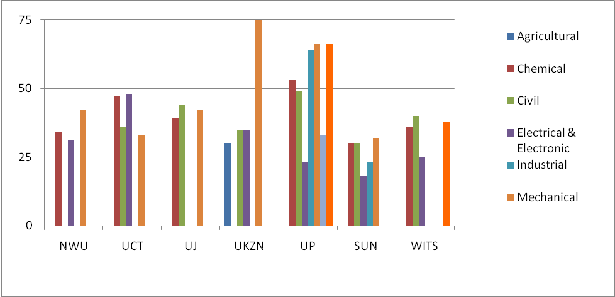
Source: Lawless & Kirsten: 2008:40

Exacerbating the decline in staff-student ratios, the 2008 study shows, were large numbers of staff vacancies and, in some cases, high staff turnover and the loss of senior and experienced staff, driven by the push-pull of unsatisfactory working conditions and the attractions of industry and alternative employment.
The 2008 research showed that 23% of permanent lecturing posts in institutions delivering engineering programmes were vacant, and Figure 14 below provides a snapshot of the percentage of filled posts, across institutions and the major disciplines.

Figure 14: Percentage of posts filled, by institution, 2006
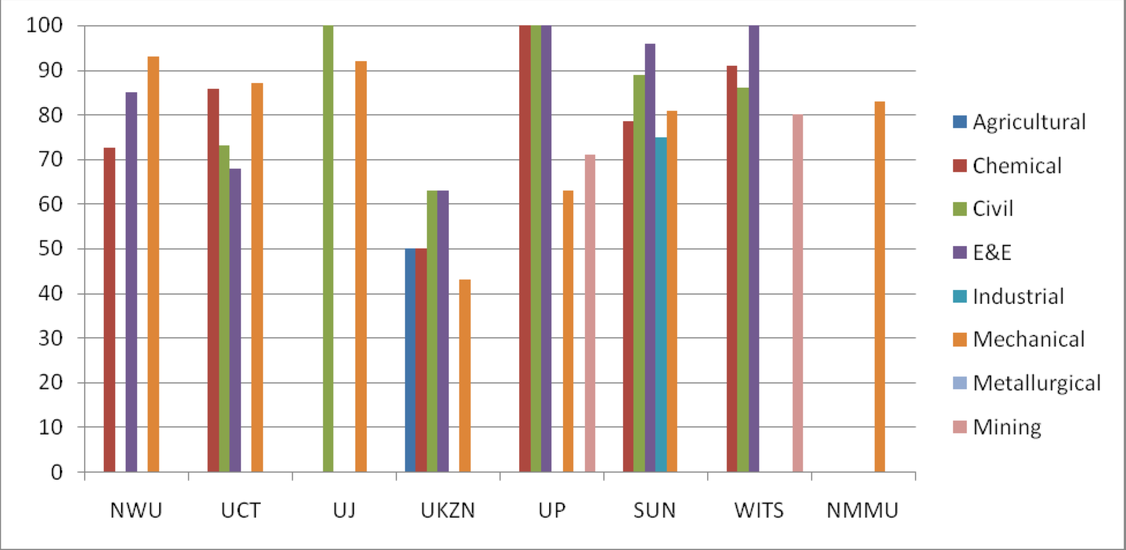
Source: Lawless & Kirsten, 2008: 13

Reasons for these staff shortages and vacancies were analysed in some detail, and are summarised in the figure below. The main reason behind the staff shortages, according to Heads of Department, was non-competitive academic salaries, followed by increasing workloads, increasing student numbers, the burden of administration, and weak or under-prepared student intakes.

Figure 15: Factors affecting staff recruitment and retention
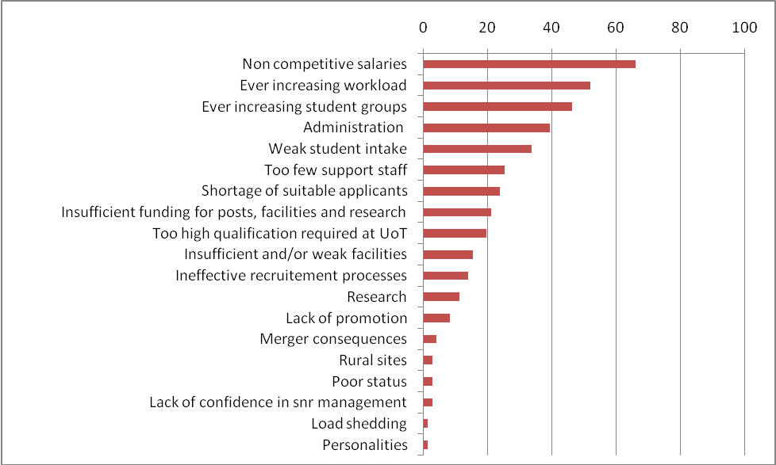
Source: Lawless & Kirsten, 2008: 15

In their recommendations, Lawless and Kirsten (2008: 6-7) focus on a range of practical measures to:

- Attract and retain experienced academics
- Develop future academics
- Develop support staff
- Address HR challenges, to enhance the recruitment of staff, and develop staffing organograms which are more appropriate to the needs of departments and faculties.

In addition, Lawless and Kirsten identify a number of measures relating to improving throughput, and recommend that a more comprehensive review should be undertaken, ‘to understand the root causes of the apparent system breakdown.’
The findings and recommendations arising from this study warrant serious consideration by ECSA, and should be used to help inform ECSA’s approach to improve throughputs going forward.

Improving throughputs: the staffing challenge
As has been noted, staff-student ratios in engineering have deteriorated as student enrolments have more than doubled in recent years, while academic vacancy rates stand at 23%. Not surprisingly, staffing is seen by many Deans and Heads of Department as one of the most serious and pressing challenges facing engineering education in South Africa.
As with the student support, curriculum, and teaching and learning issues discussed in previous sections, the problem of staffing is both a general, systemic concern and one which is context-specific, varying over time and from faculty to faculty, and from one department to another. Figure 15 above, provides a quantitative illustration of the point, showing how the percentage of filled posts varies across institutions and disciplines.
Similarly, it seems clear from the interview data that the factors behind these staff shortages are also both general and specific. For example, salaries are a general concern across the sector, as both the present study and the earlier study by Lawless and Kirsten confirm; but salary subventions by industry play an important role in staff retention in mining-related disciplines, for instance, while some institutions ‘top-up’ salaries for engineering staff or for staff who meet certain criteria, for example holding a Masters degree and Pr.Ing.
Likewise, high staff turnover and difficulties in recruitment may relate to a variety of factors. One department head observed that persistently high vacancies in his department were linked to the fact that the university was close to industry, while other departments in the same School were not affected.
In contrast with this ‘pull’ factor, the ‘push’ factor at two other universities was said to be related to the merger processes, while at a third, a deterioration in staff-student ratios and a lack of infrastructure were cited as contributing factors.
In short, the interview data from the present study confirms the significance of the staffing challenge and the importance of the push-pull factors identified in the study by Lawless and Kirsten; but it highlights as well the significance of different institutional contexts, at all three levels of the university, the faculty, and the department.
Closer analysis of the underlying issues pertaining to the staffing challenge in engineering points to four areas of concern, in particular, that warrant further investigation and debate:
- Policy choices and the allocation of resources, with respect to the staffing of mainstream and foundational programmes
- A loss of experience and ‘hollowing out’ of some departments
- The tension between teaching, research and consulting
- The postgraduate pipeline
Against the backdrop of these issues, it is also necessary to revisit the question of building teaching expertise, and of addressing the teaching and learning needs of a diverse student intake, within a flexible framework of mainstream provision.

Policy choices and resource allocation
The staffing shortages, high vacancy rates, unsatisfactory staff-student ratios and staff attrition that are evident across the system point to some complex and difficult policy choices regarding support for mainstream and foundational provision, together with some hard questions about resource allocation.

‘A major problem from a faculty point of view is the deteriorating staff student ratio. Staff can’t put in the intensive effort required–we are being pinched between more intensive teaching and support requirements and larger classes and numbers. The best way to improve throughput is to improve the staff student ratio.’
‘I would put my head on the block I could get 15-20% better throughput, if you gave me the staff and paid them proper salaries.’
‘The important thing is that the core programme should be very well resourced, but because we are putting our money into all these other things the tail is now wagging the dog.’
‘Large classes are a problem, especially at first-year level where students are least able to cope and most likely to feel lost and alienated. However, there are no resources available to teach in small classes - as we were, for example, when we were at university many years ago. Students today are getting a bum deal, compared with our generation, which had small group tutorials, taught by lecturers and not by students.’
‘Academic development staff in the departments are a luxury we can afford because of the DHET funding. But if the faculty had to choose between funding an academic development officer or a lecturer, the faculty would choose the lecturer.’

The issues of course are more complex than the comments above might suggest, and further investigation and discussion is necessary.
The fact that some students require foundational support, and that the teaching expertise required to cope with a diverse student intake is generally under-valued and in short supply - not to mention the tension between teaching, research and consulting, discussed below - indicates that there are no simple solutions. At the same time, it seems equally clear that the staffing crisis in engineering poses a challenge for national and institutional policy-making, and calls for some important choices to be made about priorities and resource allocation.

Loss of experience
A second set of concerns relates to the loss of experience and ‘hollowing out’ that some departments and faculties appear to be experiencing.
Once again, the reasons for this are complex and diverse, and vary from context to context. The head of civil engineering at one university indicated, for example, that hers was a stable department, with long-serving experienced staff, ‘unlike some other universities which have seen major staff turnover and the appointment of lots of foreign staff.’ Yet, the department had four senior professors who would be retiring in 2012, and the university would not allow her to replace them with anyone who was not ‘an established professor with an international reputation.’ She did not know where she was going to find such people, observing that ‘the competition for researchers and for status is making it impossible for the profession to survive.’
At a number of other departments, senior positions are occupied by retired professors, brought back to fill in gaps in the staff complement. Similarly, several departmental heads highlighted the dearth of senior to mid-level staff. One deputy dean observed that, in his faculty, ‘if you took only two or three people out of some departments, they would not be able to teach the undergraduate courses.’ Many staff were 55 or older, or past retirement. Confirming this, the head of one large department at the same university highlighted ‘a lack of senior academic leadership–there are only two professors in civil engineering and only one senior lecturer–all the rest are lecturers. Leadership in terms of the experience of staff, the extreme teaching loads and young staff, are all challenges.’
The head of a very large department pointed out that over the previous three years, he had never been able to fill more than 80% of his posts; ‘two years ago, not even half my positions were filled.’ In his view, the key issue was not academic support, but to ‘get it right the first time, in class.’ However, he added, ‘Only a small percentage of staff have more than 5 years of experience, there is a huge staff turnover, and inexperienced staff make mistakes. We need to put the money into getting the foundations right, not on all of the extras. We need to have academics who see their careers in terms of a 40 year span. We are putting our money into the wrong things. The problem is not the large classes, but staff turnover, and staff experience. Our service to our students is excellent, but it doesn’t help if the guy in the class cannot manage–then you have to pay for all that other stuff.’
At another university, ‘there were problems with the way the merger was handled, and many senior people left, so there was a significant loss of experience. Some of the older staff who remained feel that the university is fighting them, so they hunker down and hang in there, and don’t really commit or get involved. There is also tension within certain departments, between a younger, forward-looking generation and a bitter older generation and this makes for conflict.’
These comments, while selective, are indicative of a wider set of concerns about the loss of experience and continuity, as well as the negative consequences that arise in the wake of high staff turnover and rapid changes in staffing.

Teaching, research and consulting
A third area of concern, alluded to in the quote above about the ‘competition for researchers and for status,’ is the tension between teaching, research, and consulting.
The research imperative, in particular, was seen by many informants as both a powerful attraction for many academics and a distorting pressure from DHET, through the funding formula, and from the university, which was impacting negatively on staff recruitment and on rewards and promotions, as well as on teaching and learning. Some informants went so far as to suggest that the emphasis on research was detrimental to the basic engineering which was the department’s core business.
A common view was expressed by one informant as follows: ‘Most lecturers in engineering are at the University to pursue their research, which is what the University encourages and rewards, and not for the teaching–otherwise they would be in industry working as engineers.’
According to another, ‘The university runs on research, but in my view it is not good enough. A researcher is not an engineer. And now there is the pressure to teach, but the university puts on the pressure for lecturers to research.’
In his view, ‘A university has no benefit in training quality engineers–it gets its subsidy for research and therefore it asks why spend all that money on labs and equipment etc. There is no incentive to put in place the resources needed to really do the job in terms of producing real engineers. The research imperative drives the institution’s status and reputation, but none of this helps the country or the engineering profession.’
The head of a large department similarly observed that ‘there is a problem with the funding formula, which rewards research, and civil engineering at the University is forced to appoint researchers rather than experienced professionals or designers–this is a looming problem. Also, the department cannot find researchers who are willing to teach our students.’ Another head in the same faculty advised that ‘you should not expect too much from academic departments about improving throughput–they will say that it is not their core business: the agenda for staff is research driven.’
A third head of department, again at the same university, drew a useful connection between the staffing shortage and the tension between teaching and research. ‘Research remains the main focus of the university and teaching is seen as getting in the way of this, yet staff are still expected to produce the same student outputs. We need a balance between teaching and research. The problem comes back to not having enough people–if we had more people some could do more research and some could focus more on teaching.’
While the quotes above represent the views of individuals, they are illustrative of widespread concern amongst Deans and Heads of Department both about the balance between teaching and research and about the way in which the under-staffing of engineering faculties impacts on teaching and learning, and makes it difficult for institutions to focus adequately on both the teaching and the research missions.
These concerns are exacerbated by the apparent disconnect between the emphasis on research in the funding formula, and the pressure from DHET to improve graduate outputs, whilst institutional policies concerning the recruitment and promotion of academic staff are widely seen as over-emphasising the research agenda, compromising the ability of departments to appoint staff who have extensive practical, but not research experience, and compromising the teaching role.
The point, clearly, is not to negate the importance of research, but to establish a reasonable balance between research and teaching, and to ensure that this is supported through the alignment of DHET policies and of institutional policies on recruitment, promotion and reward.
The tension between teaching and research seems also to be connected with the problem of staff shortages and vacancies. As a number of informants pointed out, if staffing levels were improved this would allow for a division of labour in which some academics might focus more on research and others on teaching; currently, however, many felt that university policies made it difficult for them to hire academic staff who were not researchers, and difficult to reward and promote staff who were focused on their teaching.
As Fisher and Scott (2011) have argued, a clearer institutional differentiation between teaching and research universities, as well as an appropriate division of labour within each institution between the teaching and research functions, could help to ensure that an appropriate balance is established, in higher education, between the need to strengthen the research base and to expand the pipeline of new academics through advanced post-graduate training, and the need to educate and train increasing numbers of engineers for industry and the work place.
A similar set of concerns arises with respect to consulting. A number of informants stressed the importance of consulting as a key means of keeping in touch with the needs of industry, arguing that this fed back into better courses and better teaching. For some, consulting was also a lucrative source of income, and a vital supplement to uncompetitive academic salaries. However, some informants also suggested that consulting could impact negatively on the time available for, and commitment to teaching.
Again, the point seems to be that a balance needs to be established, and there are strong reasons to suggest that a wider policy debate is needed, and more research and investigation is required, both into the staffing levels that are needed, to fulfil the teaching and research missions of the universities, and into the balance between teaching, research and consulting. Such a debate, it is suggested, need not take a ‘one-size-fits-all’ approach; rather, it should take a nuanced perspective on the division of academic labour, within institutions, and on the differentiation of roles and functions, between them.

The post-graduate pipeline
A fourth, critical area of concern is the post-graduate pipeline and the development of future academics. This is both a function of post-graduate outputs and, as Lawless and Kirsten (2008: 56-8) observe, the development of an academic career path.
Available evidence indicates that total post-graduate outputs in engineering almost doubled in the decade between 1996 and 2005, from 576 to 1063 (Du Toit and Roodt, 2009: 99). While this is an encouraging trend, recruitment of post-graduates into the academic profession remains a challenge, and the recruitment of black graduates, in particular, is constrained by their ‘market value’ in industry and the uncompetitive salaries and working conditions of academic life. Conversely, equity and transformation requirements may stand in the way of employing white engineering graduates. One head of department summarised the challenge in these terms:
The better academic students, especially black students, get absorbed into industry–when jobs are advertised, there are lots of international applicants from Europe as well as the rest of Africa, but it is very difficult to get approval to appoint for example a top European academic because of equity considerations. It is even difficult to appoint the university’s own white graduates as faculty, so that those who finally do get appointed are not necessarily the best–this is one of the reasons engineering education is suffering.
Replacing an ageing white professoriate and research community is a major concern across the higher education system as well as in engineering, and Higher Education South Africa has called the reproduction of South Africa’s academic work force one of the main problems facing higher education (Stumpf, 2010: 39; see also Fisher and Scott, 2011).
Interestingly, given the ‘pull’ of industry for both young engineering graduates and academic staff, one suggestion that ECSA might wish to explore with the universities and with employers came from an industry informant, who proposed that industry could support young graduates to continue their studies and to teach as junior lecturers, prior to their employment with a company. Such a scheme would have the dual advantage of helping with the staffing crisis in engineering education and of strengthening the links between the universities and industry.
A head of department, similarly, argued that engineering was facing a ‘brain drain,’ and asked whether the Engineering Council could not ‘develop a scheme for an easy exchange of staff and skills, between the universities and industry.’
Similar proposals are made by Lawless and Kirsten, in a useful set of recommendations for building an academic career path which will develop the ‘future academics’ that South Africa so urgently needs.
Amongst the elements needed to develop an academic career path, Lawless and Kirsten (2008: 56-8) suggest, are the following:
- Ensuring career progression, supported at each stage by adequate remuneration as well as time to improve qualifications, gain industry experience and undertake research
- Promote practical training and ECSA registration for lecturers
- Develop Centres of Excellence, where departments can provide specialist industry consulting and research expertise, and mentor up-and-coming academics
- Support for research
- Rotation of staff between industry and academia
- Community service opportunities

Conclusion
As Stumpf (2010: 39) reminds us, ‘Universities are labour intensive institutions and the availability and quality of academic staff plays a crucial role in any higher education system.’ The 2008 study by Lawless and Kirsten highlighted the magnitude of the staffing challenge in engineering education, identifying some of the root causes and making useful recommendations as to how these might be addressed.
Interview data from the present study amply confirm these concerns, capturing in numerous voices, from deans and heads of department across the eight faculties, a sense of frustration and alarm about the staffing situation.
The implications of a looming staffing crisis for improving teaching and learning, and for improving throughputs seem, at one level, self-evident, but it is also clear that the issues are complex, inter-related, and to some extent also context-specific.
While addressing the shortage of suitably qualified and experienced staff is a major challenge in itself, there are important questions of policy and resource allocation to be considered, as between mainstream and foundational provision, for example, and the alignment of DHET funding and institutional human resource policies with the demands of teaching and the need to develop teaching expertise, as well as a better balance between teaching, research and consulting.
Tied up with these concerns, is the division of academic labour within faculties and departments, and the sensitive but important question of institutional differentiation, including the development of ‘centres of excellence,’ as proposed by Lawless and Kirsten.
None of these challenges is likely to be resolved in the short term. However, it may be important for ECSA to consider where action could usefully be taken over the short- to medium-term to address some of the issues that have been identified. At the same time, this study can be seen as lending further support to the call by Lawless and Kirsten, for a wider systemic review of the factors which underlie the current staffing situation, and the measures needed to ‘stem the tide and rebuild the academic skills base’ (2008: 62).
However, this study goes further, to suggest that the relationship of staffing to throughputs is not only a question of staff-student ratios, staff vacancies, or staff turnover, but a critical question of national and institutional policies and resource allocation. These larger questions should be central to any review of the staffing challenge.

Funding
State funding of higher education lies at the nexus of a set of national policy frameworks which together shape and impact upon the skills and transformation imperatives of improving throughputs and increasing graduate outputs. These include the Higher Education Funding Framework itself, the Higher Education Qualifications Framework (HEQF), the Higher Education Management Information System (HEMIS) and the quality assurance functions of the Council on Higher Education, through the Higher Education Quality Committee (HEQC).
The allocation of resources within universities, as well as the roles played by industry, are also important factors requiring consideration.
From the perspective of the present study, four key issues, in particular, stand out:
- the alignment of policy and funding with national goals, specifically with regard to improving throughput and increasing graduate outputs;
- the adequacy of state funding for the training of engineers;
- the internal allocation of resources, within the universities; and
- the role played by industry through salary subventions, bursary provision and other contributions.

State funding of higher education
A useful overview of macro-trends in the funding of higher education and of critical challenges in the funding environment is provided by Stumpf (2010). For present purposes, however, funding and related policy issues are more narrowly considered from the standpoint of improving throughputs, in particular through the introduction of a more flexible curriculum and improved teaching and learning, and the role of student financial aid. The funding implications of expanded provision for student housing are also important, as Stumpf points out, but are beyond the scope of this study.
An important point of departure for this discussion is the adequacy of state funding for higher education and for engineering education, in particular. According to Stumpf (2010: 73-4) public spending on higher education as a proportion of GDP has steadily declined over the past 10-15 years and now is lower than in ‘quite a few’ other African countries. Government subsidies have declined as a proportion of total institutional income, from around 49% in 2000 to about 40% in 2008, and institutions have ‘made up’ the gap through increases in student tuition and ‘third stream’ income, related to research contracts, sales of goods and services and so forth.

Table 9: Proportion of total income from different income streams of universities, 2000 and 2008
 | 2000 | 2008
Government subsidy | 49% | 40%
Tuition & related income | 24% | 28%
Third stream income | 27% | 32%
Source: Adapted from Stumpf (2010: 75).

Against this background, HESA has recently called for an increase in higher education spending to at least 1% of GDP, as against the current level of about 0,68%. Stumpf, meanwhile, suggests that,

…South Africa could be on a perilous path in terms of its human resources development and higher education's ability to playing (sic) a meaningful role in closing any skills gaps. This would also lend credence to higher education's lament over the past few years that it finds itself locked in a bitter daily battle for financial survival and has no hope of introducing any major new initiatives (which take time in yielding the requisite outputs) in response to changing Government priorities without additional funding being made available.

Writing more specifically about skills and the current funding and policy regimes, Fisher and Scott (2011: 57) argue moreover that there appears to be a misalignment between the stated aims of national policy with respect to skills development and graduate outputs, and the influence of state steering mechanisms, including the DHET funding framework, on higher education institutions. A closer alignment of policy and funding is needed:

The current under-performance of the sector in graduate production indicates that the combination of market forces and the existing state steering mechanisms, including the funding framework, is not succeeding in meeting national development goals. Put differently, there is an apparent tension or disjuncture between institutional interests and national skills priorities.
It will become increasingly important, therefore, to ensure that funding is progressively applied to the realisation of key output goals, in terms of quantity, quality and shape. In support of this, a balance will need to be found between input- and output-driven funding, and between rigid standardised approaches and more nuanced funding strategies that will allow for flexibility and reward institutional responsiveness to key policy objectives.

In previous chapters, two key approaches to improving throughputs in engineering, namely the introduction of a flexible mainstream curriculum and improved teaching and learning, were highlighted. While government policy recognises and provides funding for foundational and extended programmes, the funding and policy frameworks with respect to programmes and curriculum remain, in important respects, limiting and inflexible. Similarly, funding and policy do not sufficiently incentivise and reward teaching and learning.
Funding for foundation and extended programmes currently is provided through a non-recurrent grant which militates against continuity, development and professionalisation in this area. The Higher Education Qualifications Framework, moreover, which prescribes the credit requirements for all qualifications, does not explicitly provide for extended curriculum programmes, despite the fact that these are recognised and funded through the DHET. The HEQF accordingly does not currently allow for two key elements of a flexible curriculum framework, namely alternative entry levels and additional foundational course credits for under-prepared students.
Changing the HEQF to allow for greater flexibility could be achieved fairly readily by allowing for additional funded credits for those students who need extra provision. However, the HEQF is regulated through aspects of HEMIS and the funding framework, which utilise a different and more rigid credit system. HEMIS applies a fixed and strictly regulated definition of ‘formal time’ for each type of qualification (for example, three years for a general Bachelors degree) and allocates funding credits for ‘teaching input subsidy’ accordingly. The rigidity of this approach stands in the way of mainstream implementation of a more flexible curriculum framework, and changes to the HEQF will therefore need to be accompanied by appropriate amendments to HEMIS and the funding framework (Fisher and Scott, 2011).
In addition, a significant disparity exists between teaching input subsidy (a capitation subsidy based on enrolments) and teaching output subsidy, which is based on the numbers of graduates. The consequence of this is to reward growth in enrolments rather than graduate output, and a more targeted and nuanced funding approach will be needed if funding is to provide stronger encouragement and support for improvements in throughput rates and graduate outputs.
There are a number of ways in which the current funding and policy frameworks influence teaching and learning. One of these, as has been noted earlier, is the extent to which funding for research outputs - generated not only via the higher education funding framework but also through funding from other government departments, research councils, the private sector and a range of other sources, influences institutional and academic priorities and behaviours.
The extent to which the tension between teaching and research was highlighted by informants as a factor impacting negatively on teaching and learning suggests that a better, more appropriate policy and funding balance is needed, on the part of both DHET and the institutions, to ensure that sufficient attention is paid to the teaching mission of universities, and to recognise and reward teaching expertise and progress in teaching and learning outcomes.
A second aspect of the funding regime raised by informants is that while funding is driven to a large extent by enrolments, there is a two-year time lag between increases in enrolments and increased funding reaching the institutions. This impacts negatively on institutions which are growing and on their lecturing staff, leading to increased workloads and staff dissatisfaction, while deteriorating staff-student ratios affect teaching and learner support. As Monique Adams of the Minerals Education Trust Fund has observed (personal communication),

…the current model whereby universities can only gain extra teaching staff once increased numbers have filtered through the system is self-defeating. By the time the additional staff have arrived, many students have been lost and the existing staff are overworked and demoralised. Universities do not reward lecturers for their teaching abilities or successes and there is no motivation for lecturers to put extra effort into this area of work.

A third, potentially positive influence of the funding framework on teaching and learning lies in a possible change in the application of the ‘teaching development’ element of the funding framework. This currently forms part of the block grant for under-performing institutions, but consideration is being given to making it an earmarked grant for which all universities would be eligible (Ian Scott, personal communication). This could play a useful role in encouraging institutions to access DHET funding to improve teaching and learning, whilst ensuring greater accountability for results.
A coherent, ‘joined up’ approach by the engineering faculties to leverage collectively off the ‘teaching development’ grant could help to ensure that all engineering faculties benefit from this funding allocation, and that the overall quality of teaching and learning in undergraduate engineering programmes improves.
Finally, however, the impact of funding on teaching and learning needs to be located within the context of the overall under-funding of higher education (see observations by Stumpf, earlier) and of the adequacy of funding for engineering, in particular. Numerous informants argued that engineering needed to be placed at Level Four (the highest) in the funding framework, not Level Three, as is presently the case, and Lawless and Kirsten (2008) report that engineering is quite seriously under-funded.
This impacts, inter alia, on staffing levels and, relatedly, on teaching and learning and poor throughput rates, as a consequence of poor staff-student ratios and limited learner support.
According to Stumpf (2010: 80), moreover:

….(the) lack of differentiation in funding policies induces unwanted institutional behaviour in that the only way in which some institutions feel that they can improve their financial position is to become a research oriented university, similar to universities such as the University of Cape Town or the University of Pretoria.

In this way, it can be argued, funding constraints have become one of the drivers behind an increasing institutional focus on research and the generation of research income, thereby exacerbating the tension between teaching and research which was earlier identified as impacting on the quality of teaching and learning and on throughput rates.

‘It is expensive to run a chemical engineering department with state-of-the-art practical equipment and laboratories, as the current government subsidy per student is not sufficient to cover the real costs related to the education of chemical engineers. Therefore, in order for a chemical engineering department to operate successfully and effectively (on a financial basis), significant contract research work and related industrial interaction is required.’
‘We need two complementary components for funding: (a) ‘rising tide’ for all universities, simply to put them into a reasonable ‘ballpark’; (b) then, allow universities to follow differentiated routes/strategies to pursue their own particular niches.’

Institutional allocation of funding
The discussion above has drawn attention to the problems of inadequate state funding of higher education, and as a subset of this, inadequate funding of engineering. As a number of informants pointed out, however, the internal allocation of resources by the universities may also be an area of concern in some cases.
While some institutions effectively cross-subsidise their engineering faculties, others are said to underfund them, as the following quotes illustrate.

‘We are concerned that we get blamed for the lack of success of our students, but we’re doing a very good job with what we have, and are turning out some of the best engineers in the world. However we are not being given the tools we need to do the job…. It’s [deleted] expensive to educate an engineer, and this is not being adequately addressed. The universities underfund the engineering schools, resulting in understaffing and so on. The Department of Education’s funding formula is intended simply to provide a basis for funding the universities. The funding formula does not prescribe to universities how they should allocate the funds that they receive, it is for the universities to decide this for themselves. It is the internal allocation that is the problem, not the funding formula.’
‘The Engineering Council should be pushing DHET to put engineering into category four for funding purposes. However, it is important that the university’s internal allocation of funding is addressed– the internal allocation of funds might be highly problematic and this is something that ECSA could also ask the University as part of its accreditation process. ECSA should ask each university to make clear what resources are going to the faculty per student, and what other costs are covered by the University for example in terms of technical support. At this university funding internally is being strongly diverted towards research and publications and away from the core function of teaching and producing good engineers.’
‘The faculty is not hindered or penalised in terms of the state funding formula, because the university has deliberately cross-subsidised engineering by 20%–the faculty is very privileged to be supported like this by the University.’
‘The new funding formula introduced five years ago reduced funding for engineering, despite government’s goal of increasing the engineering numbers. The faculty constitutes 24% of the total university enrolment–there are more than 5000 students in engineering. The university makes sure that we get what we need.’

ECSA, in short, might usefully consider monitoring the basis on which universities allocate funding and resources to engineering faculties, as part of the accreditation process.

Student financial aid
As Stumpf observes (2010: 72) the National Student Financial Aid Scheme (NSFAS) is a ‘very important earmarked allocation’ within the government funding mechanism for higher education, and financial need, as shown in the chapter on student support, is a critical factor influencing prospects for student success and throughput rates.
NSFAS spending increased from around 7-8% of the total higher education budget in the budget cycle of 2005-7, to around 12% for the period 2008-11 (Stumpf, 2010: 82), and as Stumpf points out, the NSFAS has helped to provide access to higher education for thousands of young people who otherwise would not have been able to afford it.
While the contribution of NSFAS to broadening access is significant, Stumpf also reports on a number of problems regarding its implementation, concerns which are borne out by numerous informants.
These include the fact that demand for student financial aid has far outstripped the availability of funding, and ‘very few, if any students actually received full funding for their studies.’ Some universities have found the administration of NSFAS too complex to manage, and consequently some students are simply given a standard amount regardless of their course of study, family contribution or actual study costs. As Stumpf (2010: 83) observes, ‘this (has) resulted in much frustration amongst students, especially those in more expensive fields of study who (are) ‘out of pocket,’ compared to those in less expensive study fields….’
Late payment of NSFAS monies, referred to by many informants, combined with these factors, means that, important as the NSFAS is, many students continue to face financial hardship, and failure and drop-out for financial reasons continue to be a significant, if unquantified, factor in poor student retention and throughput rates.
As Fisher and Scott (2011) point out, however, and as this study has argued, funding is an important but by no means the only factor influencing students’ prospects of entering and succeeding in higher education. One problem, as just discussed, is that the funding that students receive may be insufficient to meet their needs, allowing them entrance to higher education but effectively denying them the means to succeed. A different set of issues relates to student under-preparedness and to the ability of institutions to respond effectively to a diverse student intake. For all of these reasons, it is important that the present approach to student financial aid is systematically evaluated, in relation not only to its effects on access, but for its impacts on success and graduation rates.
The picture, at present, is not encouraging. According to a recent Review of NSFAS, only 19% of students who have received NSFAS funding have thus far graduated; more significantly, of the 67% of NSFAS students who are no longer at university, 72% have either dropped out or have not completed their studies. As Fisher and Scott (2011: 30) observe,

…the key conclusion to be drawn is that NSFAS is contributing to increasing participation but not to increasing successful participation and improving student outcomes to an extent that is commensurate with the size of the investment. Either the current wide-and-thin distribution of financial aid to students is flawed, or other, additional forms of support and educational development are needed, or both.

The issues concerning student financial aid are not specific only to NSFAS, however, and flow over into the provision of bursaries by companies and other government departments and agencies. These are picked up below, in a discussion of the role played by industry in bursary provision and salary subventions.

A note on the costs of proposed reforms
This review has explored a range of measures which, it is believed, could contribute to improving throughputs in engineering and increasing the output of qualified graduates required for economic growth and development. These include a stronger policy and funding emphasis on higher education outputs; the introduction of a flexible curriculum framework with funded credits for foundational courses; funding and incentives to improve teaching and learning; improved staffing levels; and a more coherent, timely and effective ‘package’ of student support.
A key question that arises is the affordability of the proposed changes.
A full response to this question will require closer analysis of the real costs of engineering education, taking into consideration the high costs of student attrition and extended time to degree in the current mode of provision, as well as the costs of the proposed reforms, and such an analysis might be something for ECSA to consider undertaking.
As Fisher and Scott (2011) observe, however, an immediate response to the question can be found in the wastefulness and inefficiency of the current system of provision. It is worth outlining the argument in full:

It could be asserted that South Africa cannot afford the funding incentives that would encourage institutions to respond to key output goals, or fund the introduction of a new, more flexible curriculum structure, requiring extended funded credits. The response to this concern lies in the very significant wastage entailed by high student attrition, low throughput rates, and the extended time to degree that are direct consequences of a curriculum and learning and teaching environment that has failed to respond to the changing demographics and academic profile of the student intake.
The 2001 National Plan for Higher Education estimated the cost of unfruitful teaching input subsidy at more than R1 billion per year. Simple arithmetic on the current value of the teaching input subsidy and the proportion of the intake that will never graduate indicates that this ‘wastage’ figure will have increased at least four-fold by 2011. In addition, the state is already paying for the majority of those who do graduate to remain in the system for at least one or two years longer than the regulation time.
To the extent that this wastage and inefficiency could be reduced, considerable resources would become available, within current budgetary constraints, for the implementation of educational structures and processes in higher education that would increase participation and throughputs and contribute more effectively to the demand for skills.

University-industry linkages
Linkages and relationships between industry and the engineering faculties and departments are important and valuable, for all parties, and a noticeable feature of the interviews conducted for this study was the emphasis placed by many informants on the strength and depth of their relationships with industry, in some cases stretching back over many years or even decades. Benefits to the universities range from industry input into the curriculum to guest lecturing, tutoring and mentoring; investment in infrastructure and equipment; as well as research funding, bursaries and subvention of academic salaries.
However, and in the absence of systematic data, it would seem from the interviews that the nature and strength of these relationships varies both across industry sectors and from company to company, as well as across faculties and departments.
The mining industry, for example, appears to enjoy a particularly close, well organised and structured relationship with university mining and geology departments, through the Minerals Education Trust Fund; this entails regular visits to the institutions, personal relationships with academic staff, engagements on curriculum and monitoring of student performance, as well as funding for special projects and, importantly, a substantial and carefully targeted programme of salary subventions.
University-industry relationships in other sectors appear to be more varied and uncoordinated in nature, although companies in a particular sector may sometimes collaborate around particular initiatives.
Against this generally positive, if uneven background, some informants sounded a note of caution, suggesting that while it was necessary to ensure a good relationship with industry, it was also important that the universities ‘try not to follow fashions.’ Likewise, some informants believed, ‘it is important to resist the narrow, self-interested pressure from companies to include specific elements into the university programmes,’ and some informants expressed concern, also, about the way in which industry approached the training of the universities’ graduates:

There is a huge problem with how industry trains our candidates–industry does not have proper training programs and are not taking proper care of our students. After 1994, industry lost many experienced people, and the people who took over were often not properly competent and did not provide proper guidance to graduates. The companies then tried to put the responsibility on to the universities, to provide training and exposure which is not appropriate or practicable.

From the standpoint of this study, the perspectives of industry on the engineering curriculum and degree structure are important issues which would benefit from more detailed investigation and from wider consultation and engagement between ECSA, the universities and employers.
Similarly, the role that industry could play in fostering improvements in teaching and learning in the universities, through salary subventions, monitoring of student performance, and providing both bursaries and work exposure for students, warrants serious consideration.
Attention should most urgently be given, however, to two key issues: salary subventions, and student bursaries.
Subventions are an important, perhaps critical element in attracting and retaining talented and committed academic staff, especially in a context of persistent under-funding, deteriorating staff-student ratios and working conditions, and uncompetitive salaries. As one informant put it, ‘if the METF had to close tomorrow, all three mining schools, including…technology programmes, are in serious trouble.’ However subventions are unevenly available across departments and universities, and a more coordinated and targeted response by industry could make an important contribution to improving the staffing situation in the engineering faculties and, especially when linked to clear output measures and monitoring of student performance, to improving teaching and learning and driving up throughputs.
Bursaries, especially where bursary programmes include structured workplace experience, mentoring, social support and monitoring of student performance, constitute a substantial investment by companies, government and other funders in training the engineers of the future, and a significant contribution to broadening access as well as to student success.
As is the case with regard to subventions, however, the availability of bursaries varies considerably across industry sectors and between university departments, with some departments indicating that high proportions of students were in receipt of bursaries, while others complained that significant numbers remained in dire financial need.
Figure 16 below illustrates the differential spread of student financial aid across three institutions:

Figure 16: Student FInancial Aid, Engineering Faculties, at three universities, average for 2006-10
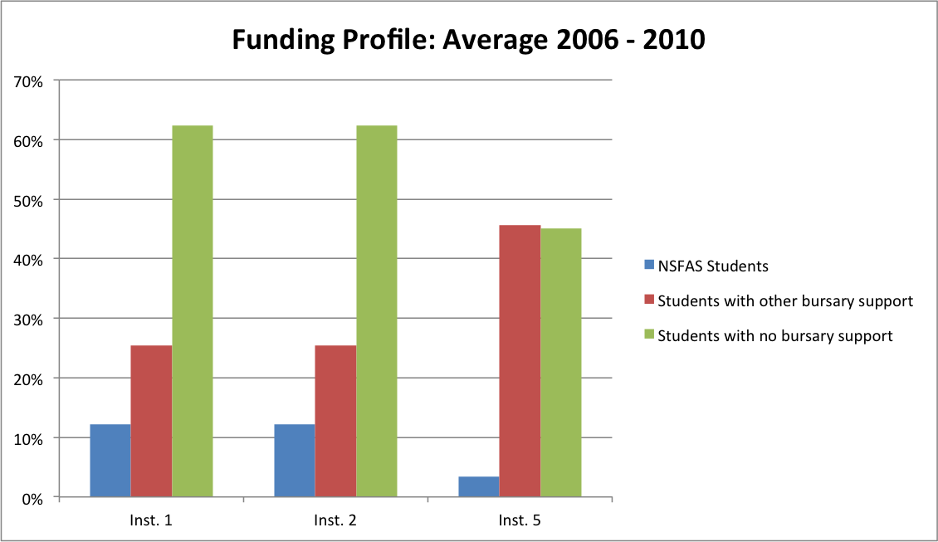

While bursaries represent a vital industry and donor contribution to student access and success, experience also suggests deep shortcomings in the approach of some funders, and informants pointed to a range of issues requiring discussion and resolution.
The first issue requiring attention is that of student selection. As was noted earlier, many university informants commented negatively about the ‘steering’ effect of bursaries, claiming that all too often students choose engineering, not because they understand or have any affinity with the field, but simply because a bursary is available. Black and female students, in particular, may have bursaries pressed upon them, driven as much by company ‘transformation’ targets as by meaningful human resource development goals or a desire to strengthen the engineering skills pipeline. Some of these students may subsequently change courses, or fail or drop out, while even amongst those who graduate, some will choose not to remain in the profession. Careful selection, not surprisingly, is the first area of concern identified by two experienced bursary administrators, Monique Adams of CareerWise, and Glenda Glover of REAP.
The second issue, or set of issues, is what Monique Adams (personal communication) calls the ‘hygiene factor’. As she explains,

…given the stresses faced by a student transitioning from school to university and settling into a demanding degree course like Engineering, it is absolutely essential that the hygiene factors such as accommodation, food, finance, books etc. are sorted out right from the start. Students need to be in a safe, secure environment close to campus with sufficient funding to access meals, transport and books. Each candidate selected for Engineering needs to have this ‘package’ sorted out and explained to them so that they can budget and plan their daily lives. Many universities hand out NSFAS loans which do not cover all the costs late in the year. The stress caused by lack of resources in the interim has a huge impact on settling in and success. We find that if a student is not sorted out early and spends most of the first quarter or semester running around trying to address this, the chances of success are very low.

Careful monitoring of students and early detection of problems is also critically important. While students need to develop into independent learners, timely intervention and support can make a critical difference between student success and failure, particularly in the first year.
Two further areas of concern identified by informants relate to company policies on bursaries. In some cases, it was reported, companies provide bursaries from the second year onwards, but not for first-year students, on the basis that first-year failure rates are high and therefore a ‘risk’ for the funder. On the face of it this may seem a rational position for companies to take, and it is clearly their prerogative to do so; nonetheless, it is at first-year level that the greatest need arises, and the greatest risk to student success, and it would be helpful if these issues could be more widely and critically debated.
The second area of concern relates to company policies on student failure and repetition. Many companies, according to informants, withdraw funding if a student fails a course or repeat a year, thereby adding to the pressure on students and increasing the likelihood that they will fail or drop out. Given that the average time to degree is over five years, and given the risk to the initial investment in students that a withdrawal of bursary support represents, there is good reason for ECSA and the universities to engage companies and funders on this critical area of concern. Bursary and student financial aid policies will also need to be addressed in order to ensure that students on extended and flexible degree programmes are supported. SAICA’s Thuthuka model of bursary support, as already noted, offers some important lessons in this regard.

Conclusion
As we have seen, the funding of higher education has a variety of impacts and effects on the higher education system, both direct and indirect.
The declining contribution of state subsidies impacts on tuition and the drive to increase third stream revenues; the tension between the teaching and research missions of institutions is influenced by, amongst other things, institutions’ need to increase research funding; and the funding framework, through its linkages into HEMIS and the HEQF, limits the expansion of extended curricula and flexible degree programmes, whilst staffing and resource constraints impact on teaching and learning and, ultimately, on throughput rates.
Student financial aid, already a substantial percentage of the overall state contribution to higher education, appears to have impacted positively on access and participation, but may not have had the necessary impact on improving student outcomes.
Industry makes an important contribution to engineering education, not only through bursaries and salary subventions, but also through investments in infrastructure and equipment, the funding of research, engagement with engineering departments on curriculum, student performance and related issues, and provision of workplace experience and training for both students and engineering graduates. Much of this involvement appears ad hoc and uncoordinated, however; ‘coverage’ of the engineering faculties, departments and student intakes is uneven; and some aspects of corporate funding policies and practices may be short-sighted or counter-productive.
A broad spectrum of informants believed that ECSA could play a valuable role in facilitating a wider dialogue and engagement between the universities and industry, to explore and develop collaborative solutions to the issues identified above.
It would also be important for ECSA to engage government on the case for a more flexible approach to curriculum, and on the changes to the funding framework, HEMIS and the HEQF that this would require, as well as on the state subsidy for engineering education, and further incentives and support for improving teaching and learning.
In particular, ECSA should consider how it might usefully engage with the reviews of the HEQF and the funding framework that are currently under way.
Finally, ECSA could usefully consider how best to ensure that universities adequately fund and resource the engineering faculties, and strengthen the policy frameworks, incentives and support mechanisms that are required to improve teaching and learning and increase throughputs.

Section Three: Conclusion and Recommendations

Conclusion and recommendations
An encouraging finding of this study is that the great majority of those interviewed responded positively to the fact that ECSA had instigated an investigation into the challenges of engineering education and indicated that they would welcome and support a broad-based ‘conversation’ about the engineering curriculum and measures to improve throughput in the Engineering Bachelors degree.
Considering the resolution that was adopted at the Engineering Summit on 22 September 2011 (see Introduction) as well as the generally positive response to the initiation of this ECSA review, there should be little doubt that the Engineering Council has put its finger on a set of issues which role-players and stakeholders would like to see addressed.
Furthermore, an important outcome of the undertaking of this study and of the Engineering Summit is likely to be that ECSA has created an expectation that the challenges of engineering education and of improving throughput will be taken up.
The question is to identify which aspects of the challenge ECSA can most appropriately and most effectively address, and how best to do so.
This review has argued that the challenge of improving throughput and increasing the supply of engineering professionals is a national priority, and critical to long-term economic growth and development. It has suggested at the same time that the challenge is complex and systemic, and that there is no single ‘silver bullet’ which, alone, can resolve the underlying issues and produce the results that ECSA is looking for.
Instead, the study has identified seven key ‘levers of change,’ locating these within a systemic framework which emphasises not only the national dimensions of the challenge, but its multi-dimensional, multi-actor and, importantly, its institutional aspects.
A brief, summative review of these levers of change may be useful, before attention is turned to a possible framework for action.

Seven ‘levers of change’

In summary, the seven levers of change are as follows:
- Schooling: improving the ‘talent pipeline’ from schools into university by, inter alia
  - Engaging government, if necessary in conjunction with other professional bodies, re gaps in the mathematics curriculum
  - Engaging government, in conjunction with other professional bodies if necessary, about school exit standards and the reliability of school-leaving results
  - Promoting school outreach and career advice initiatives
- Student selection: selecting the right students, by
  - Critically reviewing current selection approaches, in both mainstream engineering and foundational programmes
  - Investigating how selection processes could better identify student interest, aptitude, insight, and problem-solving and analytic abilities or potential
  - Providing better career advice and student placement mechanisms
  - Engaging bursary providers to improve student selection and reduce inappropriate ‘steering’ of student degree choices
- Student support services: closing the gaps in student support services, both at the institutional level and from the side of bursary funders and student financial aid agencies, in order to ensure that
  - Students receive support from the first year of their studies, which is when they need it most
  - Financial support is available from the commencement of the academic year, so that students do not have to spend the first term or semester worrying about accommodation, books, transport costs etc.
  - Ensuring that all of the ‘hygiene issues’ affecting students, such as food, accommodation, transport etc. are comprehensively packaged for each student, and explained to them at commencement of the academic year
  - Bursaries and student financial aid are available to students on extended as well as flexible mainstream programmes, and that there is flexibility to continue financial support where promising students fail or repeat a course
  - Ensuring that all institutions, at university, faculty and department level, put in place coherent and comprehensive student support mechanisms which effectively address the social and educational backgrounds of their student intakes
- Curriculum: ensuring that the engineering curriculum remains relevant and responsive to the demands of professional practice in a changing world, and flexible enough to cater successfully for a diverse student intake by, for example
  - Undertaking a comprehensive, system-wide review of foundational and extended programmes in Engineering, aimed at strengthening foundational support to students while informing the development of a more flexible and responsive mainstream Engineering curriculum
  - Monitoring and critical review of key ‘experiments’ in curriculum reform, such as those that are under way at the Universities of Pretoria, KwaZulu Natal and Cape Town
  - Engaging government, and engaging with the reviews of the HEQF and the funding framework that are currently under way, in order to ensure that the HEQF, HEMIS and funding framework provide recognition and funding for a flexible mainstream curriculum as well as, in the shorter term, for foundational and extended degree programmes
  - Convening a ‘blue ribbon’ review of the mainstream Bachelors degree, possibly in cooperation with international as well as national bodies; this should consider inter alia the policy choices and practical implications pertaining to foundational and extended programmes and a flexible mainstream curriculum
  - Engaging proactively with the review of the undergraduate curriculum currently being undertaken by the Council on Higher Education
- Teaching and Learning: strengthening the core mission of teaching and learning, inter alia by
  - Holding institutions accountable for teaching and learning outcomes, at key stages in the degree
  - Encouraging each institution to put in place an effective institutional Teaching and Learning Strategy,
  - Encouraging the development, recognition and rewarding of teaching expertise in engineering
  - Giving national recognition to teaching expertise and research into engineering education, by establishing a system of prestigious grants and awards
- Staffing: ensuring that mainstream engineering as well as foundational programmes are appropriately staffed, with a sufficient foundation of teaching expertise and professional development support available to lecturers, by
  - Facilitating the development of a coherent package of measures, including improved funding and salary subventions, to address the staffing crisis in engineering
  - Reviewing the staffing implications of a flexible mainstream engineering curriculum, alongside other options for foundational provision
  - Supporting postgraduate training and the development of engineering ‘centres of excellence’ aimed at broadening and expanding the academic staff pipeline
- Funding: ensuring that engineering education is sufficiently well-funded to meet the current and future demand for engineers, maintain quality and standards, and meet the needs of a diverse student intake, by
  - Engaging government on funding levels for engineering
  - Engaging government on the higher education funding framework, HEMIS and the HEQF, in order to ensure that foundational, extended and flexible mainstream curricula are recognised and funded through the funding framework; this should include proactively engaging with the current Ministerial reviews of the HEQF and funding framework
  - Engaging government with a view to ensuring that the teaching and learning mission of universities is sufficiently recognised and supported
  - Ensuring that institutional allocation of resources to engineering is adequate
  - Engaging with DHET, NSFAS and bursary funders, to help ensure that students’ financial needs are met in a timeous and effective manner, that students’ career choices are not unduly influenced by the availability of funding, and that bursaries and student financial aid are linked more effectively to student outcomes.

A framework for action
As has been consistently pointed out, the ‘levers of change’ outlined above need to be understood within a wider, systemic context. None of these areas can be isolated completely from the others; all form part of a complex interplay of issues at the national and institutional levels, encompassing policy and funding frameworks, institutional and disciplinary cultures and practices, as well as the roles and contributions of employers and others, for example in funding for research, salary subventions and the provision of bursaries.
From a public policy perspective, key policy levers, such as the funding framework, HEMIS and the HEQF appear to be insufficiently aligned with the goal of increasing throughputs, while funding levels for engineering are widely seen as inadequate, and the staffing situation in faculties of engineering is said to be approaching crisis proportions.
From an institutional perspective, on the other hand, it seems clear that not all universities are responding sufficiently to the diversity of their student intakes, and notwithstanding the concerns that have been identified with respect to the wider policy and funding environments, the individual institution emerges as a key locus of intervention if throughput rates are to improve. Improving student selection, adapting the curriculum, providing student support and improving teaching and learning are all essential to improving student outcomes, and institutions need to be accountable for the results.

While many factors are involved, at the heart of the throughput agenda are the questions of staffing, curriculum, teaching and learning, and student support.
As has been seen, there is a strong view from some informants that throughputs would improve if engineering departments were properly staffed. For some, this was the single most critical factor that needed to be addressed, to the extent that the value of putting funding and staff into academic development and extended programmes, rather than into mainstream provision, was questioned.
The question of how best to allocate resources is a serious one, and the shortage of experienced and well-qualified staff in mainstream programmes is a major concern. However, it must be questioned whether increasing staffing levels will, on its own, lead to improved throughput rates, unless the teaching expertise of engineering faculty is improved and institutional policies and reward systems are adjusted to reward excellence in teaching and to recognise and retain good teachers.
This report has argued, moreover, that effective teaching is not enough. Better selection and, crucially, a ‘package’ of support that ensures that all students have their needs met, with respect to such basics as food, accommodation, money and books, from the outset of their programme is absolutely essential, a view strongly endorsed by two experienced bursary administrators, Monique Adams and Glenda Glover, and reflected in many of the interviews with Deans and Heads of Department.
Finally, the curriculum, in particular its rigid course structure, heavy course load and lack of differential entry points and flexible pathways caters poorly for a diverse student intake, with negative consequences for student outcomes. These include the negative experience of failure and the financial and other consequences of having to repeat a course, or transfer to another qualification, or drop out entirely.
Some students may require a pre-university bridging course, others need a foundation year at university, and still others need an extended and augmented programme which provides an effective basis for and pathway though the degree. For many talented and hard-working students, however, greater flexibility within the mainstream programme itself would be beneficial, and would likely result in reduced failure and repetition rates and improved throughputs.

The Engineering Summit Resolution of 22 September 2011 called on ECSA, by virtue of its statutory role and its responsibility as the accrediting body for engineering education, to play

‘…a leadership, convening and facilitating role, harnessing the collaborative efforts of key role-players and stakeholders, including the universities, professional associations, employers and government, with the aim of:

- expanding the talent pipeline from schools into higher education;
- improving student selection, placement and support services in higher education;
- expanding the capacity of the higher education system to produce the engineers, technologists and technicians needed for growth and development;
- improving throughputs in engineering degrees and diplomas;
- comprehensively addressing staffing constraints in engineering education;
- promoting research-led improvements in teaching and learning in engineering education, and enhancing the status of and support for educational expertise and teaching excellence;
- ensuring the ongoing relevance and responsiveness of the engineering curriculum to the needs of society and the economy, taking into consideration international agreements, national quality standards and the needs of the diverse student intake;
- ensuring that the training of engineers is appropriately funded and resourced, and that all engineering students, including those on foundation and extended programmes, receive the financial and social support they need;
- monitoring, reporting on, and facilitating professional and public debate on progress in addressing the engineering skills bottlenecks and towards improved output of engineering professionals.

In taking up this agenda, ECSA will need to engage with policy makers and stakeholders, as well as with the higher education institutions. In doing so, it has a variety of tools and options at its disposal, including its convening power and its ability to play an intermediary and brokering role. The accreditation process, moreover, provides the Council with an important mechanism for promoting systemic improvements in student outcomes and for monitoring and reporting on progress towards agreed goals.
Three key roles, in particular, may provide a framework for action, on the institutional, policy, and stakeholder fronts respectively. These are represented in Figure 17 and centre on:
- the accreditation of institutions
- representation of the engineering profession
- facilitation of dialogue and engagement.

Figure 17: Three roles and foci of action

Building on the existing accreditation framework, ECSA could usefully focus closer attention on, inter alia, institutional funding of engineering, institutional Teaching and Learning Strategies, staffing, student support systems, and student outcomes at key levels within the Bachelors degree.
At the policy level, ECSA could play an important role engaging with the Department of Basic Education on concerns about the National Senior Certificate and the mathematics curriculum, in particular. Policy engagement with DHET on funding levels for engineering, and on the funding framework, HEMIS and the HEQF, in support of a more flexible mainstream curriculum and enhanced foundational provision is critical. ECSA could also play a uniquely important role in establishing a high level curriculum review process, and it could send out an important policy ‘message’ by establishing a prestigious awards and grants system to recognise and incentivise teaching expertise and research into engineering education.
ECSA could similarly play an extremely valuable and catalytic role in facilitating a high-level engagement with important stakeholders, in particular industry and key government departments, with the aim of establishing a strategic partnership to strengthen and support both the initial training and continuing professional development of engineers, including the candidacy phase leading to professional registration with the Council, and to encourage the development of bursary and student financial aid policies, as well as internships and work placements, that are more effectively geared to enhancing student access and success.
Such a partnership could also play an invaluable role in providing salary subventions and other forms of financial and institutional support, as well as encouraging greater transparency and institutional accountability for results.
Finally, the inauguration in September of this year of an Annual Engineering Summit has created a valuable national forum, and a critical platform for advocacy and engagement, where information and analysis, and progress on the many different elements of the challenge can be brought together, and agreement reached on directions for the future.

References

Centre for Development and Enterprise, 2010. The maths and science performance of South Africa’s public schools: Some lessons from the past decade. Johannesburg: Centre for Development and Enterprise.
Council on Higher Education, 2009. The State of Higher Education in South Africa. Pretoria: Council on Higher Education.
Council on Higher Education, 2010. Access and Throughput in South African Higher Education: Three Case Studies. Pretoria: Council on Higher Education.
Department of Education, 2001. National Plan for Higher Education. Pretoria.
Du Toit, Renette and Joan Roodt, 2009. Engineers in a Developing Country: The Profession and Education of Engineering Professionals in South Africa. Pretoria: Human Sciences Research Council (HSRC). http://www.hsrcpress.ac.za/product.php?productid=2252&cat=1&page=1&freedownload=1#
Engineering Council of South Africa, 2004. Whole Qualification Standard. Johannesburg: Engineering Council of South Africa (ECSA).
Engineering Council of South Africa, 2008. Criteria for Accreditation. Johannesburg: Engineering Council of South Africa (ECSA).
Fisher, Glen and Ian Scott, 2011. Higher Education. Unpublished paper commissioned by the World Bank. Pretoria.
Joint Initiative on Priority Skills Acquisition, 2009. Consolidated engineering, technicians & technologists report. Unpublished paper commissioned by the Joint Initiative on Priority Skills Acquisition (JIPSA). Johannesburg
Kaplan, D. 2008. Science and Technology Policy in South Africa: Past Performance and Proposals for the Future. Science, Technology & Society 13(1): 95-122
Lawless, Allyson, 2005. Numbers & Needs: Addressing Imbalances in the Civil Engineering Profession. Halfway House: South African Institution of Civil Engineering
Lawless, A. and L. Kirsten, 2008. Report to JIPSA on Academic Staff Shortages in Higher Education Engineering Faculties. Unpublished paper commissioned by the Joint Initiative on Priority Skills Acquisition (JIPSA). Johannesburg
Merrifield, Andrew, 2010. Increasing the number of engineers – a high-level position paper for ECSA. Unpublished paper commissioned by the Engineering Council of South Africa (ECSA). Johannesburg.
Scott, I. and Hendry, J. 2006. Improving graduate output in Engineering: A case study of student performance patterns and their implications for growth. Unpublished paper commissioned by the JIPSA Secretariat. Johannesburg: National Business Initiative
Scott, I., Yeld, N. and Hendry, J. 2007 A case for improving teaching and learning in South African higher education. Higher Education Monitor No. 6. Pretoria: Council on Higher Education.
Sheppard, Sheri D., Kelly Macatangay, Anne Colby and William M. Sullivan, 2008. Summary: Educating Engineers - Designing for the Future of the Field. The Carnegie Foundation for the Advancement of Teaching/Jossey-Bass. http://www.carnegiefoundation.org/elibrary/book-highlights-educating-engineers-designing-future-field
Stumpf, R. 2010 Higher Education Sub-Sector Analysis. Unpublished paper commissioned by the World Bank. Pretoria.

Appendix A: Interviewees

DATE | INTERVIEW | TITLE | FACULTY/DEPARTMENT | INSTITUTION
18 April 2011 | Prof Thoko Majozi | Professor | Faculty of Engineering, Built Environment and Information Technology. Dept. of Chemical Engineering | University of Pretoria
 | Prof Diane Grayson | Professor | Manager, Academic Development | University of Pretoria
19 April 2011 | Hu Hanrahan | Professor | Special Consultant | ECSA
21 April 2011 | DIane Grayson | Professor | Manager, Academic Development | University of Pretoria
05 May 2011 | Prof. Duma Malaza | CEO |  | HESA
 | Bheki Zulu | CEO |  | Cl. for the Built Environment
13 May 2011 | Ahmed Essop | CEO |  | CHE
 | Laura Dison |  | Wits University
 | Ian Scott | Professor |  | University of Cape Town
 | Jenni Case | Associate Professor | Faculty of Engineering | University of Cape Town
 | Duncan Fraser | Assistant Dean | Faculty of Engineering | University of Cape Town
24 May 2011 | Prof. Jack Fletcher | HoD | Chemical Engineering | University of Cape Town
 | Prof. Alphose Zingoni | HoD | Civil Engineering | University of Cape Town
 | Prof. A. Schoonwinkel | Dean | Faculty of Engineering | University of Stellenbosch
25 May 2011 | Prof. G van Zijl | Chairman | Civil Engineering | University of Stellenbosch
 | Prof. Herman Steyn | Chairman | Electrical & Electronic Engineering | University of Stellenbosch
 | Dr Andre van der Merwe | Chairman | Industrial Engineering | University of Stellenbosch
26 May 2011 | Prof. Chris Redelinghuys | HoD | Mechanical Engineering | University of Cape Town
 | Prof. Francis Petersen | Dean | Faculty of Engineering and the Built Environment | University of Cape Town
 | Dr Howard Pearce | ASPECT coordinator | Faculty of Engineering and the Built Environment | University of Cape Town
 | June Pym |  | Thuthuka - check designation | University of Cape Town
 | Jane Hendry |  |  | UCT
27 May 2011 | Prof. Chris Aldrich | Chairman | Process Engineering (chemical & mineral processing) | University of Stellenbosch
31 May 2011 | Prof. Beatrys Lacquet | Executive Dean | Faculty of Engineering and the Built Environment | University of the Witwatersrand
01 June 2011 | Prof. Takawira | Dean | Faculty of Engineering | University of KwaZulu Natal
 | Noel Powell | Head | UNITE Programme | University of KwaZulu Natal
02 June 2011 | Prof. M. Carsky | Head of School | Chemical Engineering | University of KwaZulu Natal
 | Prof. Christina Trois | Head of School | Civil Engineering, Land Surveying and Construction | University of KwaZulu Natal
 | Prof. Stanley Mneney | Head of School | Electrical, Electronic & Computer Engineering | University of KwaZulu Natal
03 June 2011 | Prof. Glen Bright | Head of School | Mechanical Engineering | University of KwaZulu Natal
 | Prof Lance Roberts | Deputy HoS | Mechanical Engineering | University of KwaZulu Natal
 | Prof. Ed Boje | Deputy Dean | Faculty of Engineering | University of KwaZulu Natal
08 June 2011 | Prof. Johan Fick; Prof Quentin Campbell; Mrs Elza Hattingh; Mr Andre Hattingh | Dean; Director - Teaching & Learning & Quality; Project Mgr Selection; Project Mgr THRIP | Faculty of Engineering | University of the North West
 | Quentin Campbell | Professor & Director: Teaching, Learning & Quality | Faculty of Engineering | University of the North West
 | Mrs Elza Hattingh | Project Manager, Selection | Faculty of Engineering | University of the North West
 | Mr Andre Hattingh | Project Manager, THRIP | Faculty of Engineering | University of the North West
 | Prof Chris Storm | Director | School of Mechanical Engineering | University of the North West
09 June 2011 | Prof Albert Helbert |  | School of Electrical, Electronic & Computer Engineering | University of the North West
 | Prof Frans Waanders | Director, School of Chemical & Mineral Engineering | Faculty of Engineering | University of the North West
09 June 2011 | Dr Theuns Eloff | Vice-Chancellor |  | University of the North West
13 June 2011 | Prof. Henk de Jager | Dean | Faculty of Engineering, the Built Environment and Information Technology | Nelson Mandela Metropolitan University
 | Mr Sarel Schoombie | Director | School of Engineering | Nelson Mandela Metropolitan University
 | Prof Igor Gorlach | HoD | Mechatronics | Nelson Mandela Metropolitan University
 | Ms Sarie Snyders | Senior Manager | Student Academic Development | NMMU
 | Ms Ronelle Plaatjies | Senior Academic Development Professional |  | NMMU
14 June 2011 | Mr Sakhile Monose | Managing Director |  | National Society of Black Engineers (SA)
20 June 2011 | Prof. Tshilidzi Marwala | Dean and Vice Dean | Faculty of Engineering and the Built Environment | University of Johannesburg
 | Dr Kim Battle | Vice Dean | Faculty of Engineering and the Built Environment | University of Johannesburg
 | Prof. Alan Nurick | HoD | Dept of Mechanical Engineering Science | University of Johannesburg
 | Prof. Johan Meyer | HoD | Dept of Electrical & Electronic Engineering Science | University of Johannesburg
21 June 2011 | Prof Elsabe Kearsley | HoD | Civil Engineering | University of Pretoria
22 June 2011 | Prof BTJ Maharaj | HoD | Electrical, Electronic & Computer Engineering | University of Pretoria
 | Prof Madeleine du Toit | HoD | Material Science & Metalurgical Engineering | University of Pretoria
 | Prof. Ronnie Webber-Youngman | HoD | Mining Engineering | University of Pretoria
23 June 2011 | Prof VSS Yadavalli | HoD | Industrial & Systems Engineering | University of Pretoria
 | Prof Kris Adendorff |  | Industrial & Systems Engineering | University of Pretoria
 | Prof. Roelf Sandenbergh | Dean | Faculty of Engineering, Built Environment and Information Technology. | University of Pretoria
 | Prof. Josua Meyer | HoD | Mechanical & Aeronautical Engineering; Head of School of Engineering | University of Pretoria
 | Prof Philip de Vaal | HoD | Chemical Engineering | University of Pretoria
29 June 2011 | Prof. F. Legge | HoD | Dept of Civil Engineering Science | University of Johannesburg
05 July 2011 | Prof Mitchell Gohnert | HoD | Civil & Environmental Engineering | University of the Witwatersrand
 | Prof Sunny Iyuke | HoD | Chemical & Metallurgical Engineering | University of the Witwatersrand
 | Prof Frederick Cawood | HoD | Mining Engineering | University of the Witwatersrand
08 July 2011 | Prof Edward Moss | HoD | Mechanical, Industrial & Aeronautical Engineering | University of the Witwatersrand
11 July 2011 | Prof Ian Jandrell | HoD | Electrical & Information Engineering | University of the Witwatersrand
22 July 2011 | Mr Wilco Uys | Chairman |  | Minerals Education Trust Fund
01 August 2011 | Monique Adams | CEO |  | CEO of Career Wise & Administrator, Minerals Education Trust Fund
01 August 2011 | Brian O’Connor | Senior Principal Engineer |  | Anglo Platinum Limited
01 August 2011 | Dr Hylton MacDonald | Group Risk Manager |  | Aveng Group
02 August 2011 | Vaughan Rimbault | CEO |  | The South African Institution of Mechanical Engineering
18 August 2011 | Piet Smit |  |  | Anglo Platinum

Appendix B: Average first-year Physics results, selected universities

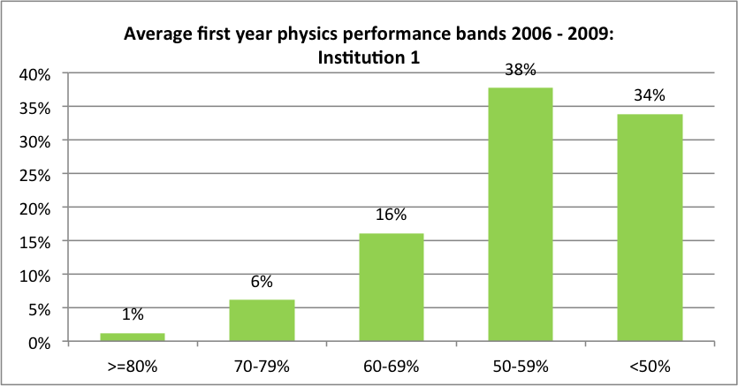

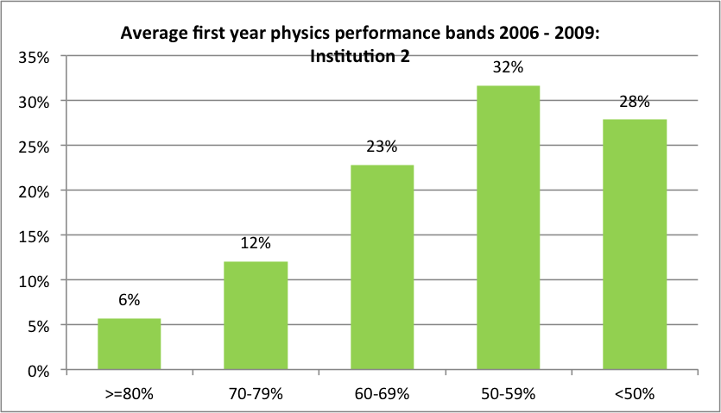

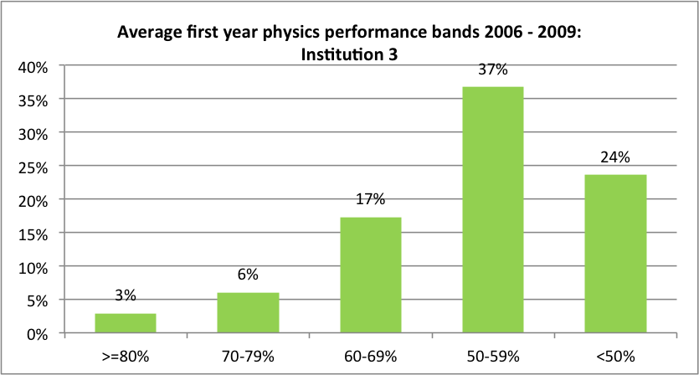

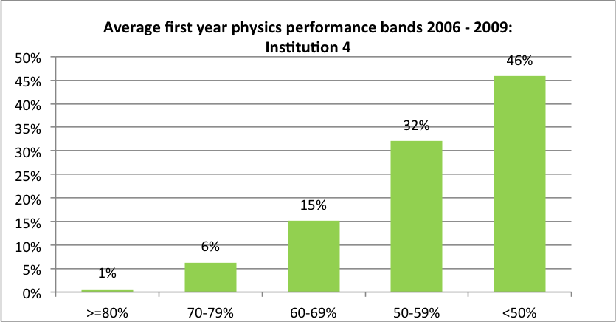

Appendix C: A note on funding

Lawless and Kirsten (2008: 32) comment as follows on the problem of state funding for engineering:

Funding impacts on most of the problems identified and was therefore identified as an area which could solve many problems.

“It is expensive to run a chemical engineering department with state-of-the-art practical equipment and laboratories, as the current government subsidy per student is not sufficient to cover the real costs related to the education of chemical engineers. Therefore, in order for a chemical engineering department to operate successfully and effectively (on a financial basis), significant contract research work and related industrial interaction is required”.

“We need two complementary components for funding: (a) ‘rising tide’ for all universities, simply to put them into a reasonable ‘ballpark’; (b) then, allow universities to follow differentiated routes/strategies to pursue their own particular niches”.

Funding is not only a problem in terms of lecturers not being paid adequately but in terms of there being insufficient funding for an adequate number of lecturers to be deployed. Engineering programmes are expensive to run but they are not categorized as such in the funding formula. The number of subjects in engineering degrees and diplomas is significantly higher than in most other qualifications. The funding formula awards a subsidy per full time student. The measure is known as a Full-time Teaching Equivalent (FTE), and is based on one student enrolled full-time in contact mode for a whole academic year. A student studying full-time for a six-month semester would count as a 0.5 FTE. Adjustments are made to the subsidy based on the number of subjects being taught, but the adjustment as currently calculated in inadequate for most engineering courses. Typically to date 8 to 10 subjects were taught per semester i.e. 16 to 20 per annum. This translates on the whole to 3 or 4 times the number of subjects delivered in other courses, but the adjustment factor (known as the Teaching Input Grant Adjustment Factor) is 2.5. Thus departments cannot afford the number of lecturers required to deliver the range of subjects.

To ensure that they break-even, departments have removed many fundamental subjects from their curricula which impacts on throughput and the calibre of the graduates. As another cost saving measure, departments have reduced contact time by making some subjects self-study. Whilst learning of soft subjects may be possible, the ability of students to develop an understanding of structural analysis and other complex theoretical subjects is questionable when adopting this approach. Sadly in many instances the more complex and therefore more expensive to teach subjects have suffered in the interests of cost savings. One must question the long-term effect of these measures as they will ultimately impact on the health and safety of those for whom infrastructure is developed.

Engineering should be funded at the highest subsidy level, if not higher and the adjustment factors must be reviewed as a matter of urgency.

A related problem is the trickle down of funds into the departments. Few report receiving the full value of additional funds raised to support their departments.

See Appendix A for a list of interviewees.
Comparisons of this kind are fraught. It is not always clear that like is being compared with like, and of course the socio-economic contexts of countries vary enormously. Nonetheless, the orders of magnitude give some comparative indication of the pool of engineering skills across countries.
Unpublished, undated briefing note for the Joint Initiative on Priority Skills Acquisition (JIPSA).
The notion of ‘throughput’ is itself a contested, and somewhat reductionist notion, given that students may follow a variety of ‘academic pathways’ through higher education, for a variety of reasons including personal interest and circumstances, academic performance, financial constraints and incentives and so forth. However, throughput remains a useful framing concept from the point of view of understanding and intervening in the skills pipeline.
The higher education Gross Enrolment Ratio (GER) is the total number of students in higher education (in any age group) in a given year, expressed as a percentage of the 20-24 year-old age cohort.
This method of calculating graduation rates has been subjected to serious criticism, as the CHE acknowledges, because it fails to take account of fluctuations in enrolments, the varying durations of different degrees, and the fact that students do not necessarily pursue a linear path through higher education. The fact that there is a delay of three to five years (or more) between enrolment and graduation is a further complicating factor (CHE, 2009: 34).
The introduction of the NSC and its impact on enrolment and throughput is discussed later in this report.
Classification of Education Subject Matter. Figures are for contact institutions, excluding UNISA.
Numbers may be inflated by students transferring to and completing a three-year degree within this period.
Graduation within 5 years for all national diplomas in Engineering, excluding Technikon SA, stands at 17%, while a further 14% remain in the system after 5 years.
According to informants, a further internal restructuring process is on the cards at UKZN, while at UJ concern was expressed that a proposed relocation of Engineering to the downtown Doornfontein campus could see students ‘voting with their feet’.
The DoE method of calculating throughput is contested and problematic, as has been noted. However, more detailed cohort analyses are not currently available.
As measured in NQF credits.
See the CDE Report, ‘The maths and science performance of South Africa’s Schools’ (CDE, 2010) for a useful analysis and discussion of this issue (I am indebted to Prof. Hu Hanrahan for this reference).
Some Faculties have established alternative admissions programmes, and foundation and extended programmes, which have lower entrance requirements than the mainstream degree programmes.
A CDE report on maths and science performance in South African schools concludes that the 2008 NSC results ‘reflect a significant degree of grade inflation’ (CDE, 2010: 12).
In one or two cases, Heads of Department indicated that they would not admit students who had selected engineering as a second option, after medicine - another indication, perhaps, that engineers see themselves as an elite.
A basic Admission Point Score is calculated according to the following NSC ratings: 7=80-100%; 6=70-79%; 5=60-69% and 4=50-59%.
Student financial aid is also discussed in the chapter on funding, below.
Total credits may be greater than this, in extended programmes such as the ENGAGE programme at the University of Pretoria.
It was suggested however that credits at the University of Johannesburg may be inflated by the way in which credits are calculated by the service departments.
A separate issue, discussed in the next section, is the place of the B.Sc programme in relation to engineering foundation programmes.
The percentage of black students in higher education increased from 40% of the total student body in 1999, to 61% in 2004 and 72% in 2005 (CHE, 2010: 35).
I am indebted to Professor Ian Scott of UCT and Professor Diane Grayson of the University of Pretoria for their helpful insights into the curriculum challenge, and particularly the case for a flexible approach to curriculum.
This assumes that lecturers in mainstream courses are equipped to teach a diverse student intake. Even in the mainstream programme, moreover, it is likely that some students will require additional time and support.
The Higher Education Management Information System.
Discussed below, under funding.
See the section on funding, below.
Professor Ian Scott explains (personal communication), ‘While the HEQF does not cap the overall number of credits in a programme, its specification of limits on the number of junior undergraduate credits permitted (especially at level 5) constrains the inclusion of substantial foundational provision in a flexible mainstream programme. The forthcoming revision of the HEQF may, however, reduce or remove constraints of this kind. Similarly, the current ECSA standard indicates that the Engineering Bachelors degree is a four-year programme; but this may also be revised.’
This is a point emphasised by the Chair of ECSA’s Strategic Advisory Committee, Professor Thoko Majozi.
These are discussed in more detail in the following section, on teaching and learning.
Scott et al, 2007 provide essential background for this discussion; see also Fisher and Scott, 2011.
Staffing is obviously central to the question of teaching and learning, and is discussed in more detail in the next section.
NMMU is not mentioned here as it offers only one, small degree programme. Its diploma offerings however are significant.
The recent establishment of the South African Society for Engineering Education, whose successful inaugural conference was held at the University of Stellenbosch in August, is a positive development in this regard.
There appears to be no generally accepted framework or typology, and different informants provided different accounts, suggesting that a more formal analysis might be useful. One dean suggested, for example, that the first year challenge centred on higher mathematics, and learning to solve problems from first principles ; the second year challenge lay in the analysis of engineering systems; the key challenge in third year was synthesis and design, while for final year students their projects were the major challenge. A number of similar, but different characterisations were offered by other informants; some believed that the first year was the most challenging, others that third year was particularly difficult, and so on.
This could include policies on staff appointments, promotions and reward systems; teaching awards and research grants etc.
The role of competent, qualified and dedicated lecturing staff remains fundamental however.
This could run in parallel with a research project on the curriculum, as suggested above, and the two projects could be pitched as ‘flagship’ initiatives of a wider, coordinated ECSA initiative on the engineering skills pipeline.
See Lawless and Kirsten (2008: 56-8) for a more detailed list of possible interventions.
The funding framework is currently under review.
Also under review.
Student financial aid is also discussed in some detail in the chapter on student support.
In addition to funding from the DHET, higher education also receives funding from all three levels of government, as well as from government-funded research councils and other bodies. For a discussion of the poor alignment of government funding of higher education, and the implications of this for the national system of science and innovation, see Kaplan (2008).
The HEQF and the funding framework are under review in 2011, presenting ECSA with an important opportunity to make the case for a more flexible engineering curriculum.
See Appendix C, which includes a more detailed analysis of the funding formula by Lawless and Kirsten (2008). Higher education funding is also extensively reviewed in Stumpf, 2010.
The pursuit of research funding may also be driven to some extent by the under-funding of higher education and institutions’ drive to compensate for reduced state subsidy levels, as noted in the comments by Stumpf, above. The issues of teaching and learning and research are tied up with the question of funding in more ways than one.
Lawless and Kirsten (2008) report a similar finding.
Stumpf (2010) observes that there is a fair amount of cross-subsidisation by universities, but that the extent is unknown.
The Thuthuka programme of the South African Institute of Chartered Accountants (SAICA) appears to be an excellent example of a comprehensive and well-designed bursary programme, including firm accountability measures with both students and the universities, close monitoring of student performance and a comprehensive package of student support. For a report to ECSA which examines the relevance of the Thuthuka model to engineering, see Merrifield (2010).
The university survey requested information on bursaries and student financial aid but very limited data was made available. A comprehensive survey and policy review of this important topic would be extremely useful.
I am particularly indebted to Monique Adams for insights into some of the challenges surrounding bursary provision and factors affecting student success.
For example, the Carnegie Foundation for the Advancement of Teaching; international professional associations; local voluntary professional associations, the Council for Higher Education etc.
See the report to JIPSA on staffing in engineering, by Lawless and Kirsten (2008).
The Minerals Education Trust Fund (METF) is an excellent example of such a partnership between industry and the universities.

